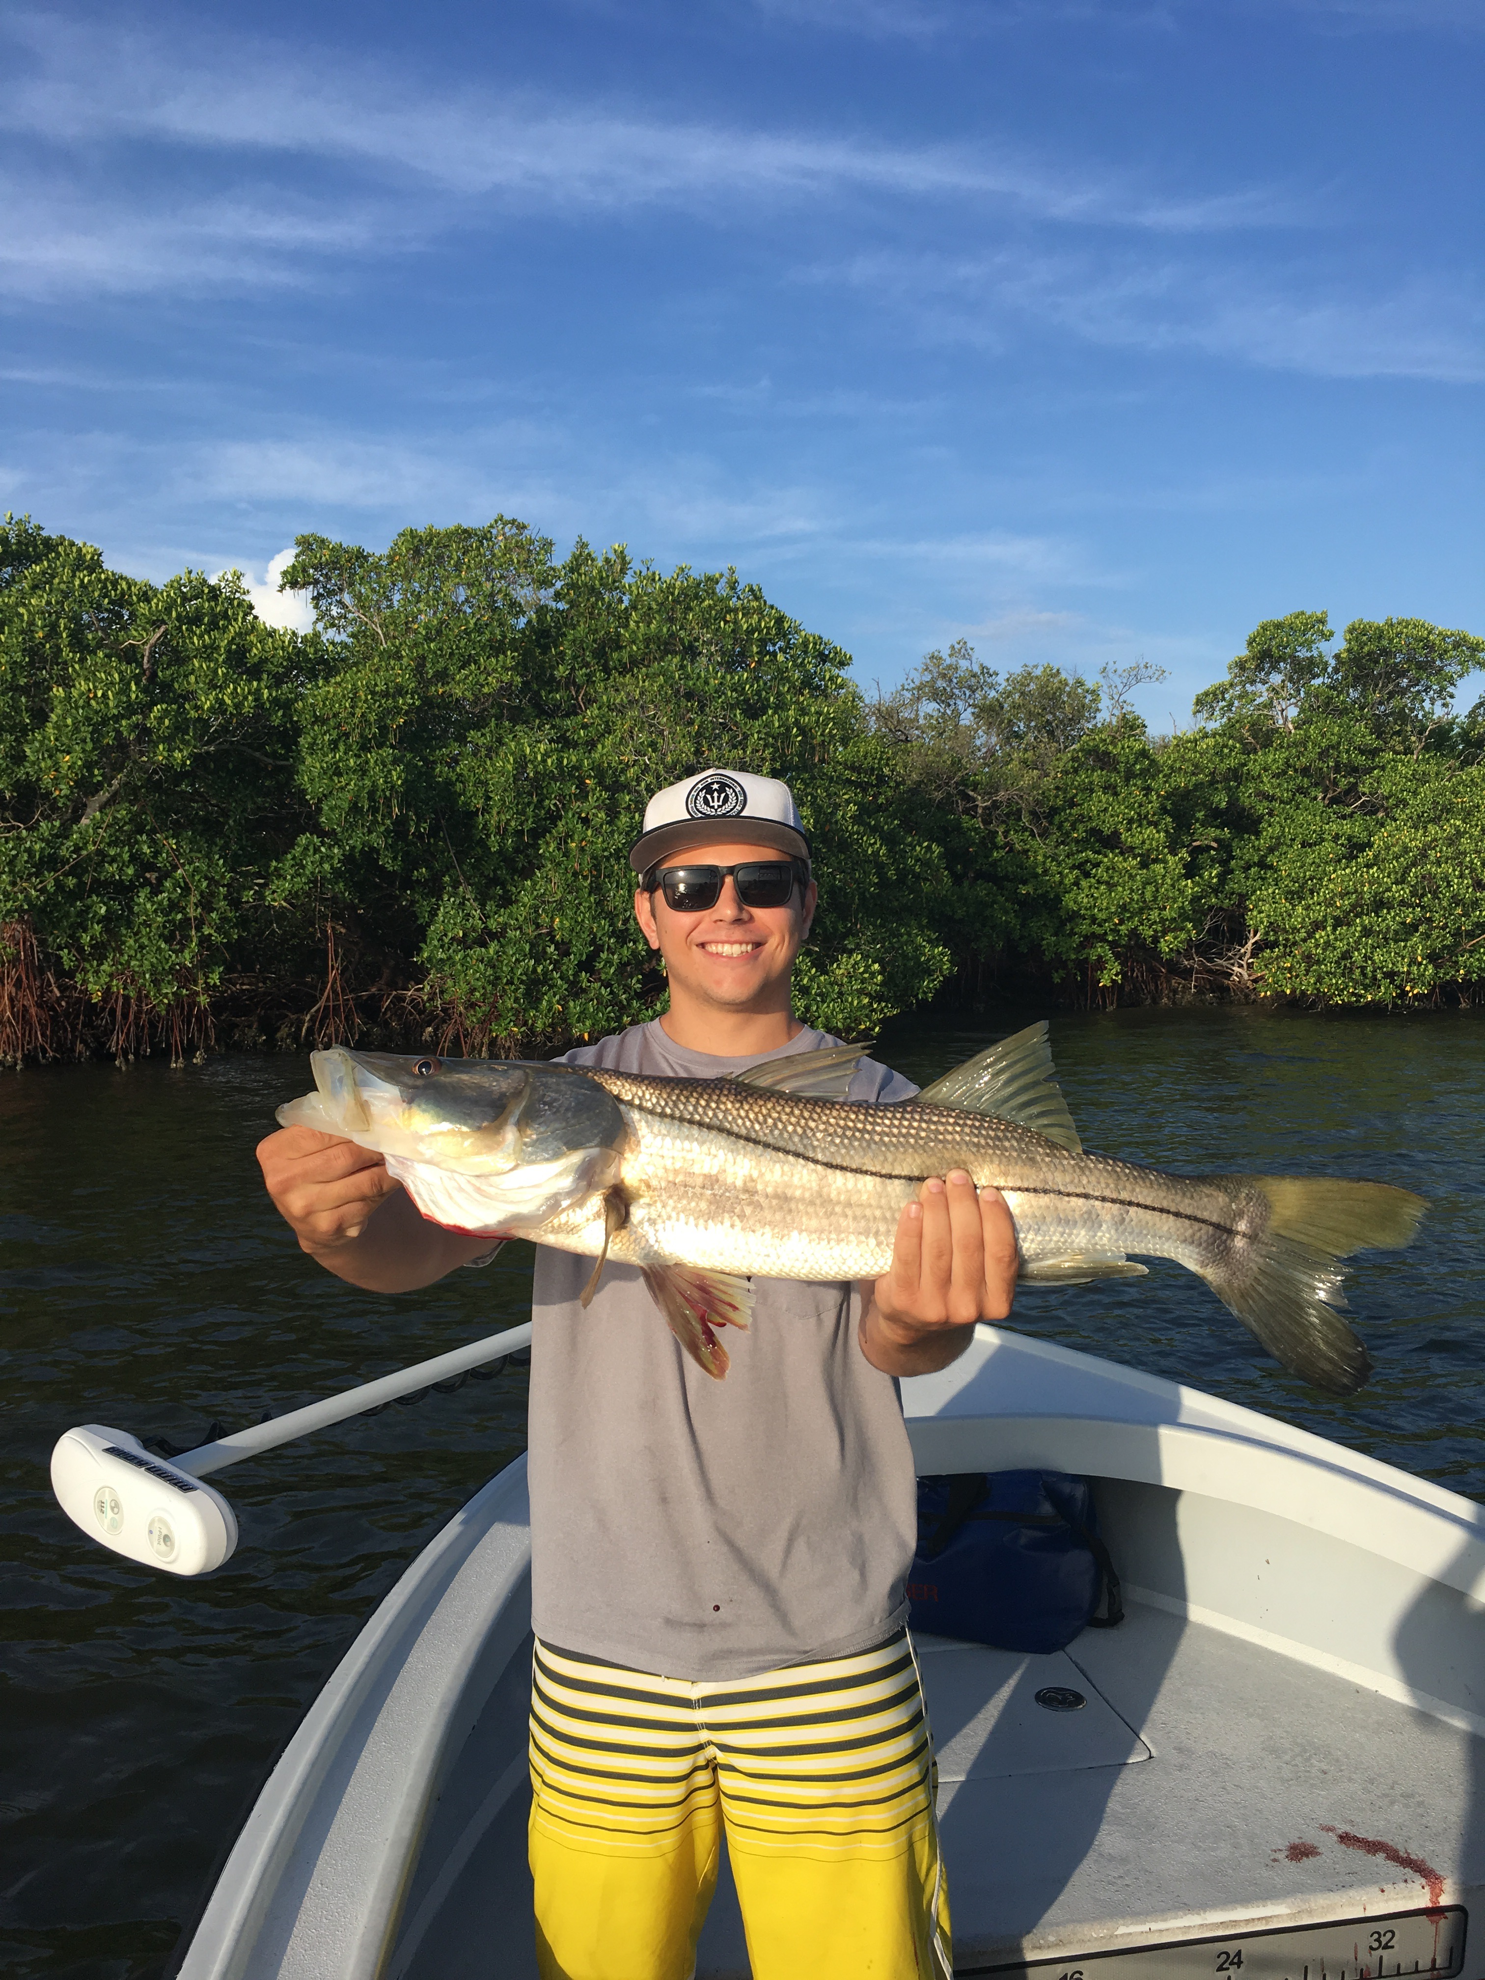

Summertime family fishing

Pic: Jack Bowser from Boca Raton with a 35 inch snook caught and released while fishing with Capt Matt Mitchell this week

The oppressive heat of summer continues to cook southwest Florida and was felt by anyone that did anything at all outside this week. Getting out on the water early and getting in before noon does help a little but with the super high humidity it already feels like 90 degree’s before the sun is even up. Sunrise and first light over the past few weeks is getting noticeably later. With so few boats out on our local waters and a wide variety of fish to catch summer remains my favorite time of year to be out on our local waters.

Most trips this week my clients had kids with them and where enjoying a family summer vacation. Most of our time was spent targeting Mangrove snapper to put fish in the box. There is just something special about going out with the family and catching your own fresh fish dinner. Depending on the days pick up location and the tide we caught limits of Mangrove snapper from the mouth of the river and southern Matlacha pass all the way up through the Sound to the quarantine rocks at Boca Grande. When going after these snapper having lots of small shiners and small pinfish has been the key to success. As we get further into summer this bite only continues to improve and these snapper just keep getting better.

Catch and release snook fishing both out on the beach and in the passes continues to be a good action too. Drifting the passes with small live pinfish and grunts on the outgpoing tide resulted in hook ups on just about every other drift during the morning outgoing tide. Out on the beaches the snook are either hanging out on blowdowns or in the troughs between the sand bars. Either place you chose to fish for them live bait is the way to go although some of the biggest snook I see all year are caught by anglers soaking big cut baits on the beach.

Other fishing options this week included Blacktip sharks, mackerel and trout. Flats just inside of Captiva pass on the outgoing tide provided non stop action on a wide variety of species. Huge schools of little threadfin herrings and everything that feeds on them could be spotted the whole backside of North Captiva on Calm days. This is relatively easy fishing using small live shiners fished 5ft under a popping cork rig. When this bite is wide open small spoons and jigs also caught fish after fish. Open water flats fishing improves drastically once you get north of Redfish pass and away from the brown water. This water is just a whole lot cleaner and a little bit cooler as it gets a better flow from the bigger passes at the northern end.

