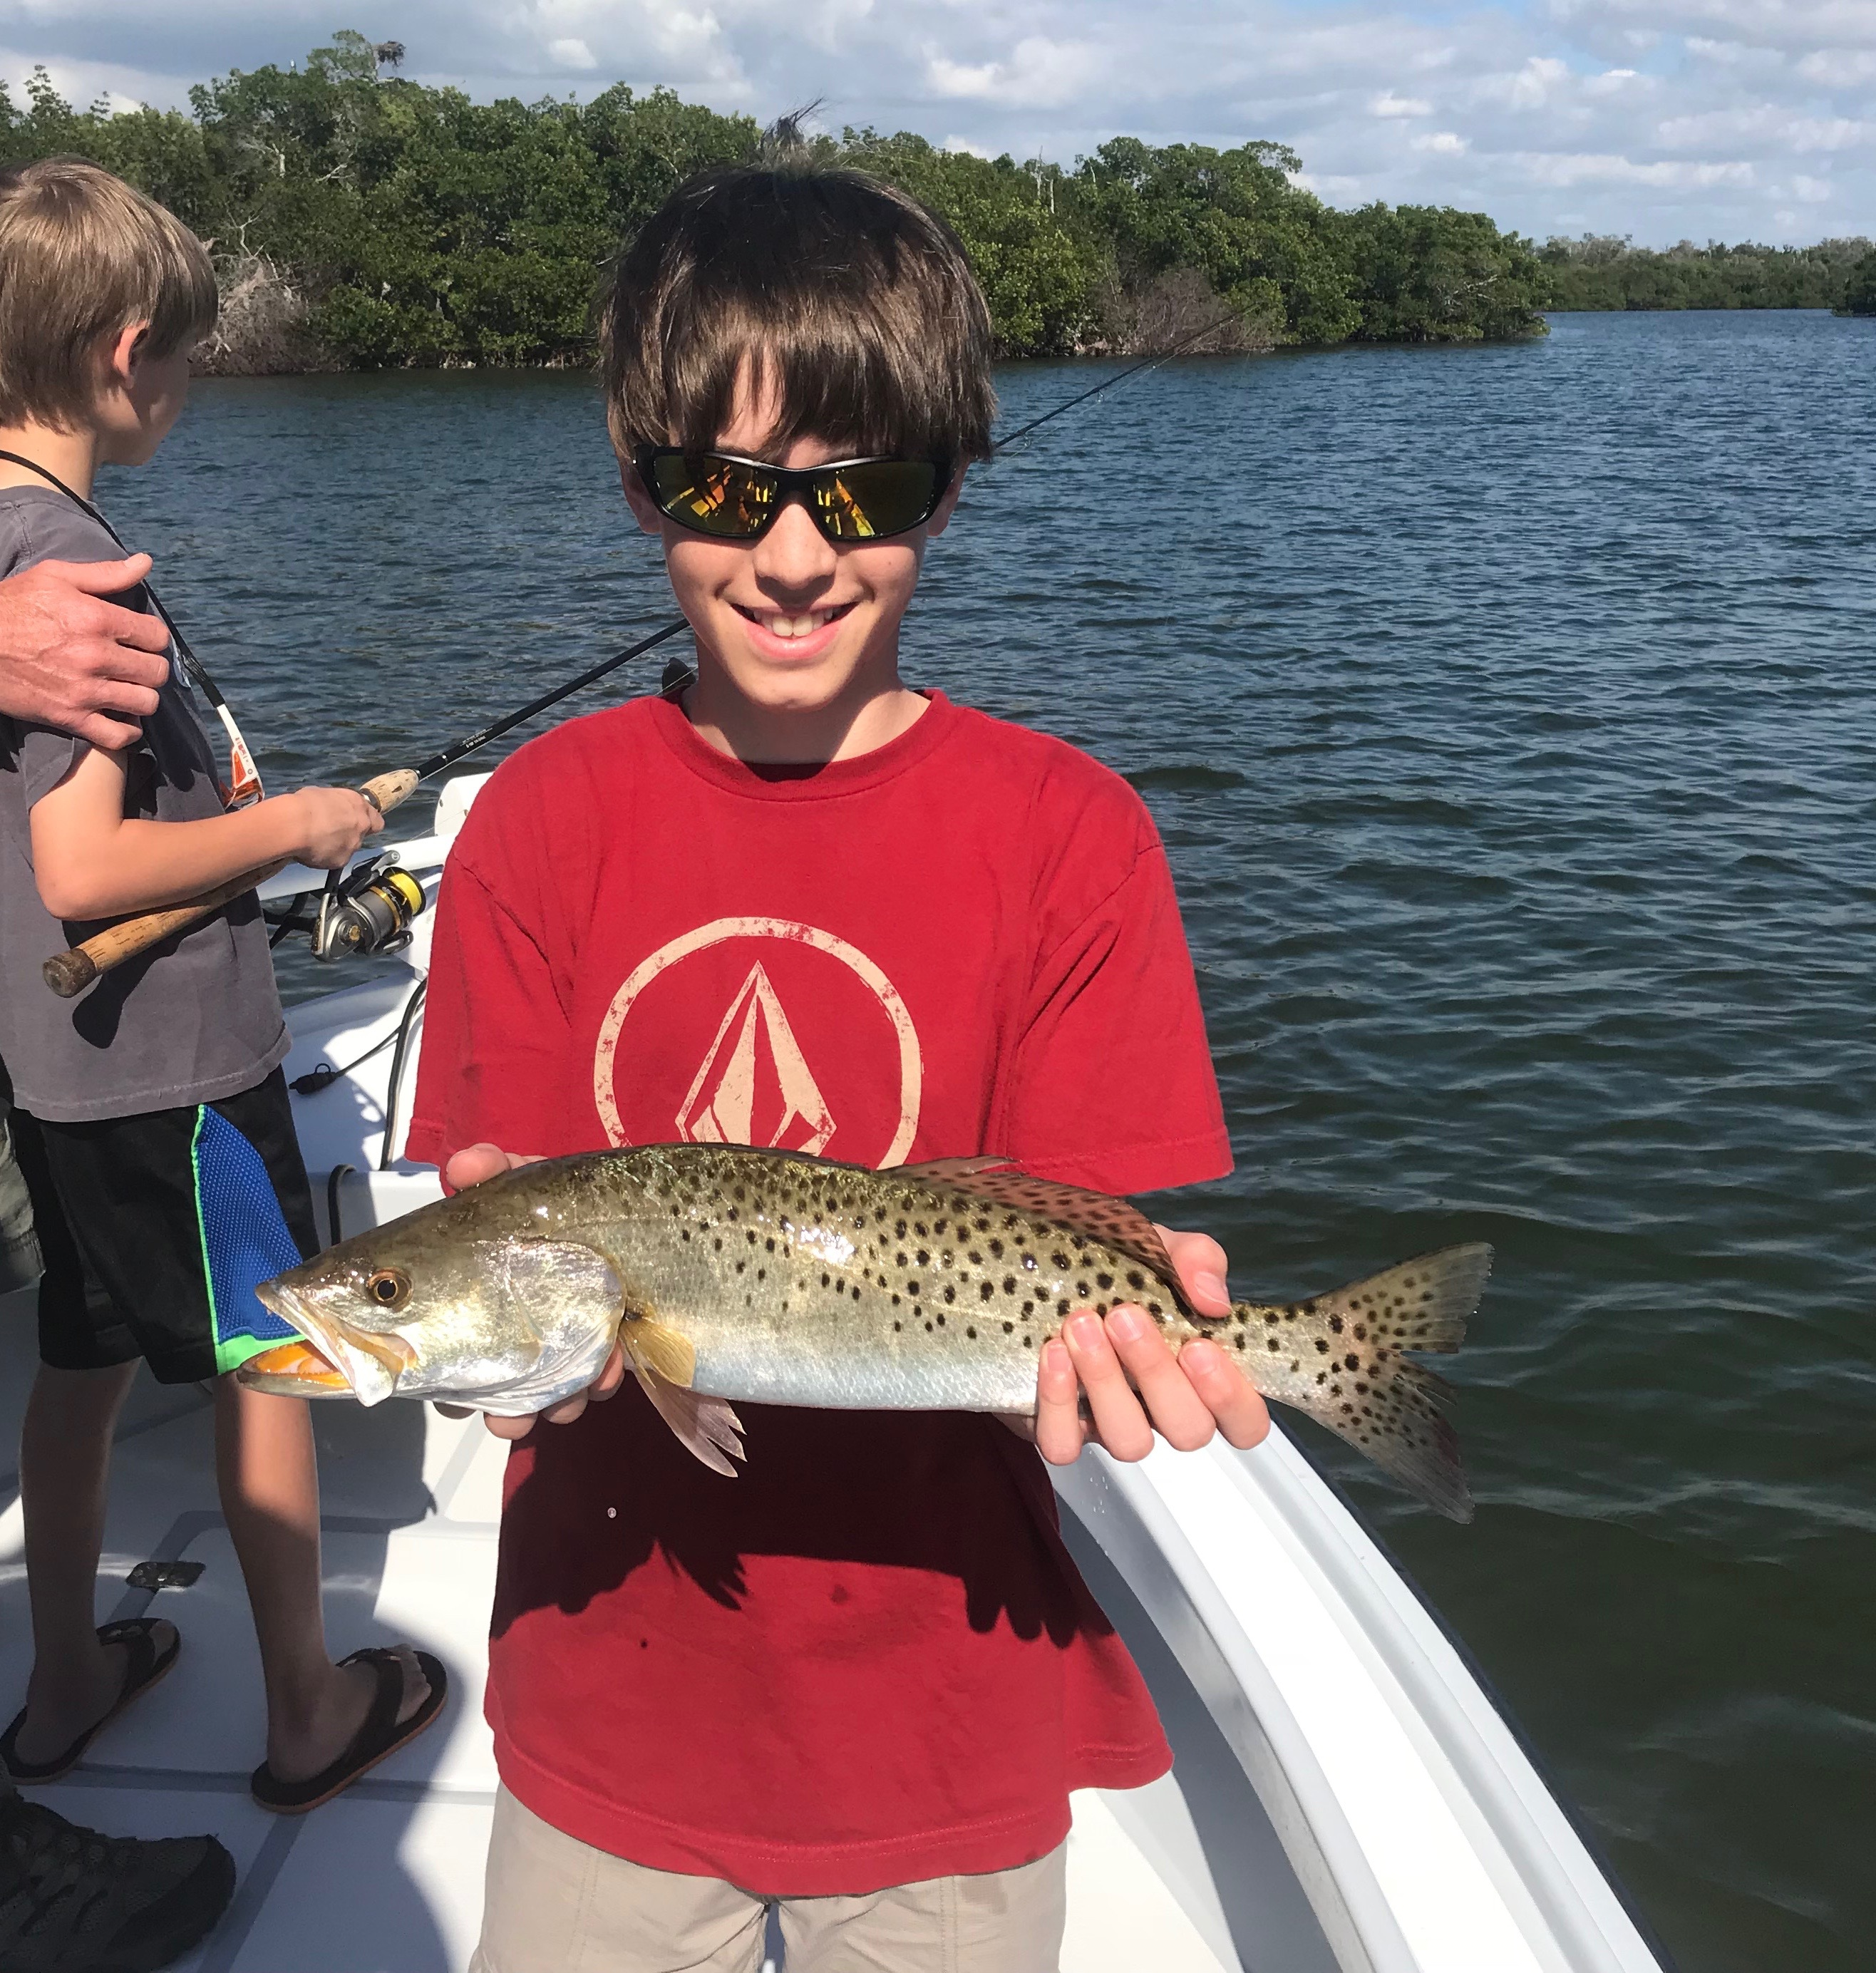Picture: Lots of Trout have been getting caught in the warm clear waters of Pine Island sound.

Spring action in February

Everyday out on the water this past few weeks has felt more and more like springtime. Day time high temperatures have been in the mid 80’s and our water temperatures have pushed into the high 70’s. Our fish don’t have a calendar to know its only mid February and have begun to show up in many places we usually don’t catch them until April. Catch and release Snook action has kicked into high gear as the sound has come to life with baitfish and birds over the past few weeks. Spanish Mackerel, Ladyfish and Jacks have invaded our waters and can be caught throughout all our inland waterways.

Over the past few weeks I’ve been catching shiners early morning again as they have been the most productive bait choice for almost all species I target. As water temperatures continue to warm these magic baits aka shiners have become more plenty full and have begun to move out to the shallow grass flats from the beaches and bridges that they are caught around during our normal winter months. Feeding birds including gulls and diving pelicans are a great way to locate bait in open water. With the water being so clear it’s been really easy to locate bait schools in shallow water then its just a matter of making a few throws of the cast net to fill the live well.

Morning minus low tides have been a great set up for catching some of the larger trout I have seen so far this winter. Many of the deeper channels and cuts through shallow water grass flats are a great place to get started. Free lined live shiners have caught lots of trout but these fish are also quick to take either a sub surface swim bait or jig that looks like a shiner. Find these natural channels with the best tide flow and you will be on some of the best trout fishing of the year. Depths in the 3-5ft range have produced lots of limits of Trout this week. As long as the tide is moving the fish will feed, once it stops moving this bite will completely shut off.

Snook are getting more and more spread out as they have began to push out of the sheltered warm water creeks of winter. Many deeper creek mouths have been great action either on the end of a falling tide or on the first hour of the low incoming tide. Although I have not been catching any real giant Snook we have been staying busy with lots of fish in the mid 20 inch range along with a few pushing the 30 inch mark. Many of these same creek mouths have also been producing some hard fighting Gag grouper along with some larger Jack Crevalle.

With our fishing action just getting better as our water temperatures rise along with a ten day weather forecast showing no cold fronts in sight I don’t think it will be much longer before we are hearing a few reports of anglers catching tarpon. February tarpon are not unheard of though what is crazy to me, is after such a cold January we are having such early Spring like weather. If you get a chance to get out on the water its a great place to escape the congestion of season and enjoy some outstanding Spring like fishing catching species that usually don’t show up for a few more months.

