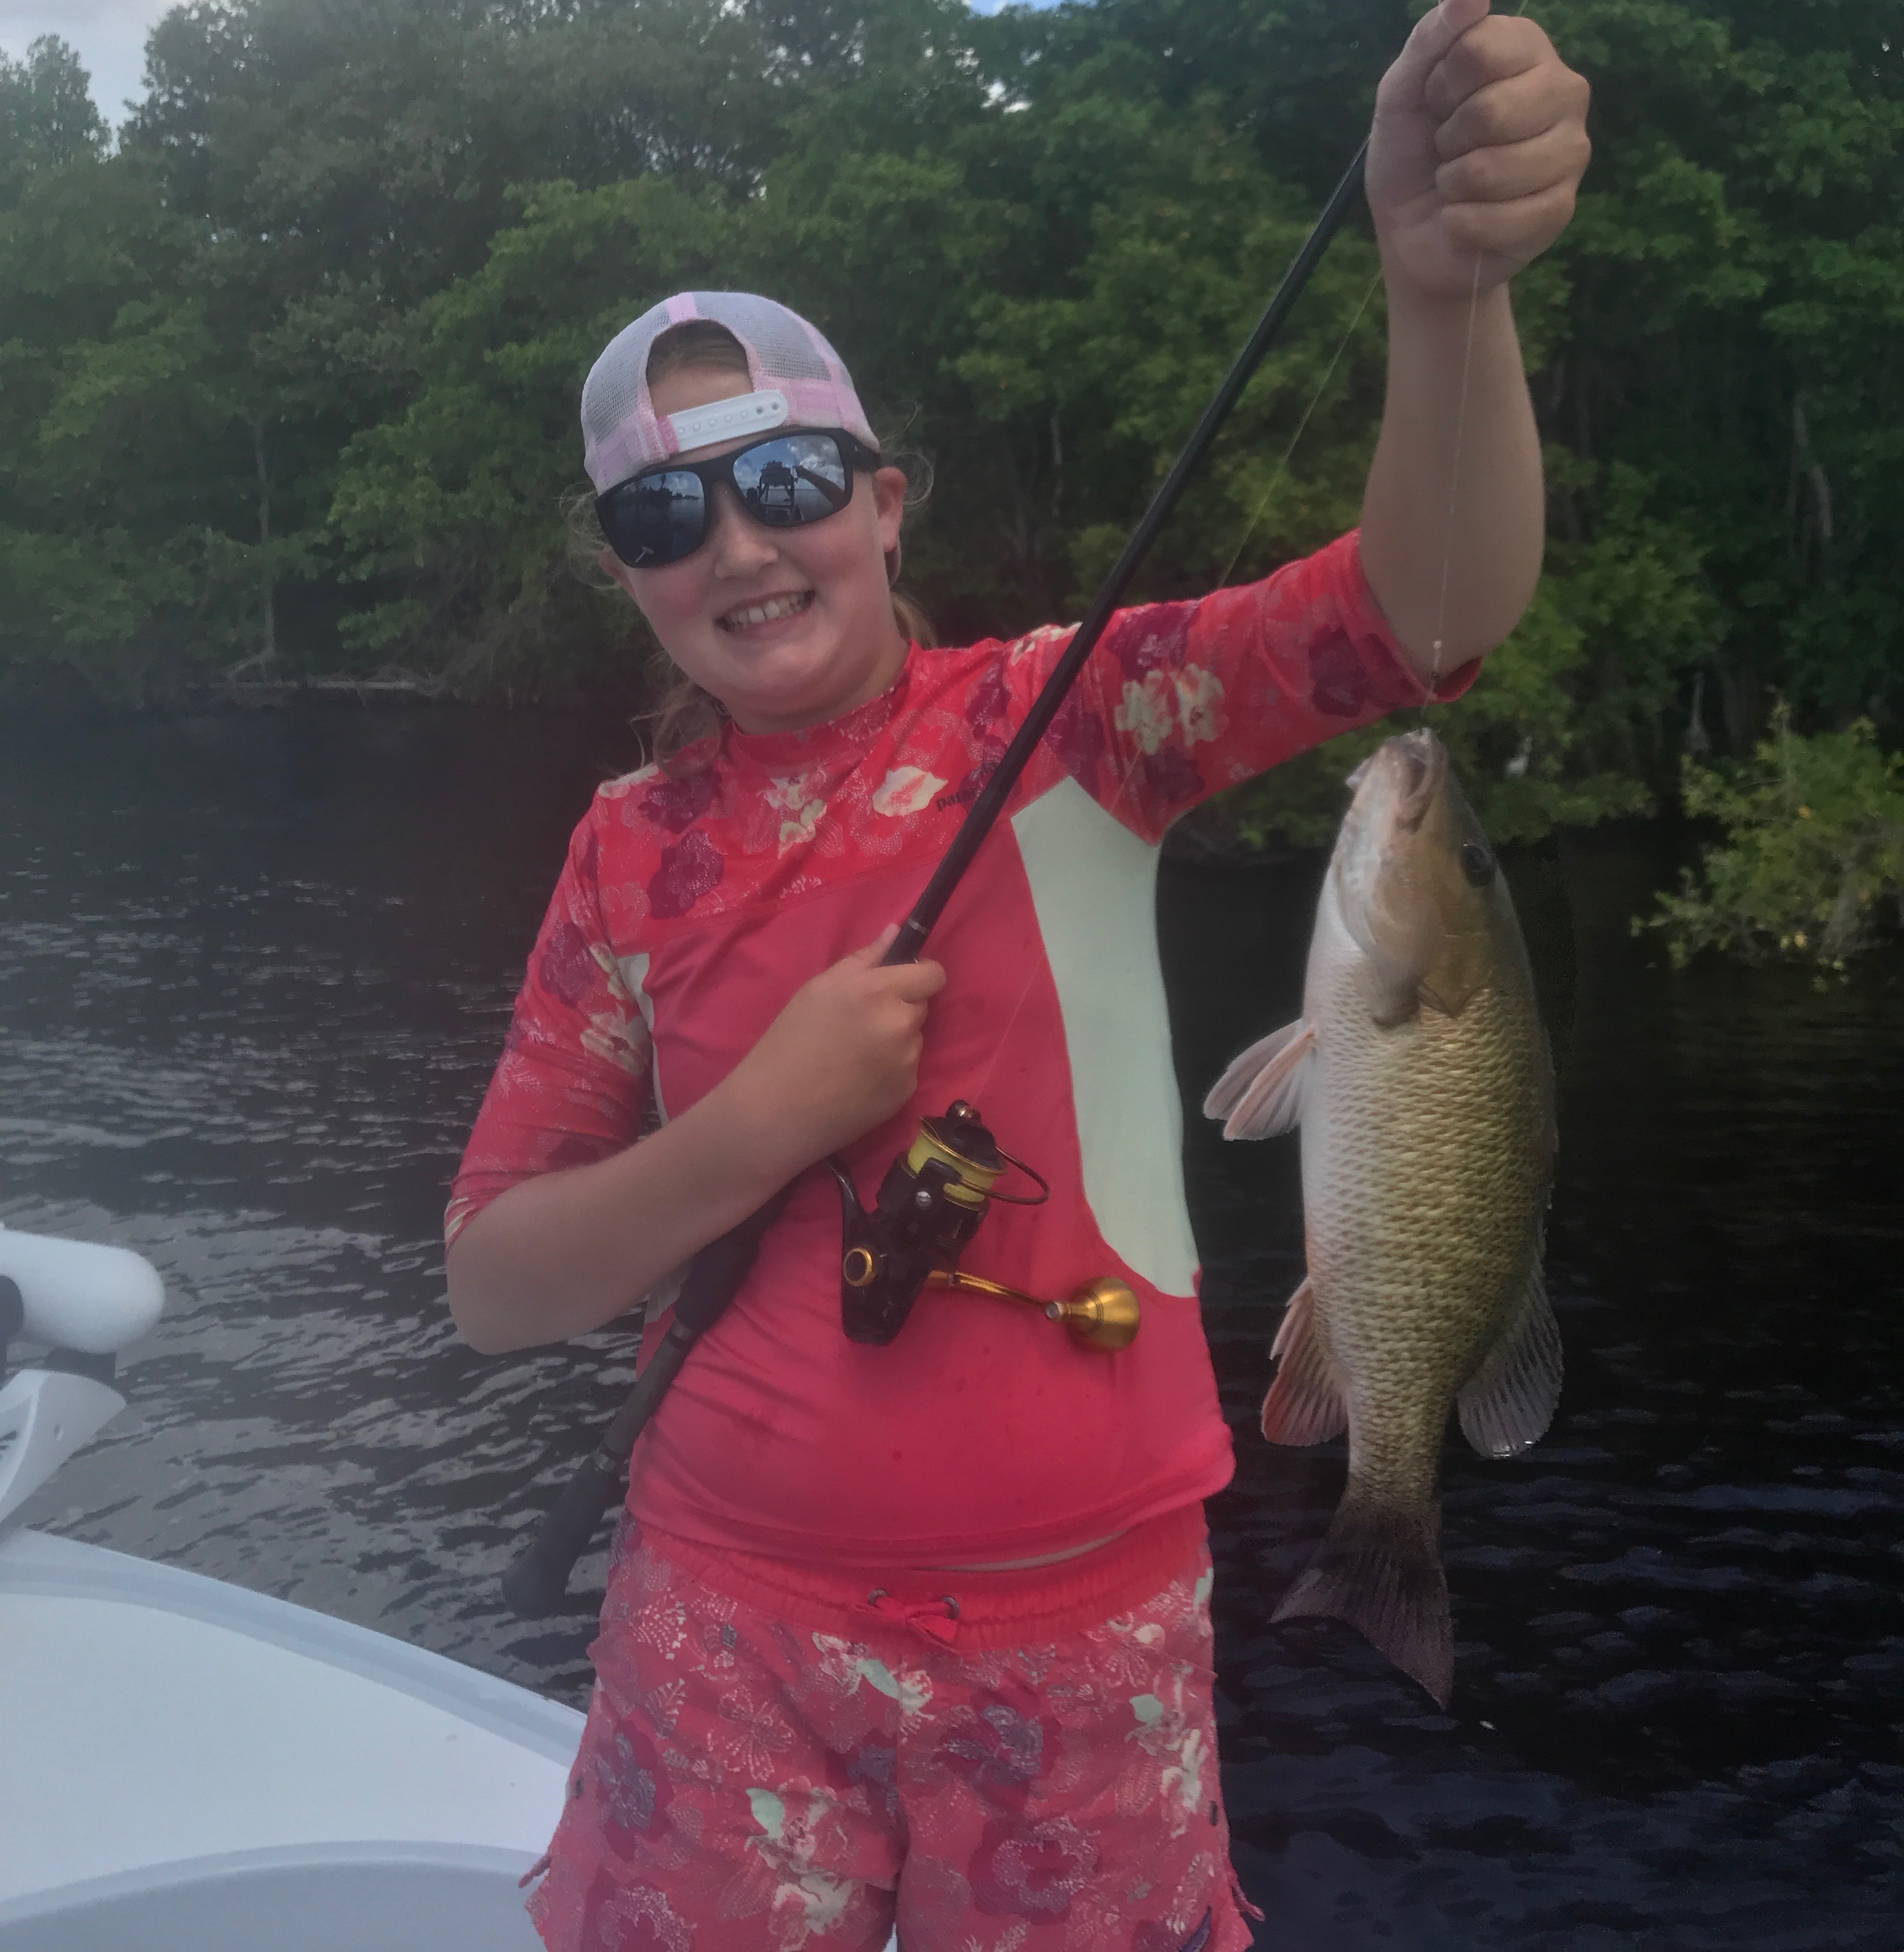

Small bait for big action

Picture: Grace Gast from Charleston SC with a tasty mangrove snapper caught while fishing with Capt Matt Mitchell this week

With the sweltering summer heat turned all the way up some of the best action this week came while fishing small shiners. Open water flats fishing with these baits caught a wide variety of fish including trout, silver trout, mackerel, jacks, small sharks and ladyfish. If you’re looking for high activity fishing this has been hard to beat. Popping corks with a live shiner made this a easy kid friendly fishery with fish coming on almost every cast at times.

Small shiners or what we call fry or maggot baits have appeared all over the sound and beaches this past week. They can often be spotted right up on the shore or out on shallow grass flats. With a couple of throws of a small mesh cast net its possible to catch a live well full of bait that just about everything that swims will eat this time of year. Having plenty to be able to live chum it’s amazing how places just come to life with a few scoops of this bait.

The few mile area on the eastern side of the sound from Chino Island to Flamingo bay channel has been a great place to get started on this open water flats fishing. Simply start fishing in 3-5ft and move until you locate the best action. This is a really popular area as you can tell by the 20 plus boats in here doing this fun fishing almost daily. Its just a great way to start the day as you can quickly get all your clients a few fish and get the skunk out. Most days we have managed a few keeper trout and mackerel in here before moving on to bigger and better things.

Despite the funky little green blobs of floating algae in the south end of Matlacha pass the fishing in this area during the incoming tide has been outstanding. Chumming the small fry bait has had keeper mangrove snapper exploding on the surface as they chase them down. Add to that a few snook, jacks and mackerel and this has been hard to beat. During the incoming tide there are many oyster bars in this area that the tide rolls over creating feeding stations for a variety of fish along with limits of mangrove snapper

This week I experienced some of the cleaner clearer water I have ever seen in the northern sound. While targeting channel markers south of cabbage key for gag grouper in certain areas you could see the bottom in 12ft of water. Although this super clear water is pretty I prefer to fish and do better in dirty or stained water. Clear water in the passes has slowed the snook bite even though you can see this fish stacked in there by the hundreds.

