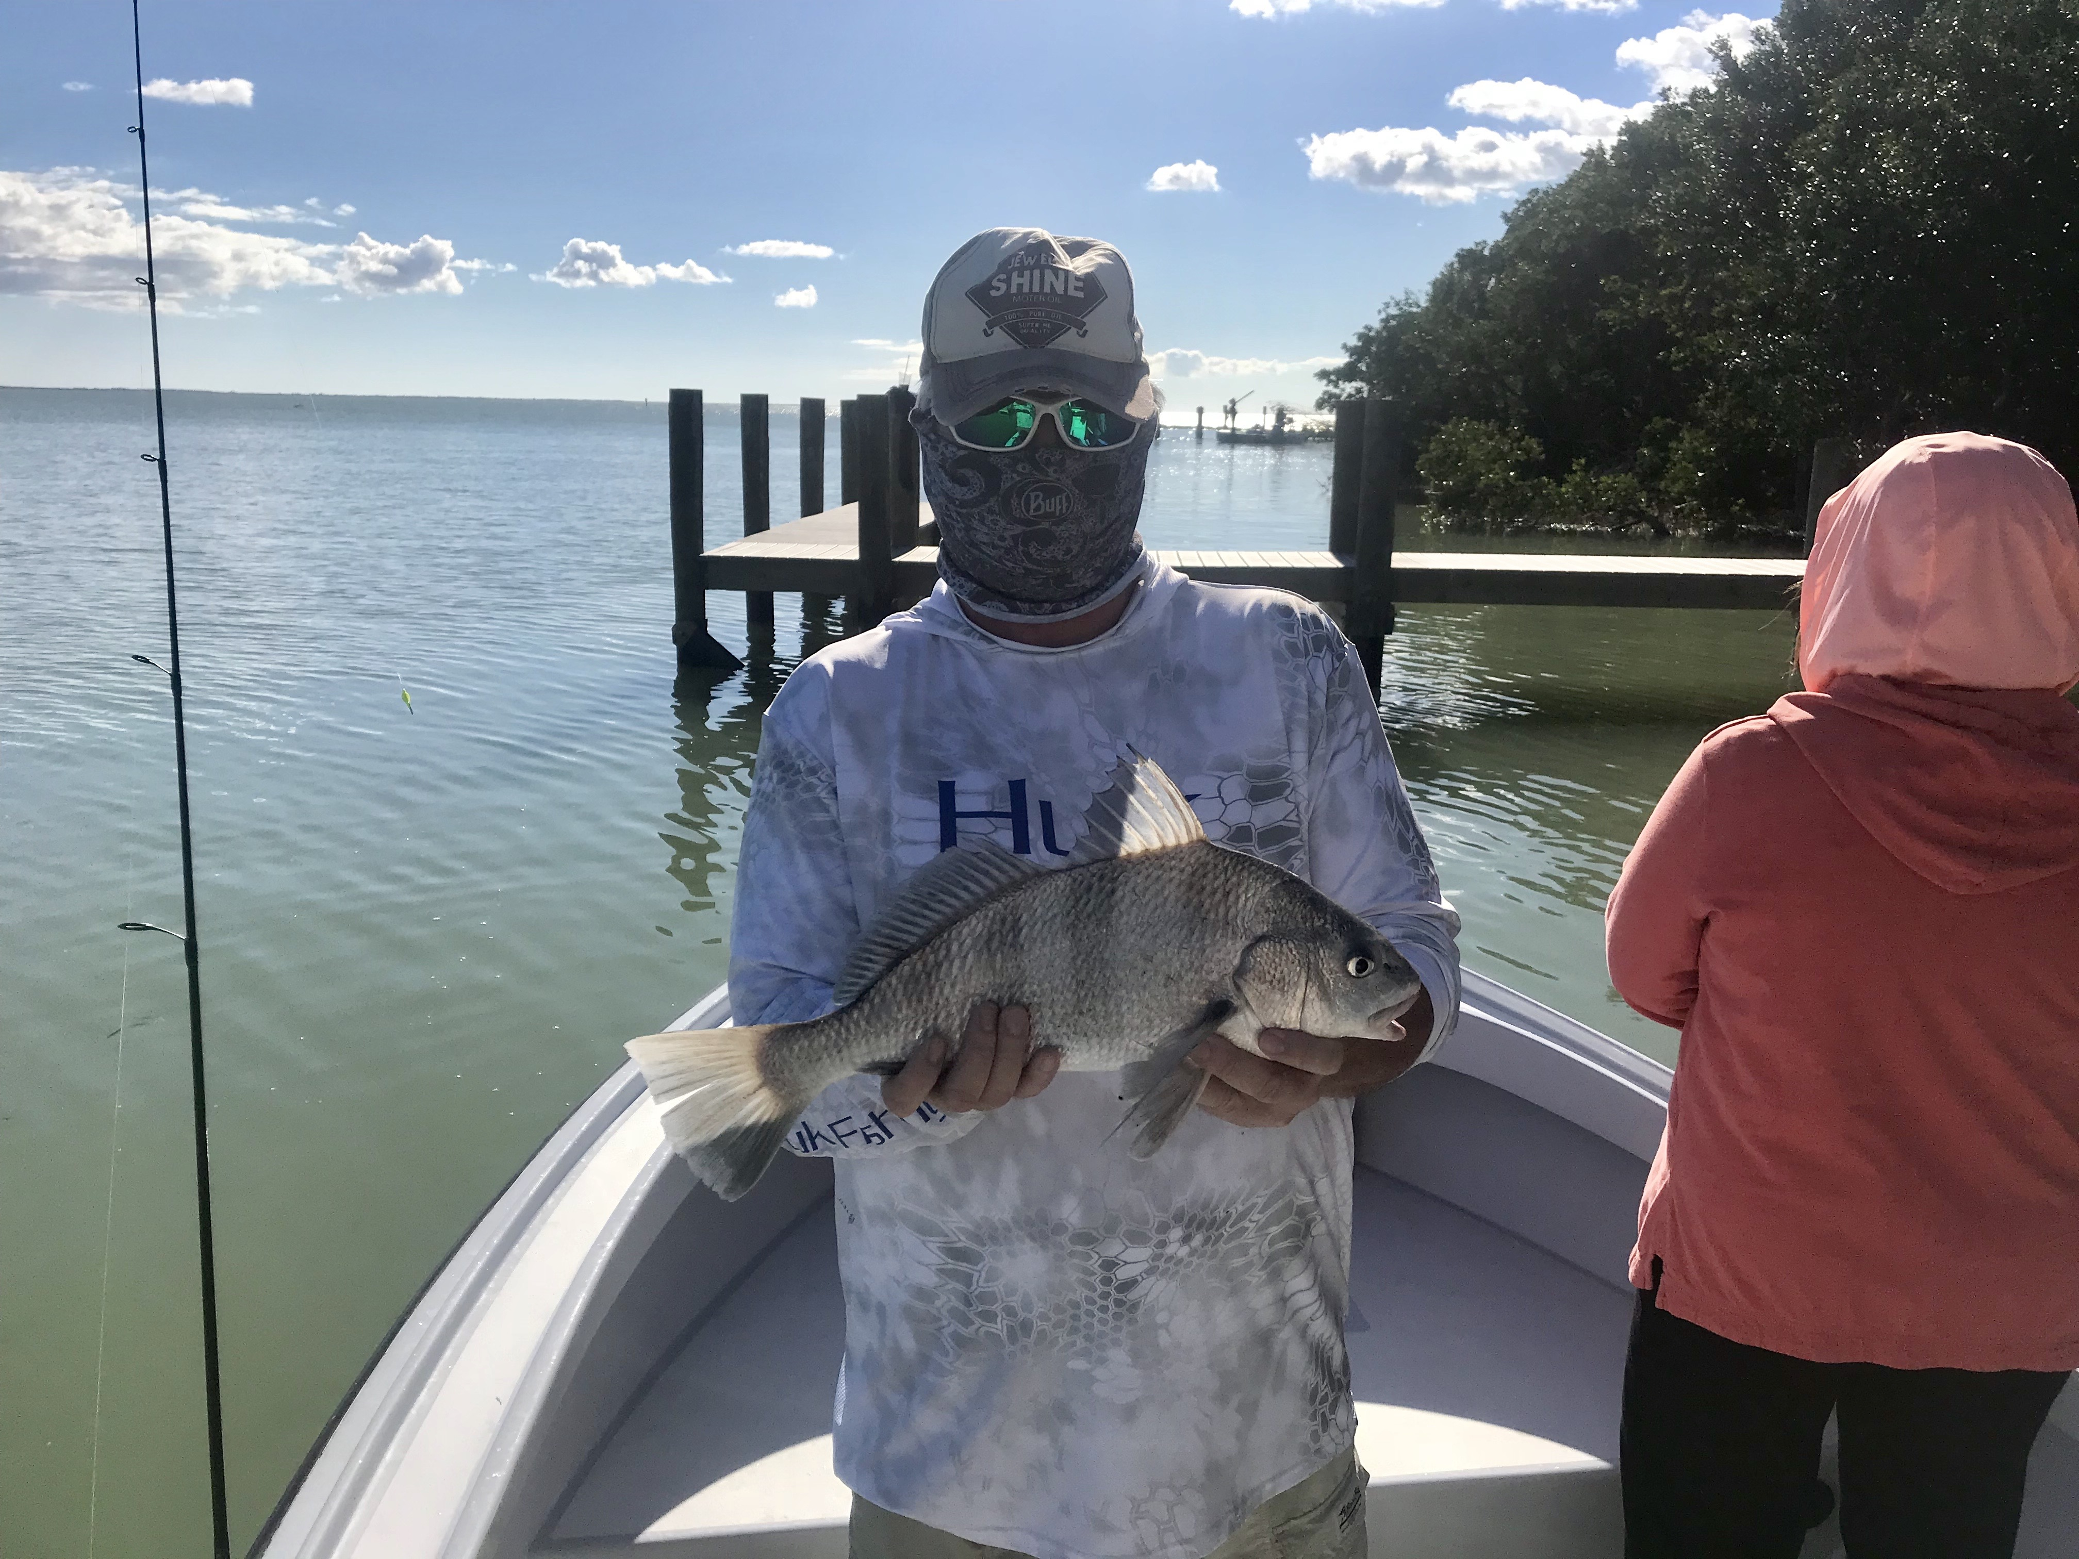
Picture: “Lucky Mike” from Lexington CC with a black drum caught post cold front while fishing with with Capt Matt Mitchell this week

Slowly warming up.

With our water temperature crashing to 61 from a warm 75 degrees in just a few days as expected shiners disappeared and to catch fish required making that switch to using shrimp for bait. Fishing in and around our passes was the better bite during the coldest periods as the water was just a little warmer coming in from the Gulf than the water in the shallow sound.

Chunks of shrimp fished on a jig head or with a split shot cast close around the docks and jetties caught a wide variety of fish including sheepshead, black drum, redfish and mangrove snapper. As long as the tide was moving the amount of action we found in and around the passes was surprisingly good for the cold conditions. As temperatures slowly began to creep back up small mangrove snapper moved into these same places and it was time to move on.

The legal size sheepshead we got to enjoy for a few days thinned out with the best action coming right after the cold front during the coldest temperatures. My anglers managed a few sheepshead on back to back days up to about 16 inches while fishing with shrimp chunks up around the passes. As things warmed up the sheepshead got smaller, this will be the pattern until the next cold front arrives and more sheepshead move in. January and February are the prime sheepshead months for our area so we are still a little early for this bite to kick into full swing yet.

Trout fishing over grass bottom in 3-5ft up in the middle sound provided some good action while throwing popping cork rigs either with live shrimp or a plastic jig. Though most of these trout are on the small side of the slot its possible to get a limit if you work at it. Along with the trout we caught ladyfish and jacks. With the water in the middle sound really clearing up look for birds both diving pelicans and terns feeding on small fry bait and the trout are there.

As temperatures gradually rebound catch and release snook fishing will pick up with deeper mangrove creeks now holding hundreds of snook. During these cold periods I see lots of snook on dock lights while heading out of the canal before the sun comes up. Going back to these lights late night can provide some outstanding snook action. My favorite ways to fish these lights is either with a fly rod or with a free lined hand picked shrimp. Set up well out from the light are work the outside edges of the light. This is some awesome sight fishing as you can often see the snook dart out and grab your bait.

