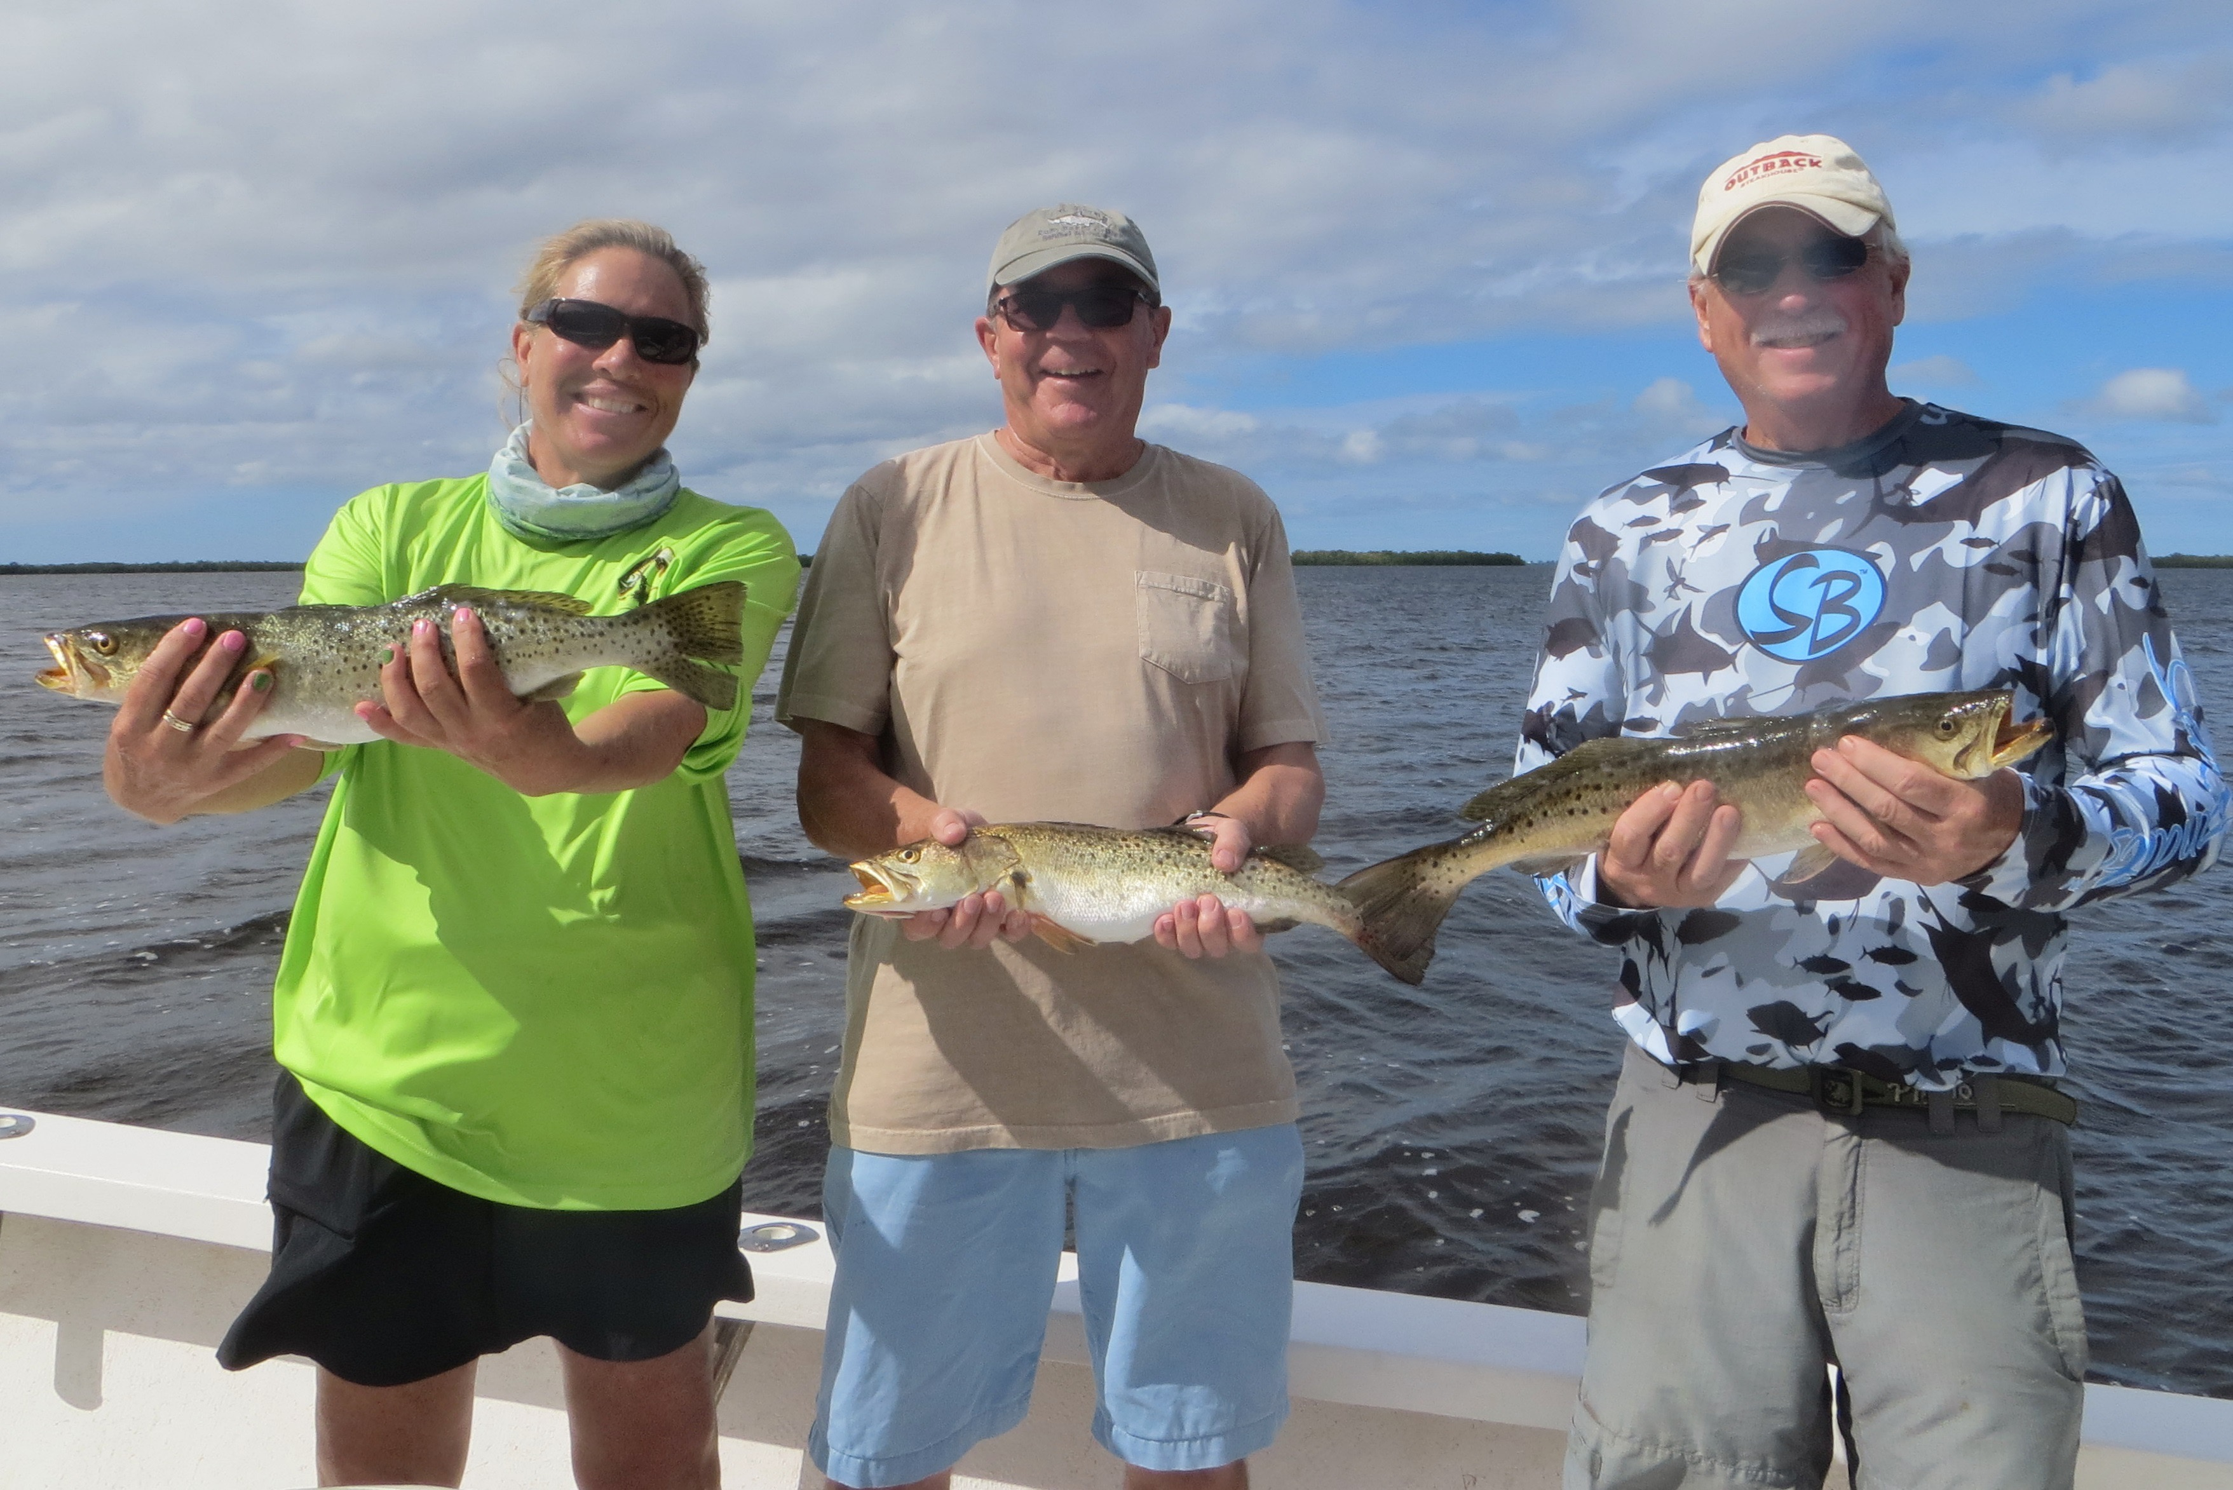

Hiding from the wind.

Picture: Big shallow water sea trout caught by Mary, Nigel and Gary this week while fishing with Captain Matt Mitchell.

“East North East winds 15 to 20 ” has sounded and felt like a broken record for what seems like weeks now. Even during these blustery conditions there are plenty of places to get out of the wind and still enjoy a great day fishing. Snook fishing this week was outstanding with non-stop action found in many of the protected mangrove creek systems throughout the sound. Along with Snook anglers caught a variety of species including over slot sized trout, mangrove snapper, grouper, jacks and a few redfish.

With another week of windy conditions in the forecast its just not looking like we will see much if any break to the wind short term. Making the best of these windy days is all you can do and unlike the offshore guys at least us back bay fisherman can still get out and catch fish. North East wind is our prevailing wind direction all winter long and learning to keep everyone comfortable while catching fish during this pattern is nothing new.

Exploring the many mangrove creek systems in Pine Island sound during these windy days and learning the places the fish stage is the key to consistently catching fish all winter long. Most of our mangrove estuaries consist of shallow bays that are connected with narrow creeks. These narrow deeper creeks increase the tide flow and are most likely where the majority of the fish are during the lower water conditions.

Target the deeper faster moving water sections of these mangrove creeks. These can often be near or on a sharp bend or turn. Look for that shoreline where the tide is driving the current hard against an undercut shoreline creating a deep open spot up against the mangrove roots. These places are often feeding stations and once located can be productive time and time again. Only time spent on the water allows you to slowly work out these patterns. As the puzzle comes together you learn what works in one creek system often works in another. Different tide directions and stages of the tide can be better in one creek than another.

Many of these creek systems have not changed much in the 30 plus years I have been lucky enough to get to enjoy them. Although one certain creek maybe better than another from year to year there are lots of bends, turns and little creek mouths that just produce fish over and over again. Learning that few square mile estuary area close to home like the back of your hand will never pay off more than when its windy.

