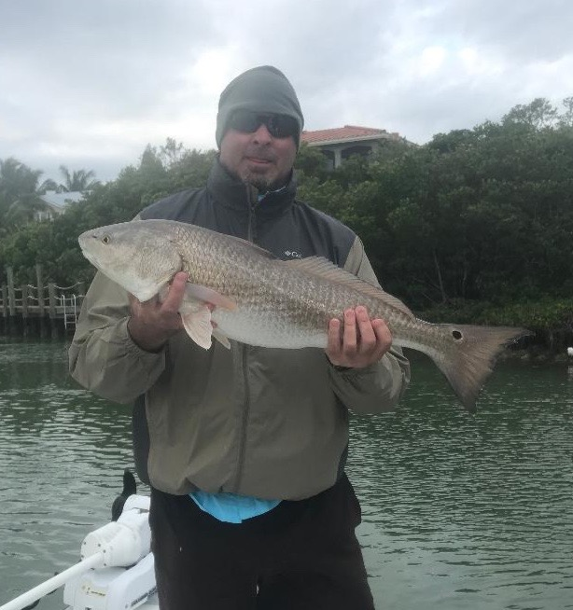

Change your mind set.

Picture: Scott Faircloth from Lake Placid with a 30 inch redfish caught while Sheepshead fishing the passes with Capt Matt Mitchell this week.

Cold fronts have continued to roll through keeping conditions cooler than normal and making it feel like winter though the official start of winter is just now here. Fishing during the cooler periods requires both a change of bait, technique and mind set. Sheepshead, black drum and redfish have become the daily targeted species until the water temperature rises. No matter how badly you want to catch Snook it can be pretty futile during the coldest periods.

We are certainly used to fishing between the passing of cold fronts though this year the timing on these has been much closer together than usual not allowing water temperatures to rebound. The winter stand by of fishing chunks of fresh shrimp on a jig head low and slow has become my daily technique to catch lots of fish along with some larger pleasant surprises.

Sheepshead fishing is going really well with lots of these fish being caught all over the region including structure on the beaches, in through all our local passes and back into the mangrove creeks. Each passing cold front brings another wave of these fish in from the Gulf. With Redfish closed to harvest and Sea trout being close to gone from the southern sound these Sheepshead are plentiful and make clients who are looking for a fresh fish dinner happy.

Some of the places I have been catching sheepshead have also been producing both redfish and black drum. This week while fishing docks around the passes we also caught a few 30 inch redfish along with black drum of all sizes with the largest measuring 24 inches. These bigger than expected fish are a real battle on the light 2500 series spinning gear. Many of the mangrove shorelines and points that hold sheepshead have also had lots of rat redfish between 16-20 inches. Its great to see so many juvenile redfish around.

A draw back of Sheepshead fishing around the passes is how aggressive some dolphins have become. At times its impossible to land or release a fish without a dolphin charging in and getting a free meal. Do your best to release your fish so the dolphins don’t get them. Often this means throwing the released fish up to the shoreline or dock so it has any chance of survival. Some times the only option is to move no matter how good the fishing is. Although people think its cute to feed these dolphins not only is it illegal they quickly learn this behavior and become a nuisance.

