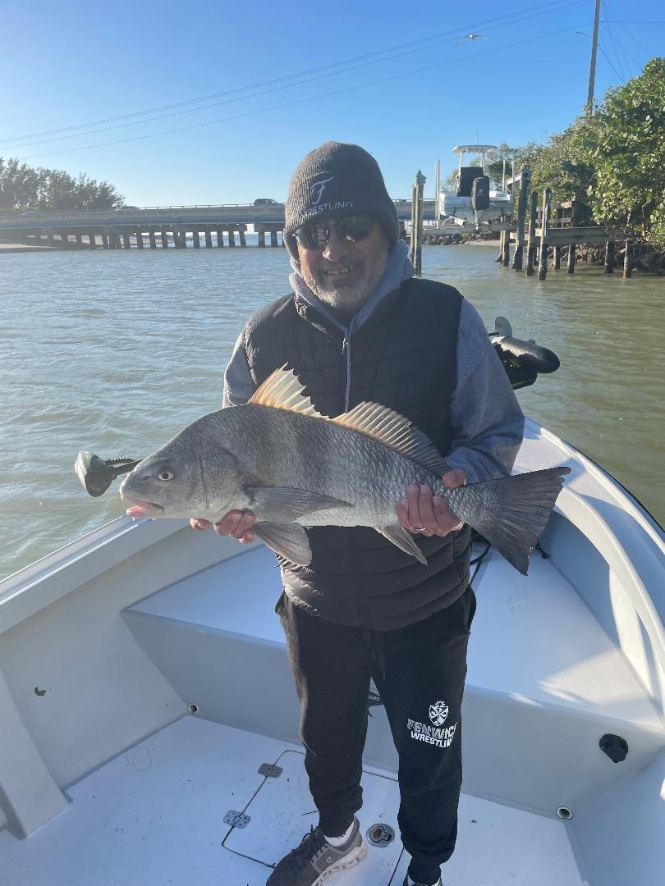

Wow, its winter.

Pic: Black drum are one of our many winters targets

Until this week we have only had a few little brief brushes with the cold of winter before temperatures have rebounded. As I’m writing this and looking at the ten day forecast we are not see much more than a chilly 70 degree high anytime soon. Although this is not the weather everyone heading south from the frigid north is hoping for its still possible to get outside and enjoy the Florida sunshine.

Sheepshead and Black Drum will be heading to fillet tables everywhere as water temperatures fall into the low 60’s. My go to this week will be fishing the many shell bottomed mangrove creeks both in the river and the southern end of Matlacha pass. Many of these creeks with fast moving current produce some of the most wide open sheepshead bites we see all winter. St James creek and Punta Blanco though both hard to access have deeper holes between the many shallow oyster bars which load up with thousands of sheepshead.

Cold water means clear water which is the perfect set up for trout fishing. Look for trout in the many protected bays of the Ding Darling as they move in from the more exposed flats of the sound. These fish will be in the transition area’s where the shallow grass touches the edges of the deeper channels. Live shrimp under a popping cork is a hard method to beat although anglers slow bouncing soft plastic jigs across the bottom cover more water. As temperatures stabilize look for these trout to move just to the outside of the creeks that feed the Ding Darling. It’s often possible to see them in the many white sand holes as your moving around.

Action on “Rat Redfish” will be both in the twisting mangrove creeks along with deeper holes against the mangroves and oyster bars. Bouncing a live shrimp on a jig head slowly across the bottom can locate some of the best redfish action of the year. Though most of these blue tailed redfish of winter are between 16-20 inches the bite can be every cast once located.

Although fishing is going to change over the next week switching gears to this winter pattern offers anglers different opportunities. I really enjoy winter along with the change of tactic’s required to catch these different species. Our cold water winter fishing is outstanding and requires a sharp fillet knife as most of these winter targets are legal to eat.

