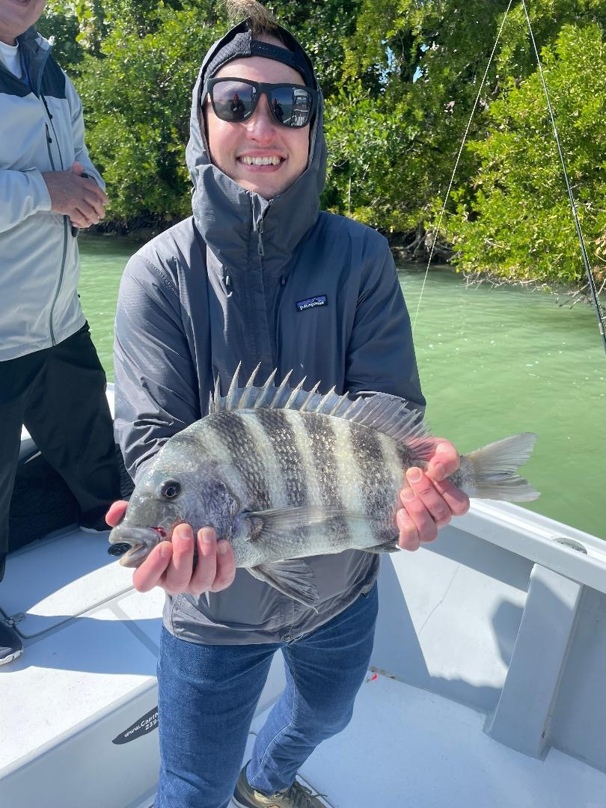

Working man’s fish

Pic: Adam from WS with a stud Sheepshead caught while fishing with Capt Matt Mitchell this week

Love them or hate them Sheepshead are one of our most consistent fish all winter long. When conditions are cold and not much else will feed this is what we target. They are both plentiful and delicious to eat. Catching them requires a totally different technique compared to every other species we catch.

As a guide teaching clients to catch these fish, that only ever seem to nibble a bait while not taking the hook can be challenging. I really enjoy this change of techniques from our everyday Snook and Redfish fishing. Anglers can often loose their patience while trying to successfully catch sheepshead though once they get the hang of it everything falls into place.

Small bait on small jig heads gives you the best hook up ratio. When using Shrimp are my goto bait, I like to thread it on the jig head to hide the hook. This bite is all about feel and anticipating that the fish is holding the bait before setting the hook. Once the fish starts to tap the bait, I slowly lift the rod tip waiting to feel it slightly bend as it loads up. The small tooth filled mouth of a Sheepshead requires a few short hard pops once the rod is bent to make sure that they are hooked.

Sheepshead are a popular fish for the anglers without a boat as they are often targeted around bridges and piers. All you need to catch sheepshead is a bag of fresh shrimp though many of the serious die-hard shepherds swear by fiddler crabs, sand fleas and even clams. Scraping barnacles off pilings and seawalls to chum these fish into feeding is also a old school technique.

These are one of our few fish that allow the angler a large bag limit of 8 fish per person. Even though the minimum size limit is 12 inches unless these fish measure 14 inches they simply don’t have much meat on them. These are not the Sheepshead of the great Lakes they are a Stripped Porgy that has a diet of shellfish making it one of the tastiest fish to eat.

