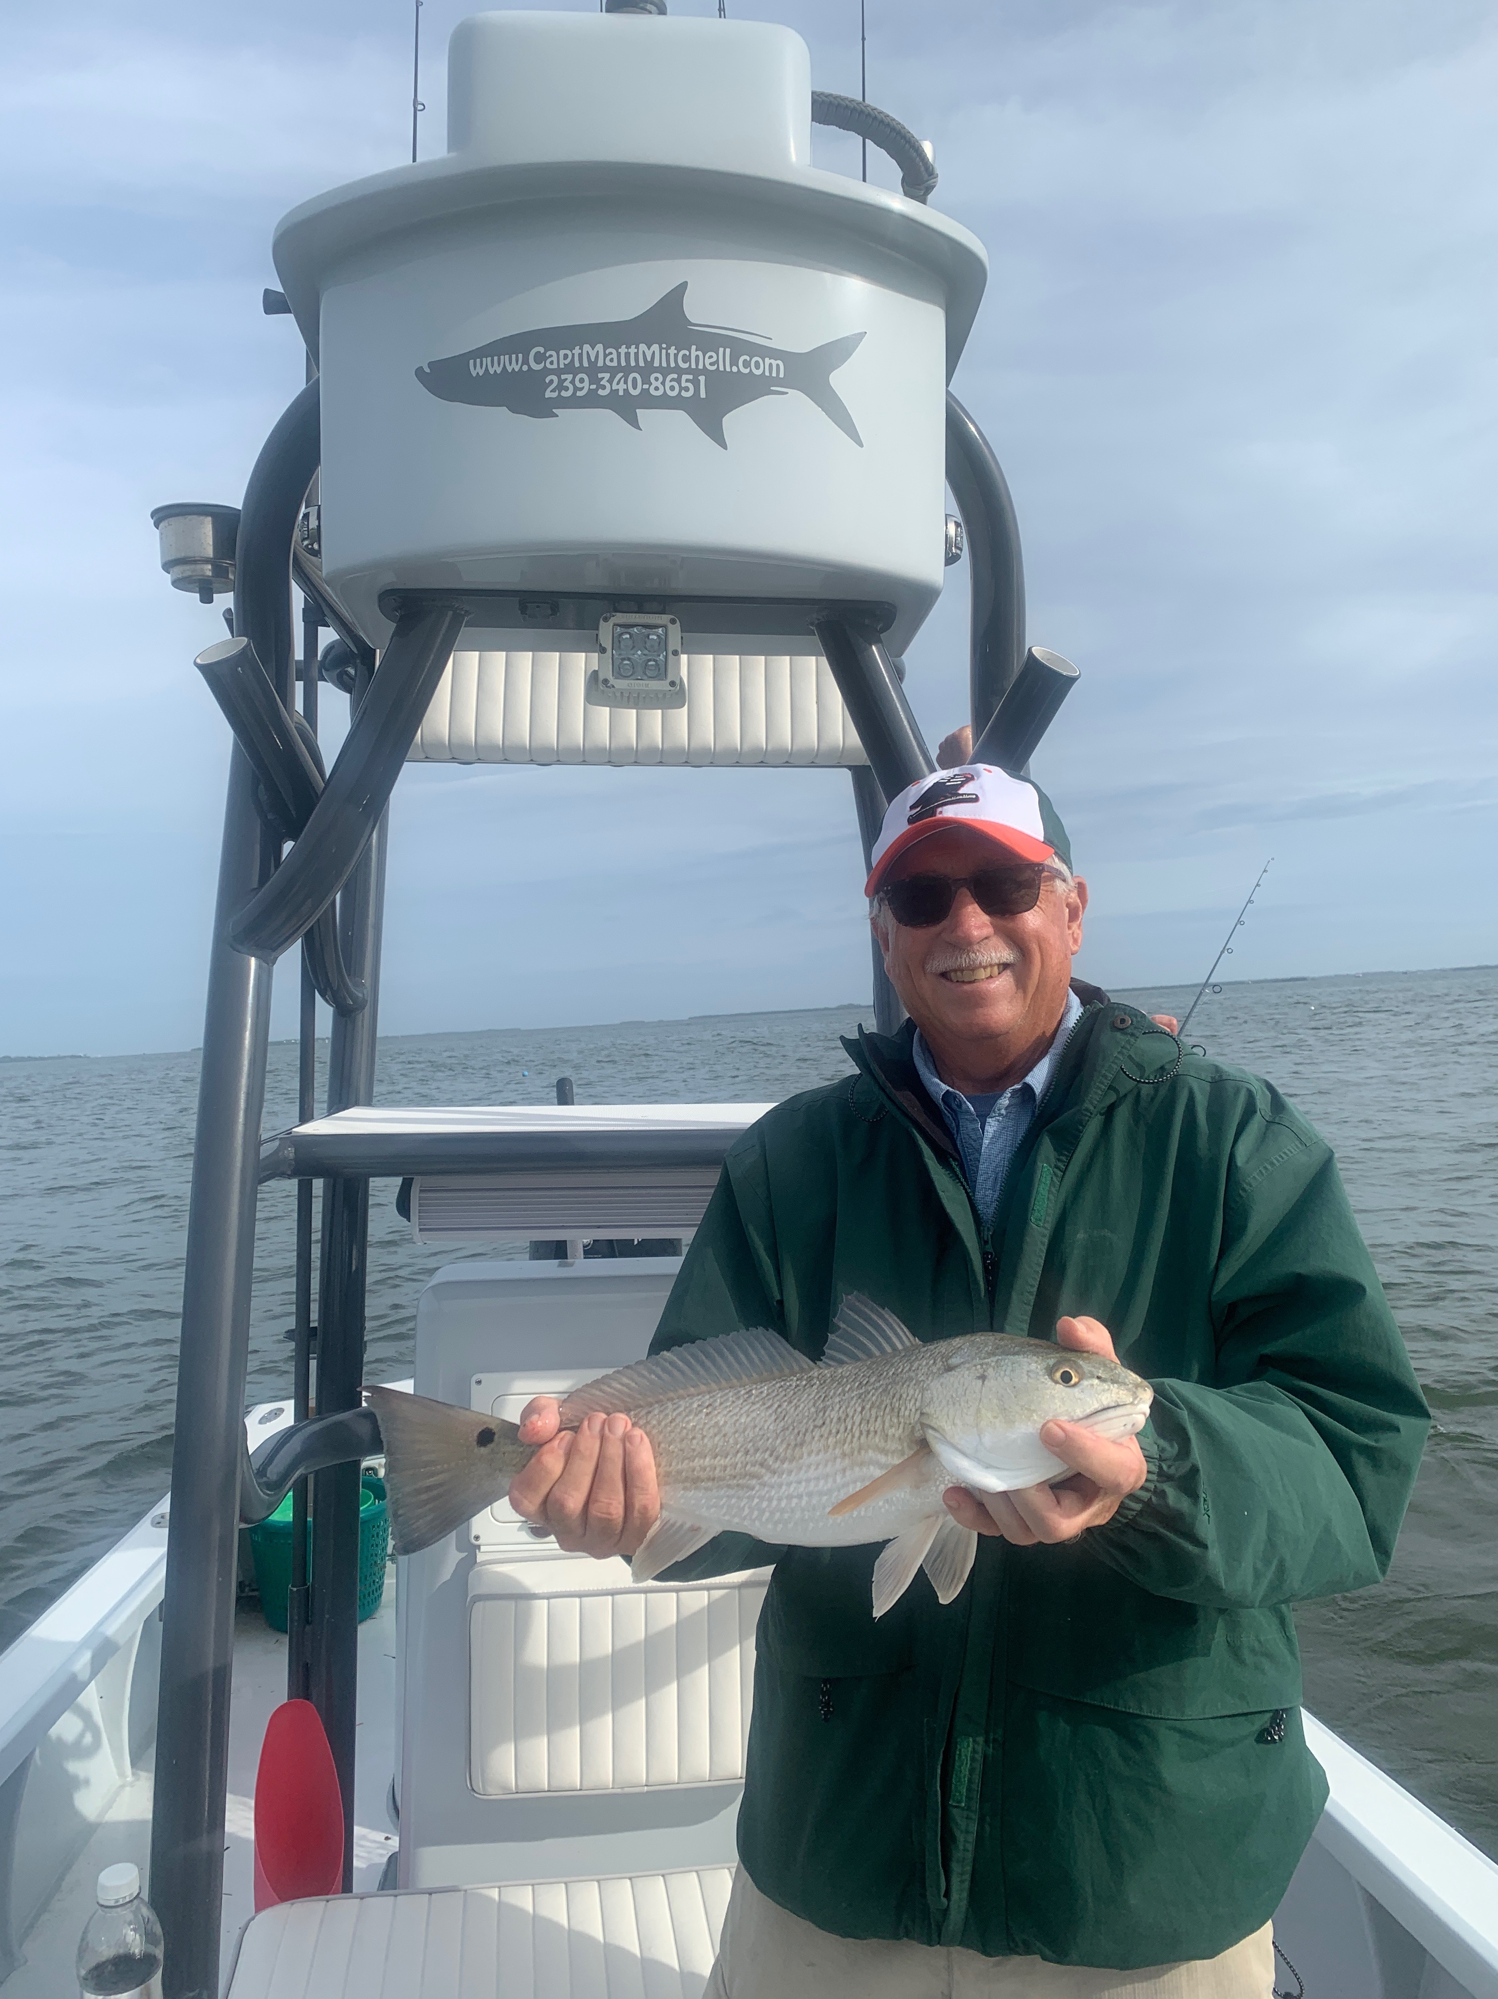

Picture: Gary Biltgen with a redfish caught with Capt Matt Mitchell

Winter finally arrives

Summers protective warm weather bubble has finally broken and cold fronts have begun to roll through our area on a almost predictable schedule. Fishing between these cold fronts can bring some of the most wide-open action of the year. All winter timing your fishing trip is everything. Within a few days right up to when the front goes through action can be epic. If you get the timing wrong the back side of a cold front is not only a slow bite but generally really windy too. Fishing gradually improves in the days following a cold front and peaks again right as the next cold front moves through.

Fishing in and around the passes was the best action this week. Redfish, snook, Black drum and even some keeper sheepshead where all caught in these same area’s. The redfish bite this past month has been as good as it gets with huge numbers of them being found in and around the more tidal movement of the passes. Once you locate these redfish its been fish after fish. Use both shrimp and baitfish rigged with either a little weight or on a jig head to slow it down in the current and get to the bottom. Pitching in close to docks and structure we caught redfish from 16-26 inches.

Red tide was much less of a factor this week than it has been with my baitfish staying alive almost everywhere I went though. The Roosevelt channel remains one of the problematic bodies of water. Many people view this problem possibly coming from Captiva as its not on city sewer and has lots of nutrient rich run off feeding this red tide. I’m still seeing a few smaller dead baitfish and mullet in the middle sound though they look like they have been dead for days. The effects of this lingering red tide are most noticeable between Blind pass and Redfish pass. I’ve been fishing either north or south of this area and constantly keeping a eye on my bait. Wind and cold from these passing fronts will help break up what is left of these small patches of red tide.

November 15th marked the end of the Manatee zones in Pine Island sound. These Manatee Zones are now switched over and in effect in the Caloosahatchee river as cooler water starts manatee’s migrating up to the warmer water of the power plant. Many areas in the southern sound are now accessible to fish again. Be observant of the change in our seasonal Manatee speed zones. While some area’s we are now able to run other area’s in and around the river are now idle speed zones.

