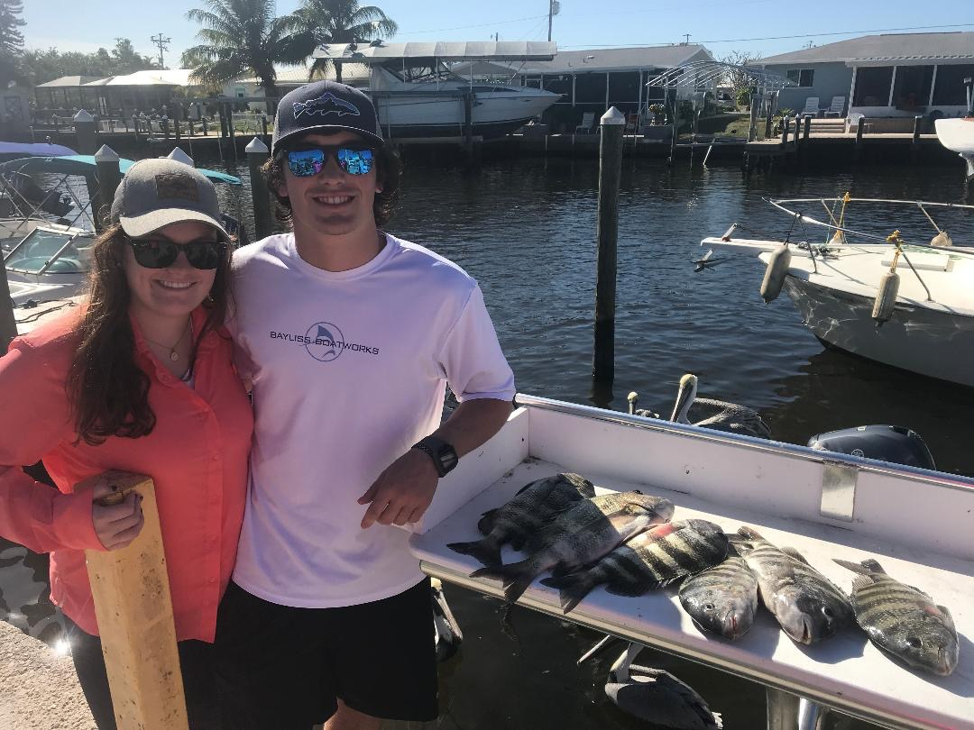

Picture: While visiting from Maryland Cheseca and Adam caught lots of Sheepshead while fishing with Capt Matt Mitchell

Winter dock fishing time

What a crazy week of weather we had to deal with. Tropical storm winds along with gale warnings caused lots of beach erosion and brought some of the worst marine forecasts I have ever seen in December. So far this year our cold fronts have been coming from the NW and moving SE at a much more rapid frequency than the usual north to south pattern. Fishing in between these fronts has been great although cancelled or rescheduled trips have been a big part of my work week.

Sheepshead fishing using shrimp has been the daily go to as our water temperature has stayed in the mid 60’s for the past few weeks. Along with catching lots of Sheepshead I have also been getting on some non stop rat redfish action. Most of the bigger Sheepshead I’m catching have been relatively close to the passes with the best action coming in the northern part of the region from Redfish to Captiva pass. During clear water periods when conditions are settled its been just a matter of riding docks around the passes until you find the sheepshead stacked up. During stirred up conditions fish dock to dock until you find them as there has been no visibility.

Some the docks I’ve been targeting sheepshead have also been holding rat redfish though the better redfish bite has been coming in mangrove creeks during the low incoming tide. Finding a bend or place the current splits or creates a eddy in these narrow creek systems can be gang busters on these awesome bright colored hard fighting winter redfish. Jig heads baited with a chunk of fresh shrimp threaded onto the hook has caught both species.

When ever I mention Sheepshead I hear complaints about how hard they are to fillet. I fillet lots of these fish every winter and really don’t think of them as hard to clean. When I fillet them I don’t break the rib cage by cutting around it. Leave the fillet attached at the tail, flip the fillet back and cut the meat off the skin. Sheepshead for there size do not have as much yield as many of our other species due to the large head and rib cage though they are some of the better eating fish in our waters.

