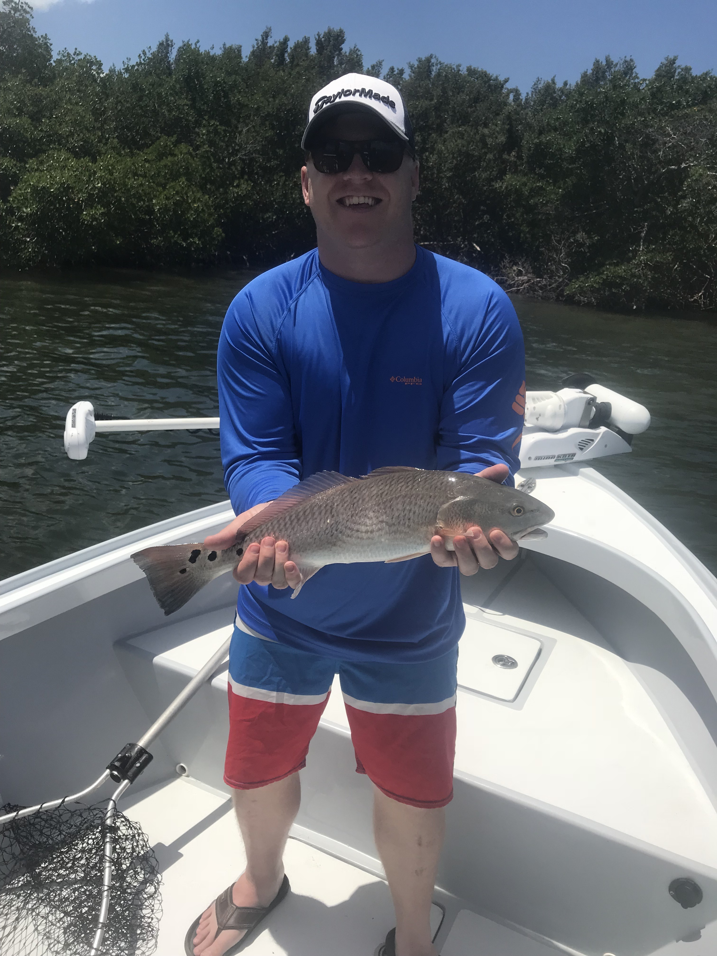

Picture: Chase Calkin with a slot sized Redfish caught this week while fishing with Captain Matt Mitchell.

Windy Tarpon tactics

With our Tarpon fishing now in full swing it makes you realize how many factors can play into the days fishing plan. Tarpon fishing is seldom easy even during perfect conditions although a few times a season you have those days when the fish seem to just eat every bait put out there. Memorable Tarpon hook ups and battles wash away all those tough lean days. Targeting these often finicky fish can be extremely frustrating at times although the thrill factor of catching one more than makes all the time invested worth while.

Wind, weather, tides, water clarity and moon phase are just a few of the factors that play a huge part in the days Tarpon fishing. No matter how good a certain spot was the day before a change in any one of these factors will change everything. Choosing a location to tarpon fish because it sets up better on that tide and wind direction will certainly will increase your odds. The shape of Pine Island sound and the barrier islands make it possible to be almost always be able to find somewhere to tarpon fish no matter what our wind direction.

Reacting to the wind direction will dictate where you’re going to spend your time hunting tarpon. During east winds the eastern side of the sound along with out on the beaches from Knapp’s point north is the sheltered calmer water. West wind’s mean fishing the west side of the sound from the power lines all the way to Cayo Costa is often the call. During periods of north wind its all about the southern end of Sanibel from lighthouse point to Knapp’s point along with a few other places in the sound that are either sheltered by shoals or mangrove islands. Throw in northeast, southeast, northwest etc and its a game of angles dodging the wind looking for that little bit more sheltered calmer water that will give you a chance at spotting these Tarpon.

During calm conditions all our water is fishable and you can cover lots of ground and spot tarpon from a long way off. Throw in a big full moon and it seems the Tarpon simply disappear as it’s presumed they move offshore to spawn. Even when everything variable comes together and you’re sat in rolling Tarpon the one factor you have no control over is if they will bite.

This week marks the 7th annual Ding Darling & Doc Fords annual Tarpon tournament with more than 50 of the best local Tarpon teams coming together to decide the winner. All the above factors will come into play as the past few years weather conditions have been a major factor in this event. At the end of the day one team will have a big payday, a converted pink tarpon sport jacket and best of all bragging rights for another year.

