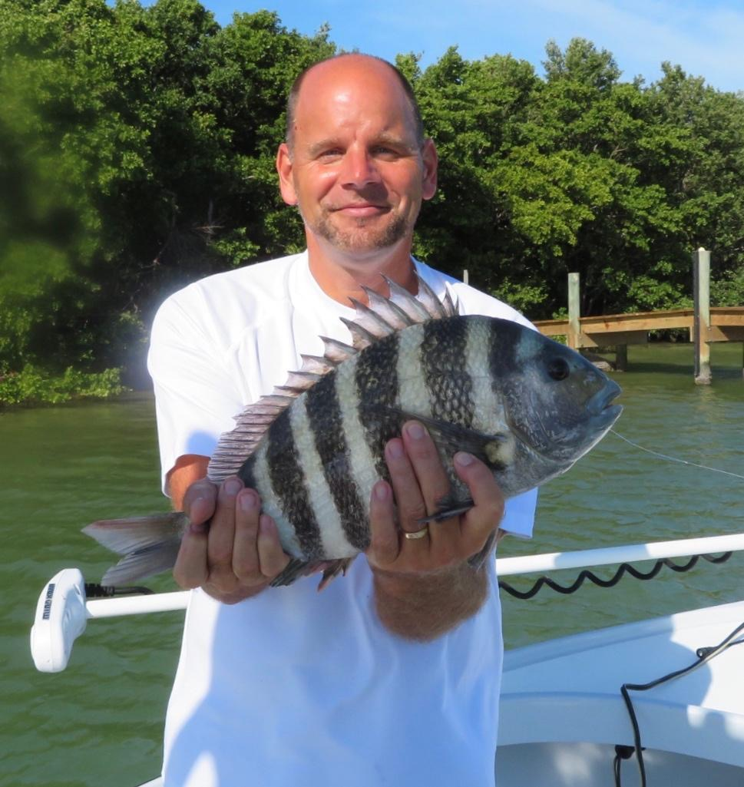

Picture: Chris from Sanibel caught some larger sheepshead while out with Capt Matt Mitchell this week

Wind or fog does not stop the sheepshead action.

Fast changing conditions require changing the game plan no matter how well its worked in the previous few days. Dense fog and strong winds where just a few of the hourly changes that anglers experienced this week. One thing that did remain consistent though was the sheepshead bite. Catching sheepshead and rat redfish was great action though during the 80 degree days it just somehow did not feel right.

Like most anglers and fellow guides, have been trying to locate shiners without success. Now that our water temperature has crept back into the mid 70’s a live well full of shiners would basically guarantee a awesome day of Snook fishing. Unlike in years past our shiners have just not returned as they usually do with warming water temperatures. Looking for shiners has been frustrating to say the least. Luckily we are catching lots of fish on shrimp though they are not the species that i would prefer to be targeting.

The average size of our sheepshead increased this week though the number of fish per trip seemed to go down. Most days out we finished the day with between 5-10 sheepshead in the box ranging in size from 14-18 inches. Dock fishing anywhere around the passes proved to be the best action. Along with the sheepshead I’m also catching lots of smaller redfish in the same places.

Teaching clients to sheepshead fish is a little more difficult than fishing for most species just because of the way they nibble a bait and never really completely take it. Most of the sheepshead fishing I do is generally around structure which is mostly dock pilings and mangroves. To get a bite often requires landing the bait close to the piling so it can sink and be around the base. A few feet can make all the difference in catching a fish or never even getting a bite.

A casting technique that works really well for a close accurate presentation is what I call the pendulum cast. With a chunk of shrimp on a jig head I line the up with the target and swing it back and forth until releasing the line from my finger. This is a straight cast than that is basically like flipping for bass. With my left hand i control the distance of the cast by feathering or grabbing the line when it reaches the target. This is a low controlled cast that will keep you from hanging it on the dock and also when the bait hits the water it sinks straight down the piling.

Once the sheepshead start to nibble the bait its time to be patient and delicately lift the rod tip using only your wrists. If you feel the rod tip bend and the fish on there give it a solid pop to set the hook, once on pop it one more time to make sure the hook is in these hard mouthed fish. If on the lift of the rod the sheepshead lets go of the bait, simply let the bait fall again and pick up the slack line with the reel. Most of the time the sheepshead will continue biting the bait. These fish can be very frustrating until you get in the grove of how to hook them.

