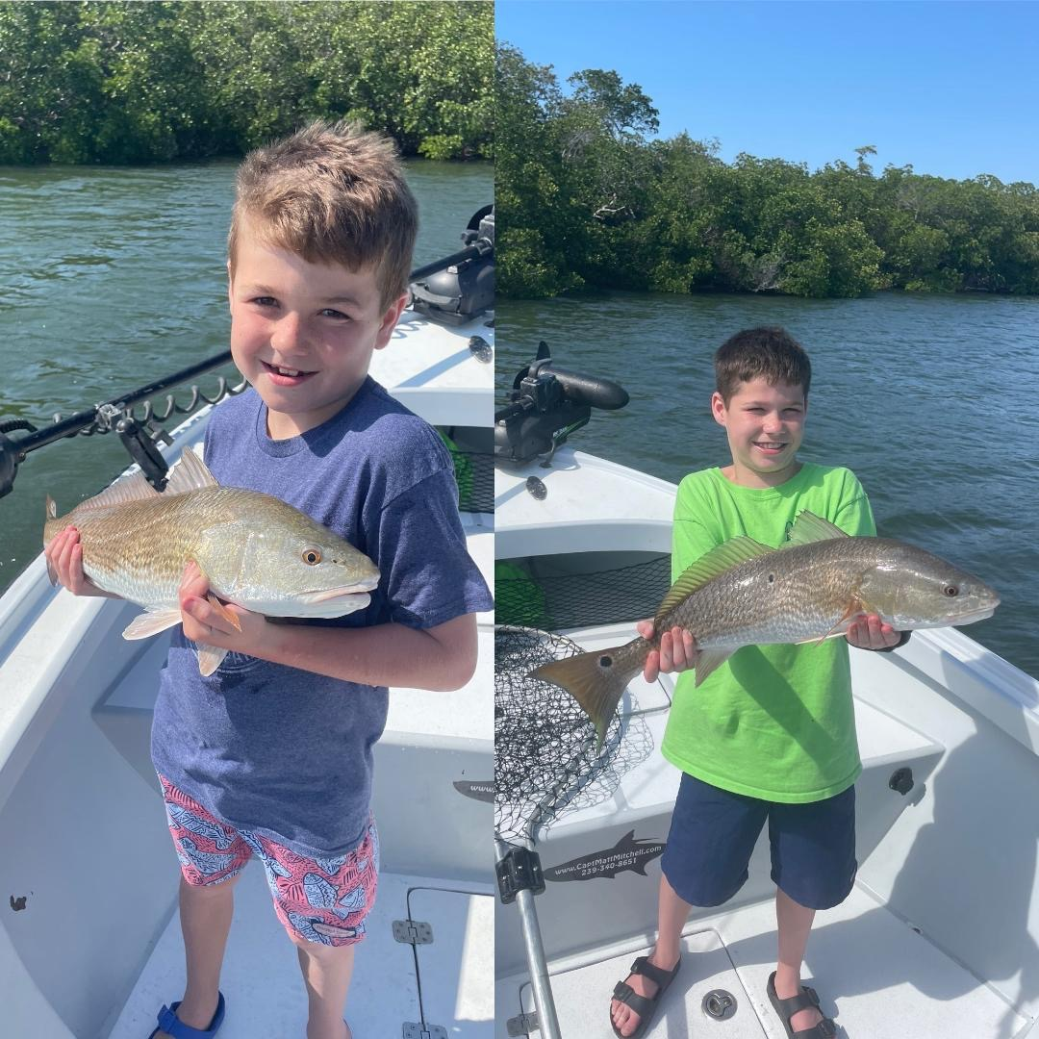

Wind from the south

Pic. Indiana brothers put a beat down on the redfish before the cold front both catching there1st slams with Capt Matt Mitchell

I cannot think of a week when the saying “Wind from the south fish open their mouth” was more accurate. Over the past week despite awful tides south wind gave us high water and kept the water moving. Most days we dealt with breezy if not straight up windy and while hiding from the rough bay we had great success catching snook trout and redfish. All in all, the weeks fishing was outstanding until yet another cold front crashed the party.

Fast forward to the weekend and strong NW winds totally changed everything. Falling water temperatures and still little to no tide created 16hrs of low water. Returning to the same area’s that had been so consistent all week long the fish had simply moved or just totally shut down. Suddenly I went from great days of fishing to all that can be described as a grind. Texting other guides hoping for someone to throw me a bone everyone was in the same shape of little to no action.

After a few crazy windy days and small craft advisory’s big high pressure did little to help the situation though as things calmed down the bite slowly improve. It just never fails a April cold front quickly reminds us it’s not quite Spring and drops our water temperatures after what has been weeks of amazing fishing. Although with a warm forecast for the week things will rebound back within just a few days.

March and April are consistently our windiest months of the year. Dealing with the wind is ok as long as it stays out of the same direction. Once it starts changing up and blowing differently, then fish that have been staged up in certain places tend to move making patterning them almost impossible.

Days that are a grind require moving and trying different things. Trout have been the bailout plan and luckily if you can find clean clear water have seemed to bite almost no matter what. When it comes right down to it though if every day was a sleigh fest the great days would not be so special.

