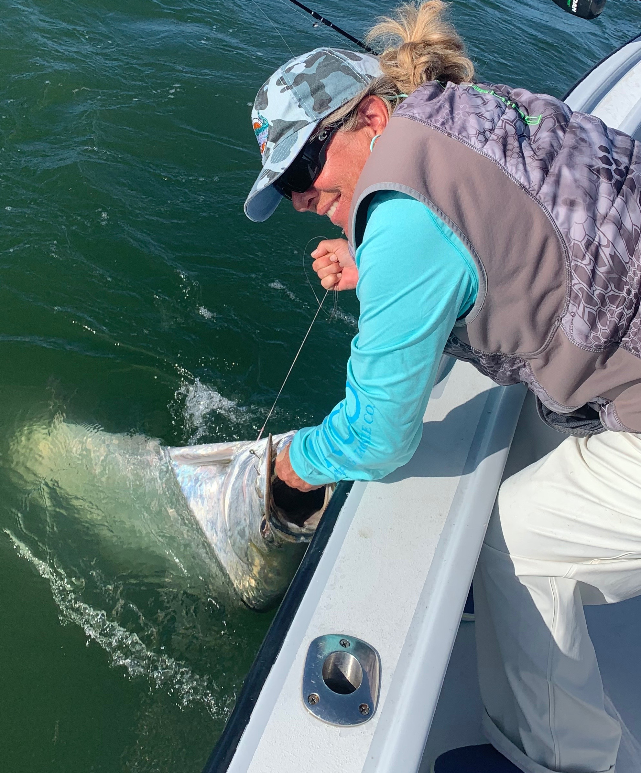

Wind and more wind

Pic: Mary Laser with her first Tarpon of the season

After yet another week of what seemed like non stop winds getting out on the water for several days was a tough proposition. Catching snook and redfish in these conditions is possible by getting tucked away but when your clients have tarpon charters booked this open water style of fishing is almost impossible.

Having had a big high pressure stuck on top of us for an entire week winds blew from the east at 20-30 mph everyday. I felt so bad for clients that had multiple days booked with us for tarpon fishing this past week as our conditions went from bad to worse. Making a long trip from out of town to chase tarpon and you get weather like that just sucks. No matter how well planned a trip is its still up to mother nature if your gonna get a shot at one these magical fish.

As I’m writing this its looking like we will finally get a break from these extreme conditions. Water temperatures have dropped back into the mid 70’s and tarpon have gone back into what seems like a early season pattern. Deeper channels in the southern sound from the causeway and just off the intercostal were the best bet for anglers soaking cut baits on the bottom. During the choppy conditions it was hard to spot any fish up on the surface unless the free jumped or where hooked up.

While set up in a pack of boats in one of the many finger channels between tarpon bay and St James City Saturday we watched several boats hook up on Tarpon. Soaking cut fresh mullet on the bottom it only took us 10 minutes to get that much awaited bite. After a crazy drag screaming 200 yard first run we dumped the anchor buoy giving chase to this jumping tarpon. Running the boat we finally got some line back on the reel managing to get this big fish under control. Once at the boat I got a face grab and removed the circle hook while getting a few quick pictures. I’d estimated the fish at around 120 pounds. At one point there where 3 boats hooked up at the same time. Coming back to our marker buoy we set up again and as quick as the bite had started it was done.

With better conditions on the way this week tarpon fishing should gradually improve. Consistent weather and light winds will give us much better opportunities for catching tarpon again.

