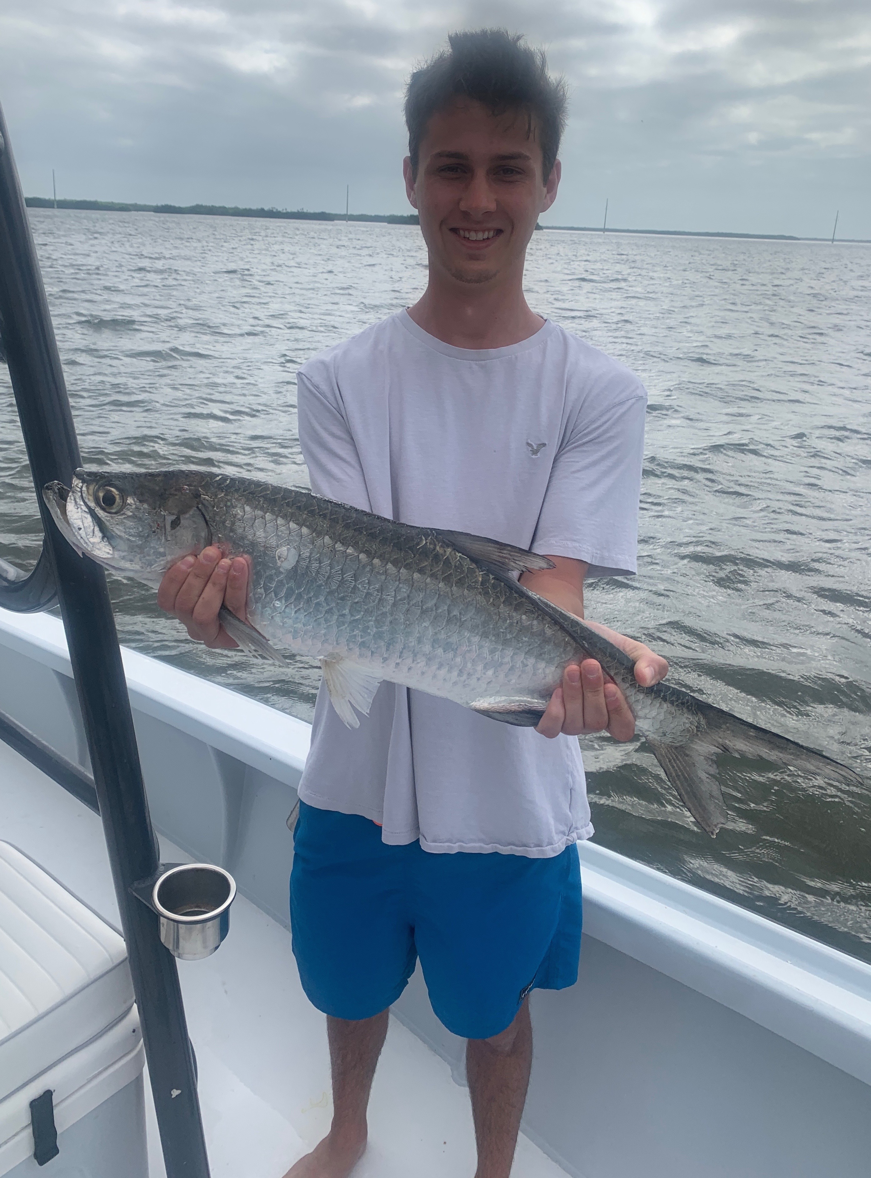

Pic: A surprise for the Marvel Family was this juvenile tarpon caught while sheepshead fishing with Capt Matt this week.

Weather rollercoaster

If there is one thing I have learned, spending lots of time afloat it is to take the weather forecast with a grain of salt. This held true this week as we had a forecast of super strong winds for days that just never really panned out. Waking up with a wait and see attitude has saved many a days fishing. With all the weather apps and forecasting tools we have at our fingertips its very easy to overthink the forecast. The only way to really know what the weather is is to step outside.

For the start of this week we had the strongest cold front so far this winter dropping morning low temperatures into the high 40’s. After two really cold mornings our water temperature in the sound dropped from mid 70’s to mid 60’s. Switching gears to shrimp fishing for almost a entire week clients enjoyed some great sheepshead action along with black drum and redfish.

Staying close to home for days with breezy conditions we had some of the best bigger sheepshead action we have seen so far this winter. Several favorite docks around St James and the eastern end of Sanibel produced sheepshead up to 20 inches. Then as water temperatures gradually rebounded back to that magic 70 degree tipping point we started catching shiners again.

It never fails to surprise me the variety of fish you can catch while targeting sheepshead. The big surprise of the week came while fishing a afternoon trip with the Marvel family. After picking them up I headed right back to a dock we had finished the morning trip strong on catching lots of sheepshead. The first cast on this dock we immediately hooked up to a large fish which turned out to be a black drum. After releasing the drum we instantly hooked up on a little tarpon weighing roughly 10 pounds. After several amazing jumps we landed the tarpon got a quick picture and watched it swim off.
For as bad as the weather forecast was for this entire week we not only managed to get all our charters out but caught a amazing variety of species along with some real quality fish. Without that wait and see attitude watching the weather we may have never even left the dock.

