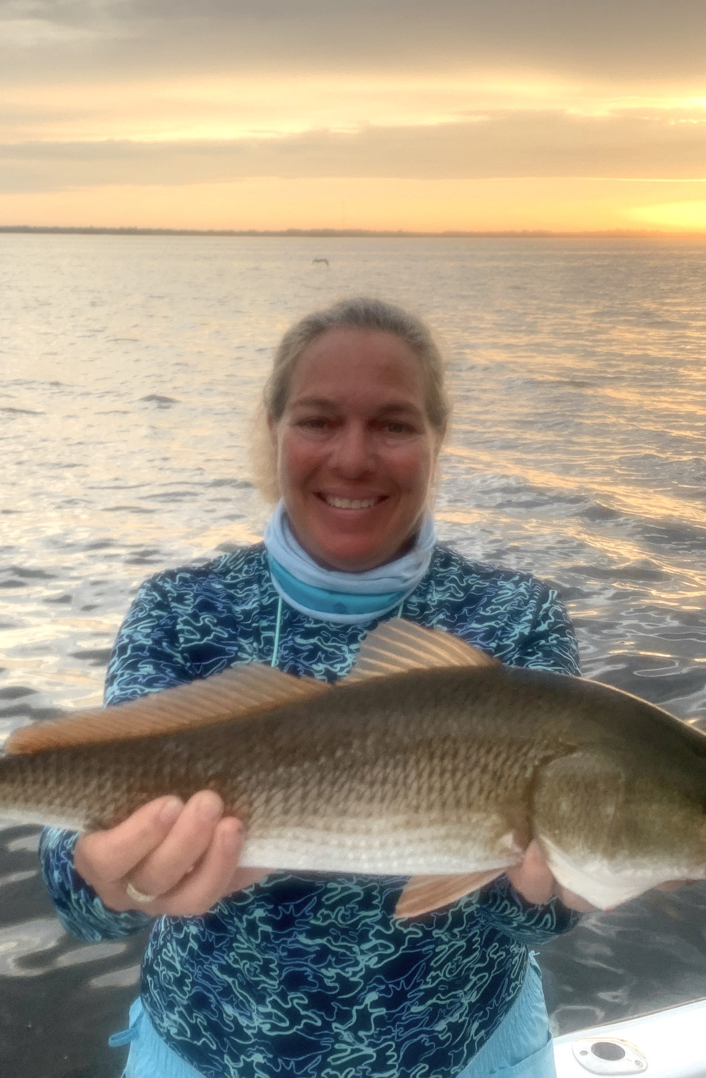

Variety and quality

Pic: Mary Laser with a early morning redfish caught on a recent scouting trip.

Rain from a stalled out cold front and then from Tropical storm Gamma sat right on top of us for most of the week. This wetter than usual weather pattern did bring a nice break from the heat though made getting out on the water challenging. Managing to get out for brief periods low morning water had the passes fired up with both snook and redfish. Out along the beaches birds and bait are everywhere with anglers catching a great variety of fish.

During days of northeast winds its the perfect set up for getting out along the beaches. Once out through the choppy pass your often greeted by calm seas within a 1/2 mile of the beach. With the bait migration in full swing it does not take long to spot the massive schools of Threadfin herring and feeding birds. Mackerel and Bonita make easy targets as they can be found breaking the surface in and around these bait schools. With so much life out here sharks are always an option.

Most of the tarpon we have located over the past few weeks have been out along the beaches too. The western end of Sanibel, Ft Myers beach and Captiva have all given us shots at fish. These hungry fall tarpon like to hang out just outside the large schools of Threadfins. Look for mudded areas with lots of bait to start your hunt. Once you find a area that looks right shut down and take your time, While moving slowly hunt with your eyes until you find em. This fall tarpon bite can be amazing and will continue until our first major cold front arrives dropping water temperatures into the low 70’s.

October always means redfish and this has rung true. Just about anywhere from the passes to the mangrove creeks you have a great shot at catching them right now. During low water periods the passes have been hard to beat with many of these fish being bruisers.

Live pinfish with enough lead to hit the bottom has been the bait of choice. During higher tide periods mangrove islands and oyster bars have been the better option. A cut pinfish thrown up to the structure is hard to beat for a bait. Schools of hungry redfish are also out on the shallow flats though have been a little tough to find due to windy conditions.

With fall fishing in high gear this time of year is not only about quality but also variety. Carry different types of tackle so you can take advantage of whichever opportunity presents itself. Being able to switch it up from one species to another is what our amazing fall fishing is all about.

