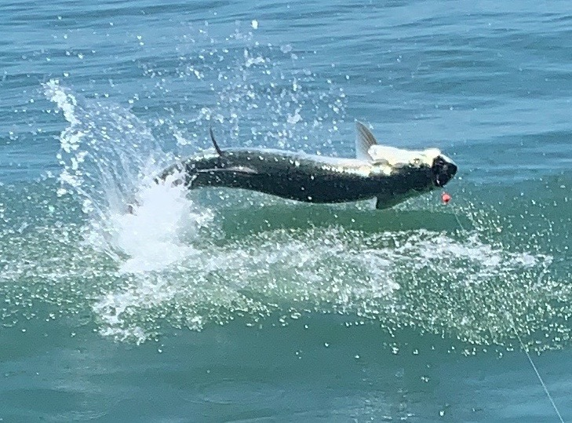

Useppa Tarpon tournament.
Pic: Side ways jumping tarpon

This week was the Useppa Island Izaak Walton tarpon tournament. This historic tournament has been going on for over over a 100 years. The format is a two day event fishing for tarpon in the afternoon then again the following morning. This year’s field was 15 guided boats each with a team of two anglers that blindly draw there Captain.

The first afternoon I started by running out to the barrier island beaches and sight fishing strings of tarpon as they crossed a shallow shoal gulf side. High sun and clear water made this the perfect set up as we could see fish approaching us from almost a hundred yards. Seeing so many tarpon and taking shots at them we finally managed a hook. Watching this fish gulp a bait in shallow clean water is what tarpon fishing is all about. Unfortunately, this fish came right at the boat going airborne within 20ft as we could do nothing but gasp as it came loose.

As the beach side sea breeze picked up we ran back inside to the sound looking around without success. With a hill tide in full swing it was time to head to the chaos of Boca Grande pass. I don’t fish this pass very often though if you ever want to fish it the hill tides of May and June are as good as it gets. Heading into the pass it was loaded with a few hundred boats not only fishing but dip netting crabs. These “Hill Tides” happen when a big 2.0ft or greater tide falls out to a minus tide. All this water flow flushes out the pass sucking out the swimming crabs as the waiting tarpon feed.

Coming up towards the huge pack of boats we followed the weed line and quickly dip netted a few dozen crabs. Crabs where everywhere along with hundreds of tarpon coming up and gulping air. Rigging the rods with a large split shot up from the circle hook we got in on the drift lowering our freshly caught crabs to the bottom. We did manage a few bites but had both fish break off.

The spectacle of tarpon fishing in this pass is like nothing you will ever see anywhere else. Old time Boca Grande inboard boats along with every other kind of boat you can imagine all drifting gunnel to gunnel as Captains back down into the tide keeping the lines straight up and down. Looking through the many boats you would see anglers fighting fish as they tried to keep the boat over the hooked tarpon in order to move it out of the pack. Day one of the tournament 25 fish where caught with almost all of those fish coming out of Boca Grande Pass.

Day two of the tournament was a early start and a much slower bite. Finding a few fish here and there we did find one hungry group on North Captiva that once we got in casting range quickly ate our bait. Chasing our hooked fish down on the trolling motor we got our leader touch within 10 minutes. Only 5 Tarpon where caught where caught the second day of the tournament even though most Captains sat in rolling fish all morning long. As suspected these fish where waiting for that hill tide buffet later in the day.

