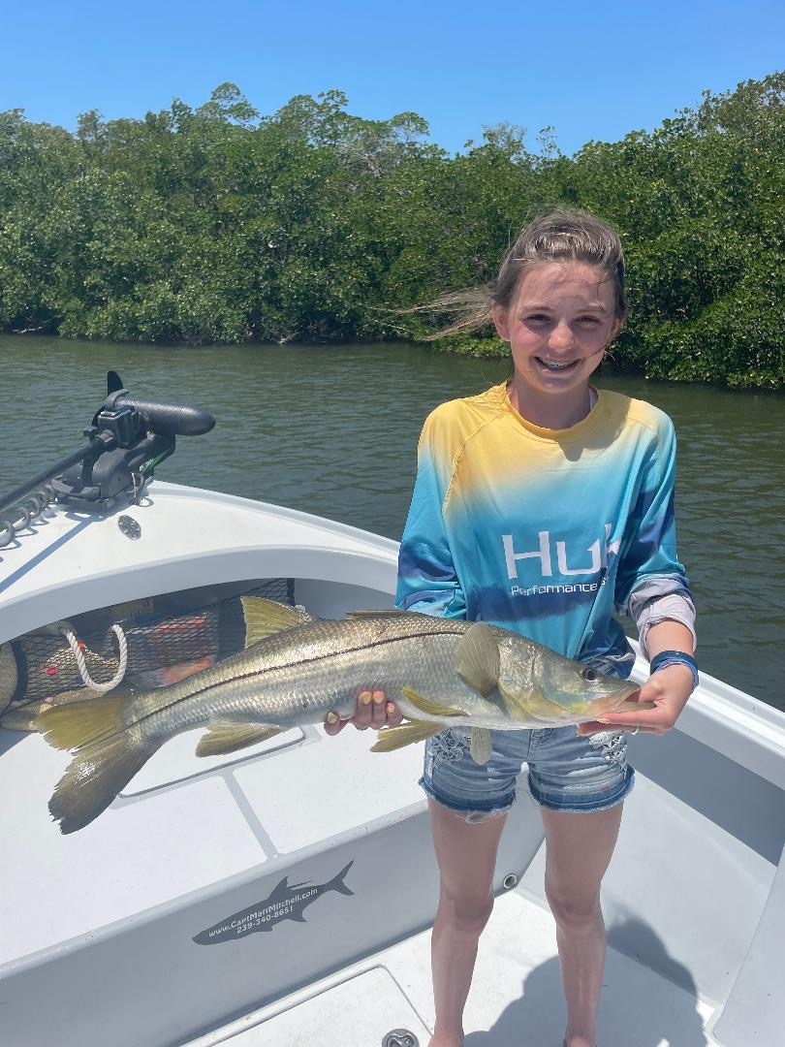

Turn this wind off

Pic: Emily from VA with a great mangrove Snook she caught while fishing with Capt Matt Mitchell this week

After yet another full week of high winds, hiding and getting it done required a few rough rides. Luckily bait came easily and once out of the open bay fishing action was outstanding. Snook, trout and mangrove snapper kept the rods bent. With so many protected area’s on the back sides of Sanibel, Captiva and Pine Island even with less than perfect conditions we found lots of hungry fish.

Most trips I would pick a protected bay and target the shorelines that had wind and tide moving together. Add some live shiners and it did not take long to locate feeding fish. Even a little shift in the wind direction opened up shorelines I hadn't fished recently and the fish where there. Although we didn’t land any monster Snook we had several opportunities and caught many right around that respectable 30 inch mark.

Many of these protected mangrove bays have lots of different fishing. Deeper shorelines and mangrove points are always a good bet for Snook while natural channels pushing onto shallow grass flats held trout and jacks. If not for the winds I would not have worked these area’s quite so thoroughly. Some days you just have to slow down and take what the days conditions give you. Keeping everyone comfortable and catching fish in these conditions is a successful trip.

Despite the extreme wind we have lots of tarpon here even if they are a little harder than usual to locate. During a brief few calm morning hours we found rolling tarpon at basically every stop we made in the bay. Reports of tarpon being caught have been coming in from all over including the river, out on the beach on the east end of Sanibel along with many of the usual places in the sound.

While fishing the Demere Key area of the sound early in the week we watched hundreds of tarpon pushing around. After sitting for over a hour without seeing a single hook up the wind switched to NW and the fish ate. We were lucky enough to hook into a 150 pound plus fish that quickly had a 100 yard head start on us while we cleared lines. After a few crazy big jumps we kept the fish on while steering it around the many crab pot hazards. Then roughly 10 minutes in this still very green giant tarpon went between 2 barnacle crusted crab pots that where only 5ft apart and parted ways. This was the first fish of the season hooked on my boat and quickly reminded me of the excitement and adrenaline rush these fish give us.

