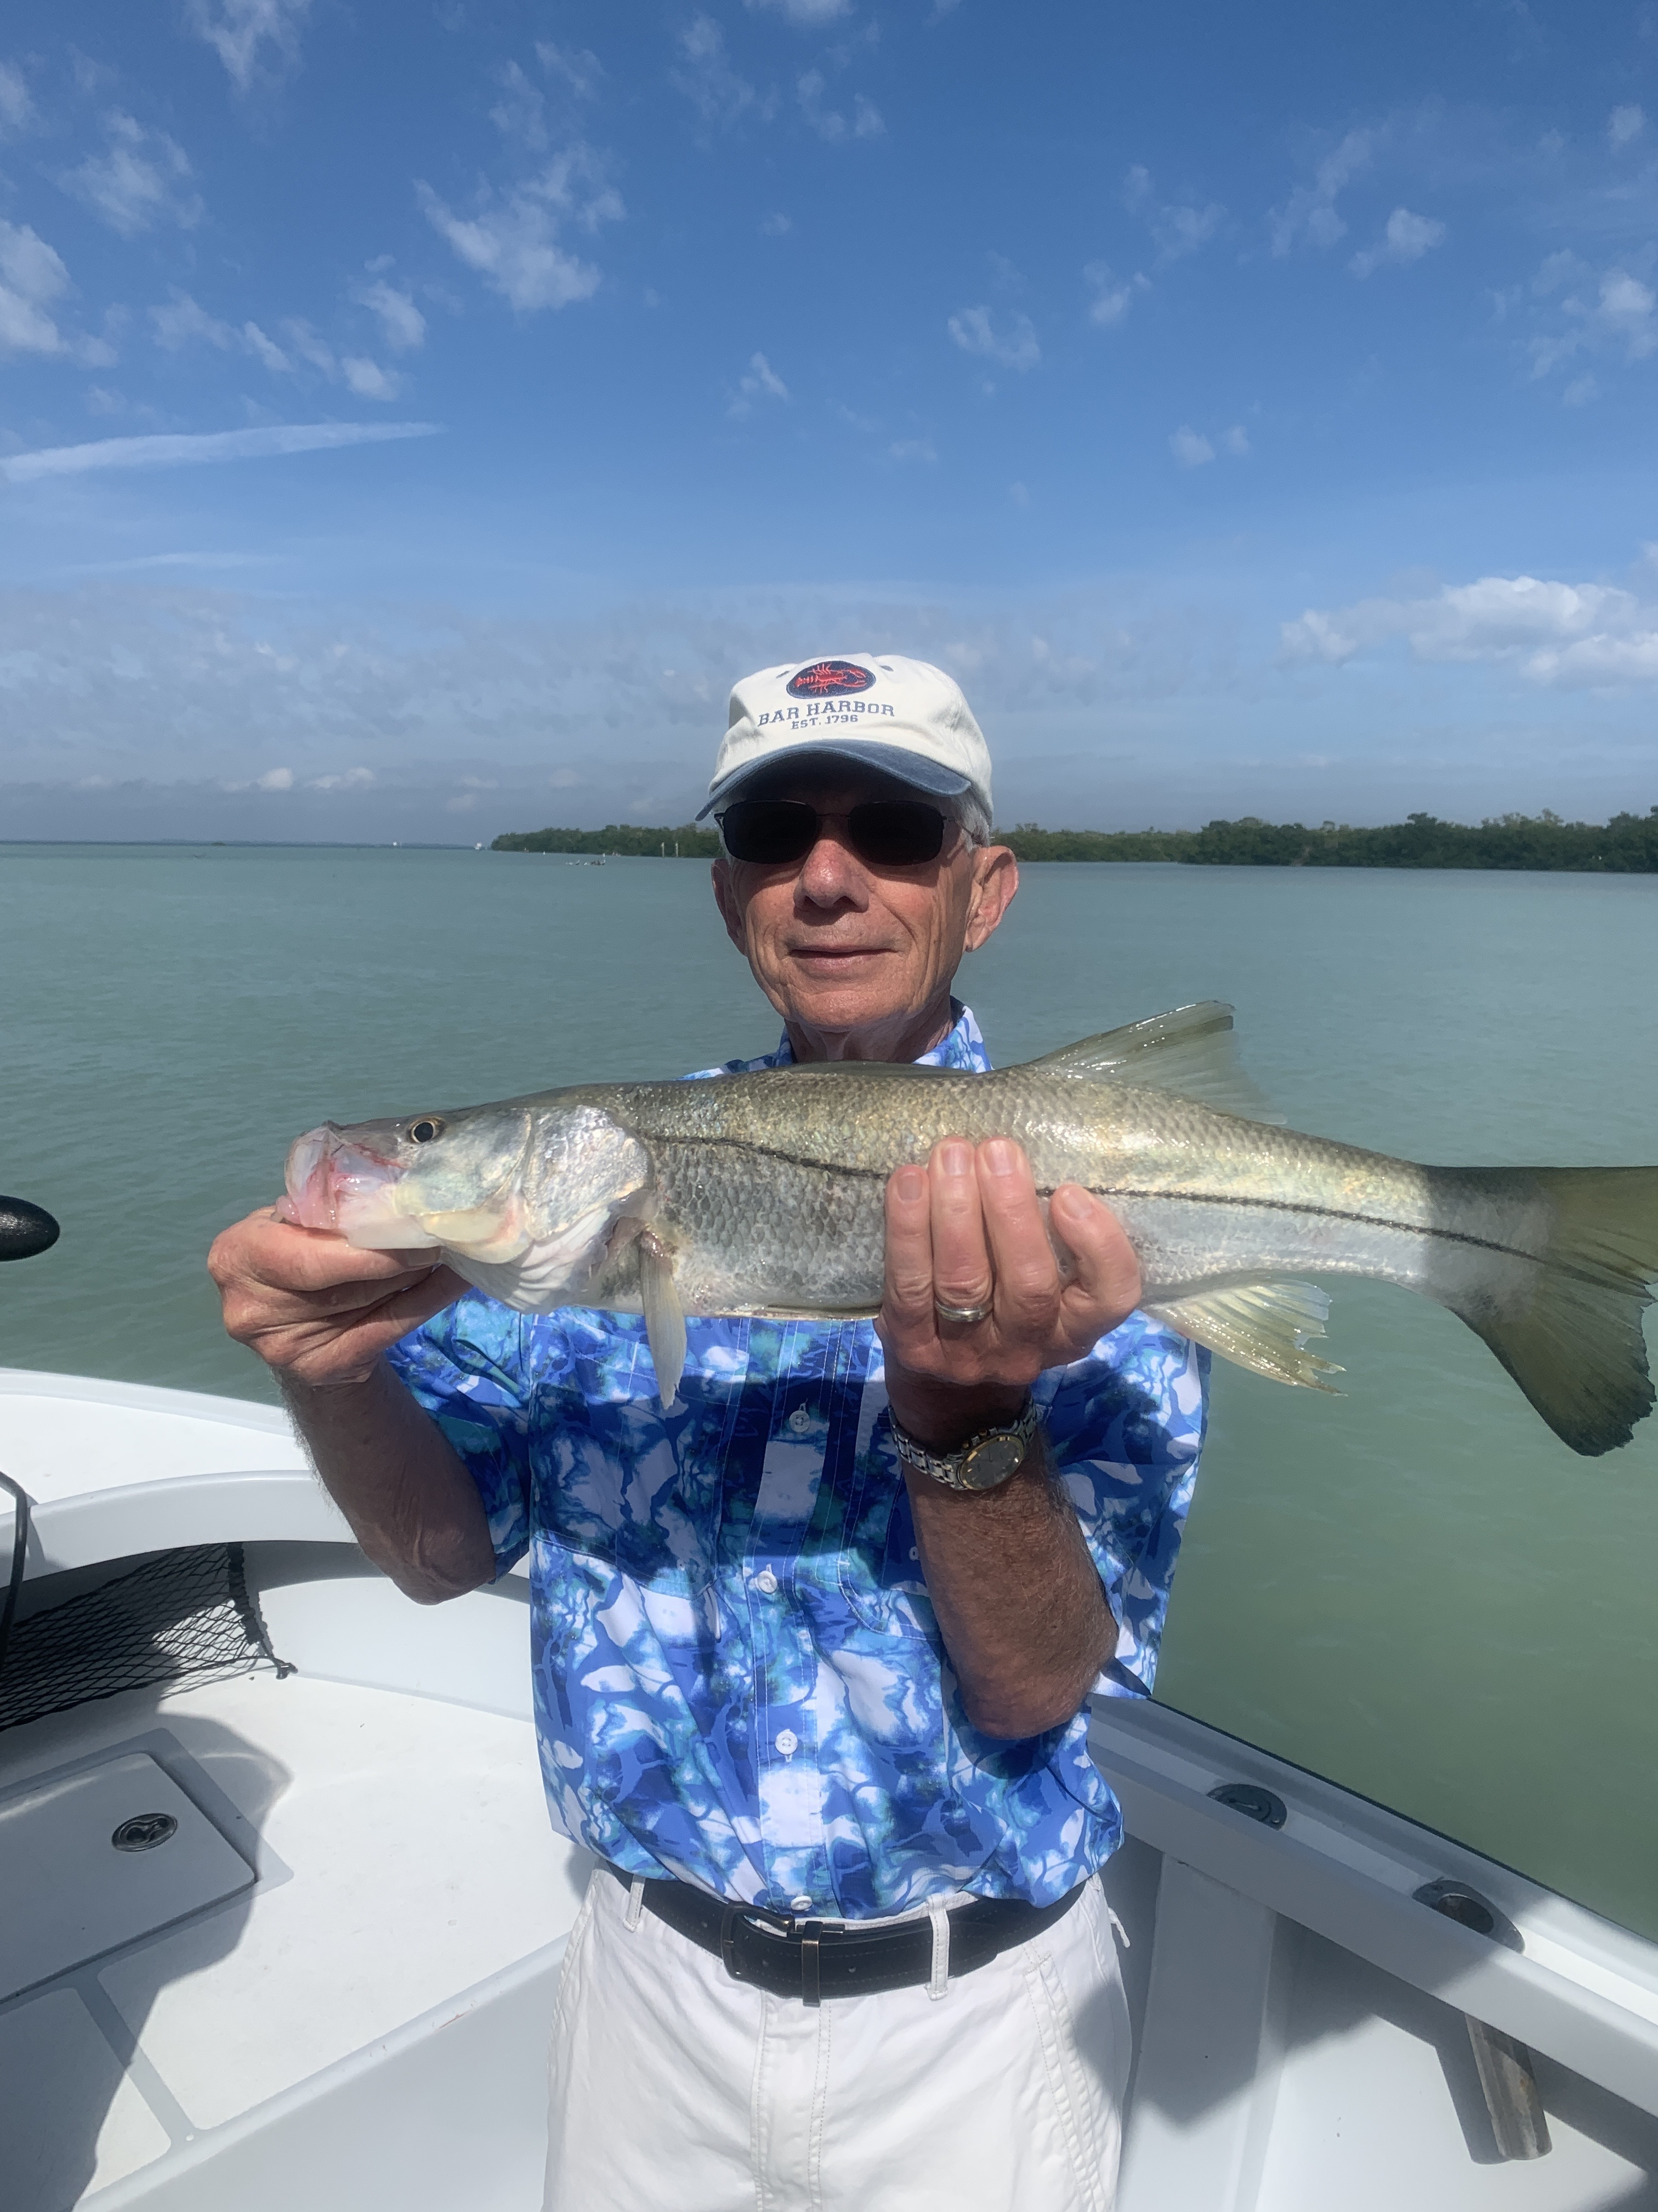

Pic: Steve from IN while out on his birthday got in on a crazy pre front bite catching snook and reds while out with Capt Matt Mitchell

Timing during winter is everything.

Cold fronts over the past month have rolled through like they are on a regular weekly bus schedule. The last three weekends in a row we have been blown off the water for a few days. When I wake up and check the live time at redfish pass and the wind is sustained at 25mph with gusts over 30mph its a simple decision to make… we have to cancel.

I cannot repeat enough that timing during our winter months is everything for catching fish. This exact same pattern will play out again this week. In the first few days following this last cold front with the sudden drop in our water temperature sheepshead will be on fire again. A few days past the cold front we will begin catching shiners and start to mix it up with a few snook and redfish along with the sheepshead. Then as the water creeps back into the low 70’s the snook and redfish bite will turn on as the next cold front approaches. This is our usual cycle.

If you are down here on vacation for a week I would strongly suggest making your plans or booking your fishing as early in your trip as possible. Having to cancel charters due to weather happens quite often this time of year. Being able to reschedule just a few days later after the weather has passed through will be the difference between getting out or wishing you were fishing.

Finding a few hot sheepshead spots put lots of meat in the cooler this week. During the cooler mornings we would start our day catching enough sheepshead for the clients to have a good meal before switching up the target species. One specific dock was my money spot as we put over 40 keeper sized sheepshead in the cooler. This bounty included one memorable 21 inch “Sheepzilla” the largest one on my boat so far this winter.

