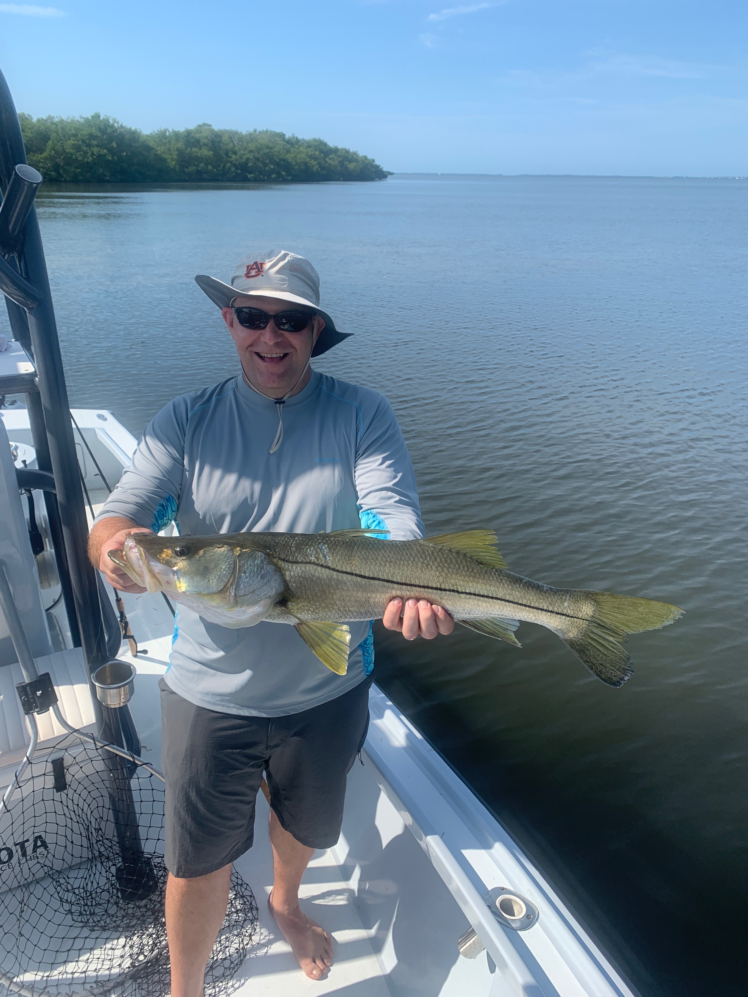

Time to think tarpon

Pic: John Stockdale from Tampa with a 32 inch Snook caught while fishing with Capt Matt Mitchell this week

As we approach the middle of April several times a week I’m seeing tarpon during my travels through the sound and hearing more and more reports of them being caught in random places. Booking April tarpon trips can be good or bad depending if we get a late cold front causing all the fish to simply disappear. Most years I wait till May 1st before I schedule tarpon charters though this year with so many fish here so early I’m planning on starting at the end of April.

If you have never spent any time tarpon fishing you get it. Simply put its addictive as we sit for hours some days chasing that crazy adrenaline rush that only a tarpon hook up can gives the angler. There is not another fish that swims our waters thats arrival brings such anticipation. Things that come to mind when trying to describe a tarpon to someone who has never tarpon fished are crazy strong, hard fighting, thrilling yet majestic. Such a adrenaline rush leaves the lucky angler shaking and often exhausted.

Water conditions in the sound for the annual tarpon migration are better than we have seen in years. The sound is not only clean and clear but loaded with bait that will keep these fish around. Schools of ladyfish and Spanish Mackerel have been popping up all over the sound and where ever you find this set up the tarpon are not far behind.

This week my second boat with Capt Jason hooked our first tarpon of the season while shark fishing in the northern sound. Though I am carrying tarpon gear on every charter its not quite time for me to make the switch yet. If I run across these fish while doing something else though I’m ready to do battle.

Our prep work for tarpon has already started with new rods reels put together, re-spooling new line along with getting the tackle together. along with re connecting with my crab and mullet people. Phone calls among our close circle of fellow guides have already started as the more eyes out there during tarpon time the better. This will be my 20th tarpon season as a fishing guide and even after doing it for so many years the anticipation still gets me fired up.

