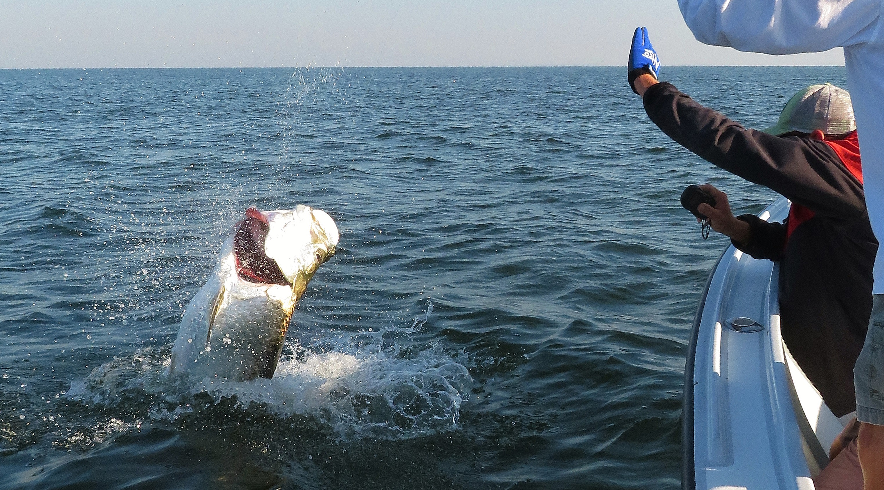

Picture: A Tarpon jumps one last time at the boat before being released this week.

Prime Tarpon time

The week’s Tarpon fishing brought some good days and some not so good days. The one thing that was very consistent was being able to find tarpon every time we fished for them. Being set up in lots of rolling tarpon is always a good thing and the calm conditions we had most days really helped out when it came to locating them. Pods of happy tarpon could be found anywhere from the beaches through the passes and in all the regular spots in the bay. The best action on my boat came while fishing them in the sound where I was able to set up and fish a full spread of both live baits and cut baits.

Some day’s tarpon eat, and then other days they just don’t that’s the only way I can explain it. While sitting in rolling fish in the sound you can often tell from there behaviour when they are happy and content with no real movement almost like they are floating or just milling around. Often you will see free jumps and a few crash baits on the surface. Gulf side tarpon generally seem to have a more movement to them and are traveling these fish require staying on them and making multiple presentations. This week I was able to return to a few of the same places and pull right up on these fish day after day.

Baits that Tarpon wanted to eat seemed to almost change by the day. One day both our bites in the bay came on cut mullet then the next day both bites came on live crabs drifted under a float. Putting out a variety of baits insured at least you had it covered if they decided they wanted to eat. Even the fish we jumped fought totally differently with one staying close to the boat and making lots of leaps while the other made crazy long runs that required us to chase it between other boats. We jumped three other tarpon but did not manage to keep them on for very long.

The only guarantees when going tarpon fishing is that no two days of tarpon fishing nor any two tarpon battles will ever be the same. As a fishing guide tarpon fishing is a love hate relationship. When you have a good day there is nothing else that compares to it, then there are those days when you can sit in rolling fish and just not get a bite or worse yet not even find the fish. These bad days are as much of a part of tarpon fishing as the days you go out and make memories for a lifetime. Tarpon trips go one of 2 ways: get that first bite and be a rock star or get no bites and it might as well have been a sightseeing trip. Tarpon fishing is rolling the dice and fortunately, the good days stay in your head much longer than the bad days!

