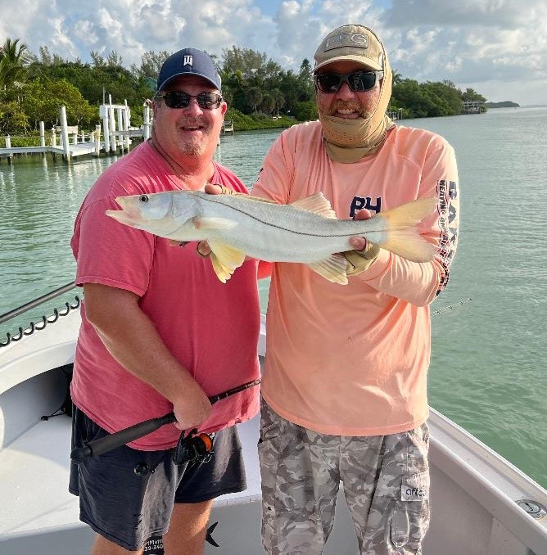

Tarpon frustration

Pic: John Scott from IL with a snook caught with Capt Matt Mitchell this week

With tarpon trips all this past week I cannot remember in my guiding career having such a bad streak. Although we found tarpon everyday no matter what I did I just could not get my clients hooked up. Sat in a group of other guide boats in several well known tarpon highways we had at times lots of fish passing right through our bait spread over a five day period. The only thing that may have made this agony worse is if other boats around were hooking up but this was not the case. Over this 5-day period I may have seen two tarpon total caught.

Frustration and tarpon fishing can go hand in hand and it is definitely part of the game. It’s not that unusual to be in tarpon and not get a bite as they fin or basically give you the finger as they pass by. All you can do when this happens is continue to present different groups of passing fish with an assortment of baits. Downsizing leader and baits can often be the difference to get that bite.

No matter how long I’m lucky enough to tarpon fish I don’t think I will ever quite know what was different from the day you hook four fish to the very next day you can’t get a single bite. This time of year, many of the tarpon we locate are in daisy chains and exhibiting mating behaviour the last thing on their mind is eating. The tarpon we look for are the ones that are slowly rolling and have very little movement to them often just raising up. From the way tarpon show themselves its often possible to know if they will respond to a bait. Fast moving high rolling fish are almost impossible to catch.

Without a doubt our best tarpon bite will come in the Fall. Although these fish are a little harder to locate than our Spring fish they are packing on calories before the migrate south and are thinking food not love. Often these fish can be found out along the beaches on massive schools of fry bait. This without a doubt is the most wide open
Tarpon bite we ever get. Casting baits to cruising tarpon results in hook ups. The difference between Spring and Fall tarpon fishing can be night and day.

Tarpon fishing like most things in life require patience for success. With or without a bite presenting baits to pods of fish is as exciting as it gets. When it boils right down to it if you put baits in front of enough tarpon you will get that magical bite.

