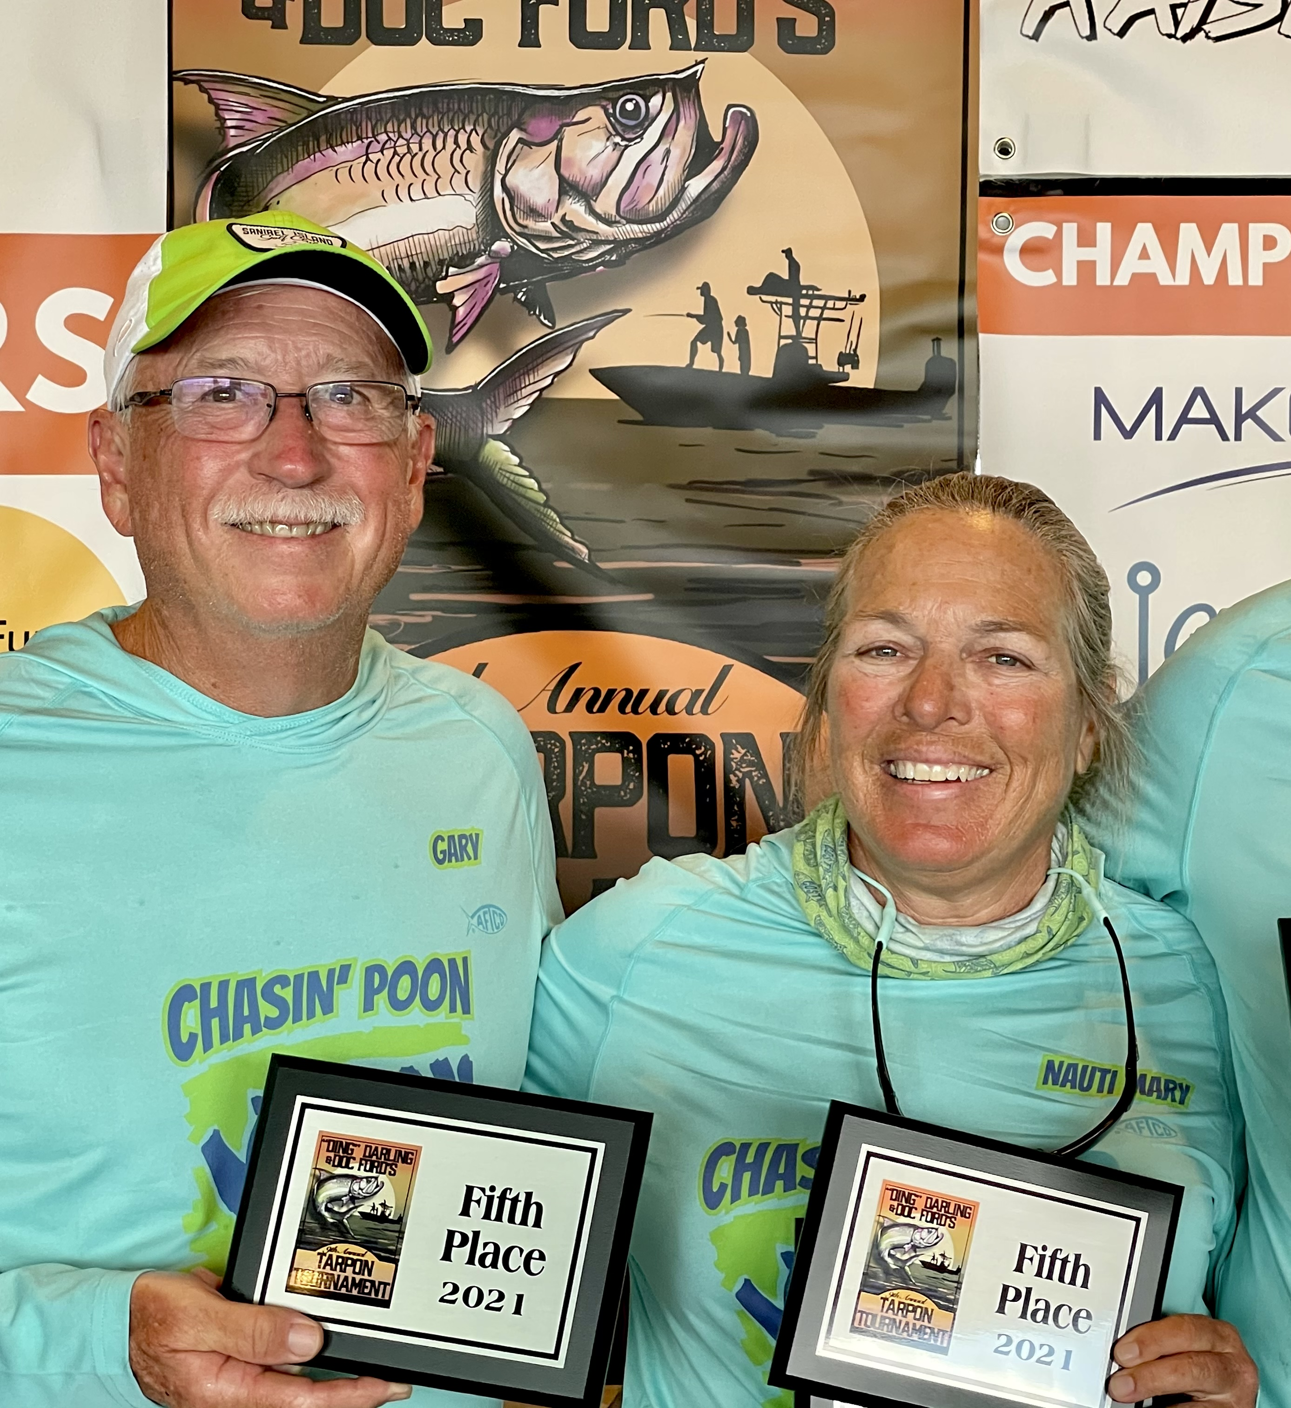

Pic: “Chasin Poon” with a 5th place finish in Ding Darling Doc Fords tarpon tournament.

Tarpon tournament

This past week was the Ding Darling & Doc Fords 9th annual Tarpon tournament. With last years event cancelled due to Covid the big payout for the tournament had been doubled. This is the premier tarpon fishing tournament and always draws the best professional and ammeter tarpon fishing teams. Competition is fierce as every Captain wants to be the owner of a prized Pink tarpon jacket and be part of that elite small club of winners. Prize money was $55K this year in the 100% pay out tournament.

After several days of pre fishing with my team “Chasin Poon” I had a game plan going into the event. This years weather conditions where far from favourable with NE winds blowing over 20 mph and a cool start. Tough weather days usually favour the teams that prefer to fish in the bay and also mean a much lower fish count for the tournament. Being able to chase fish out on the beach becomes almost impossible during windy conditions .

After the start we opted to make the long rough run up the sound as we headed for a sheltered channel up by Cabbage key. This area was some what protected from the gusty wind and had tarpon moving through it all week during the incoming tide. As we set up it didn't take long to hear that a fish had already been caught within 15 minutes of lines in. As we sat anchored even in the choppy conditions we did see fish moving through on the surface roughly every 10 minutes so our hopes were high.

Right around 8am we hooked up on one of the live bait rods. This smaller estimated 50 pound tarpon made several jumps and short runs as we quickly got it under control. Coming boat side we managed a leader touch and got conformation we were on the board. Over a three minute period 3 fish where on the leader board with ours putting us in precarious 5th place.
Over the rest of the day score updates would be text as the number of releases slowly crept up. We did luckily manage to hold onto our 5th place spot which was just enough to be in the money.

At the end of what was a 9hr fishing day only 15 tarpon where released by the 55 boats. “Tarpon Time” managed 4 releases and easily won the big prize. My team “Chasing Poon scrapped out a 5th place finish and still ended up with a check at the end of the tournament. Gary Biltgen our “Ace in the hole” from our team also won the senior division.

Tournaments like this are a real reality check of just how hard tarpon fishing can be. Conditions are the game changer as tarpon are simply finicky to say the least.

