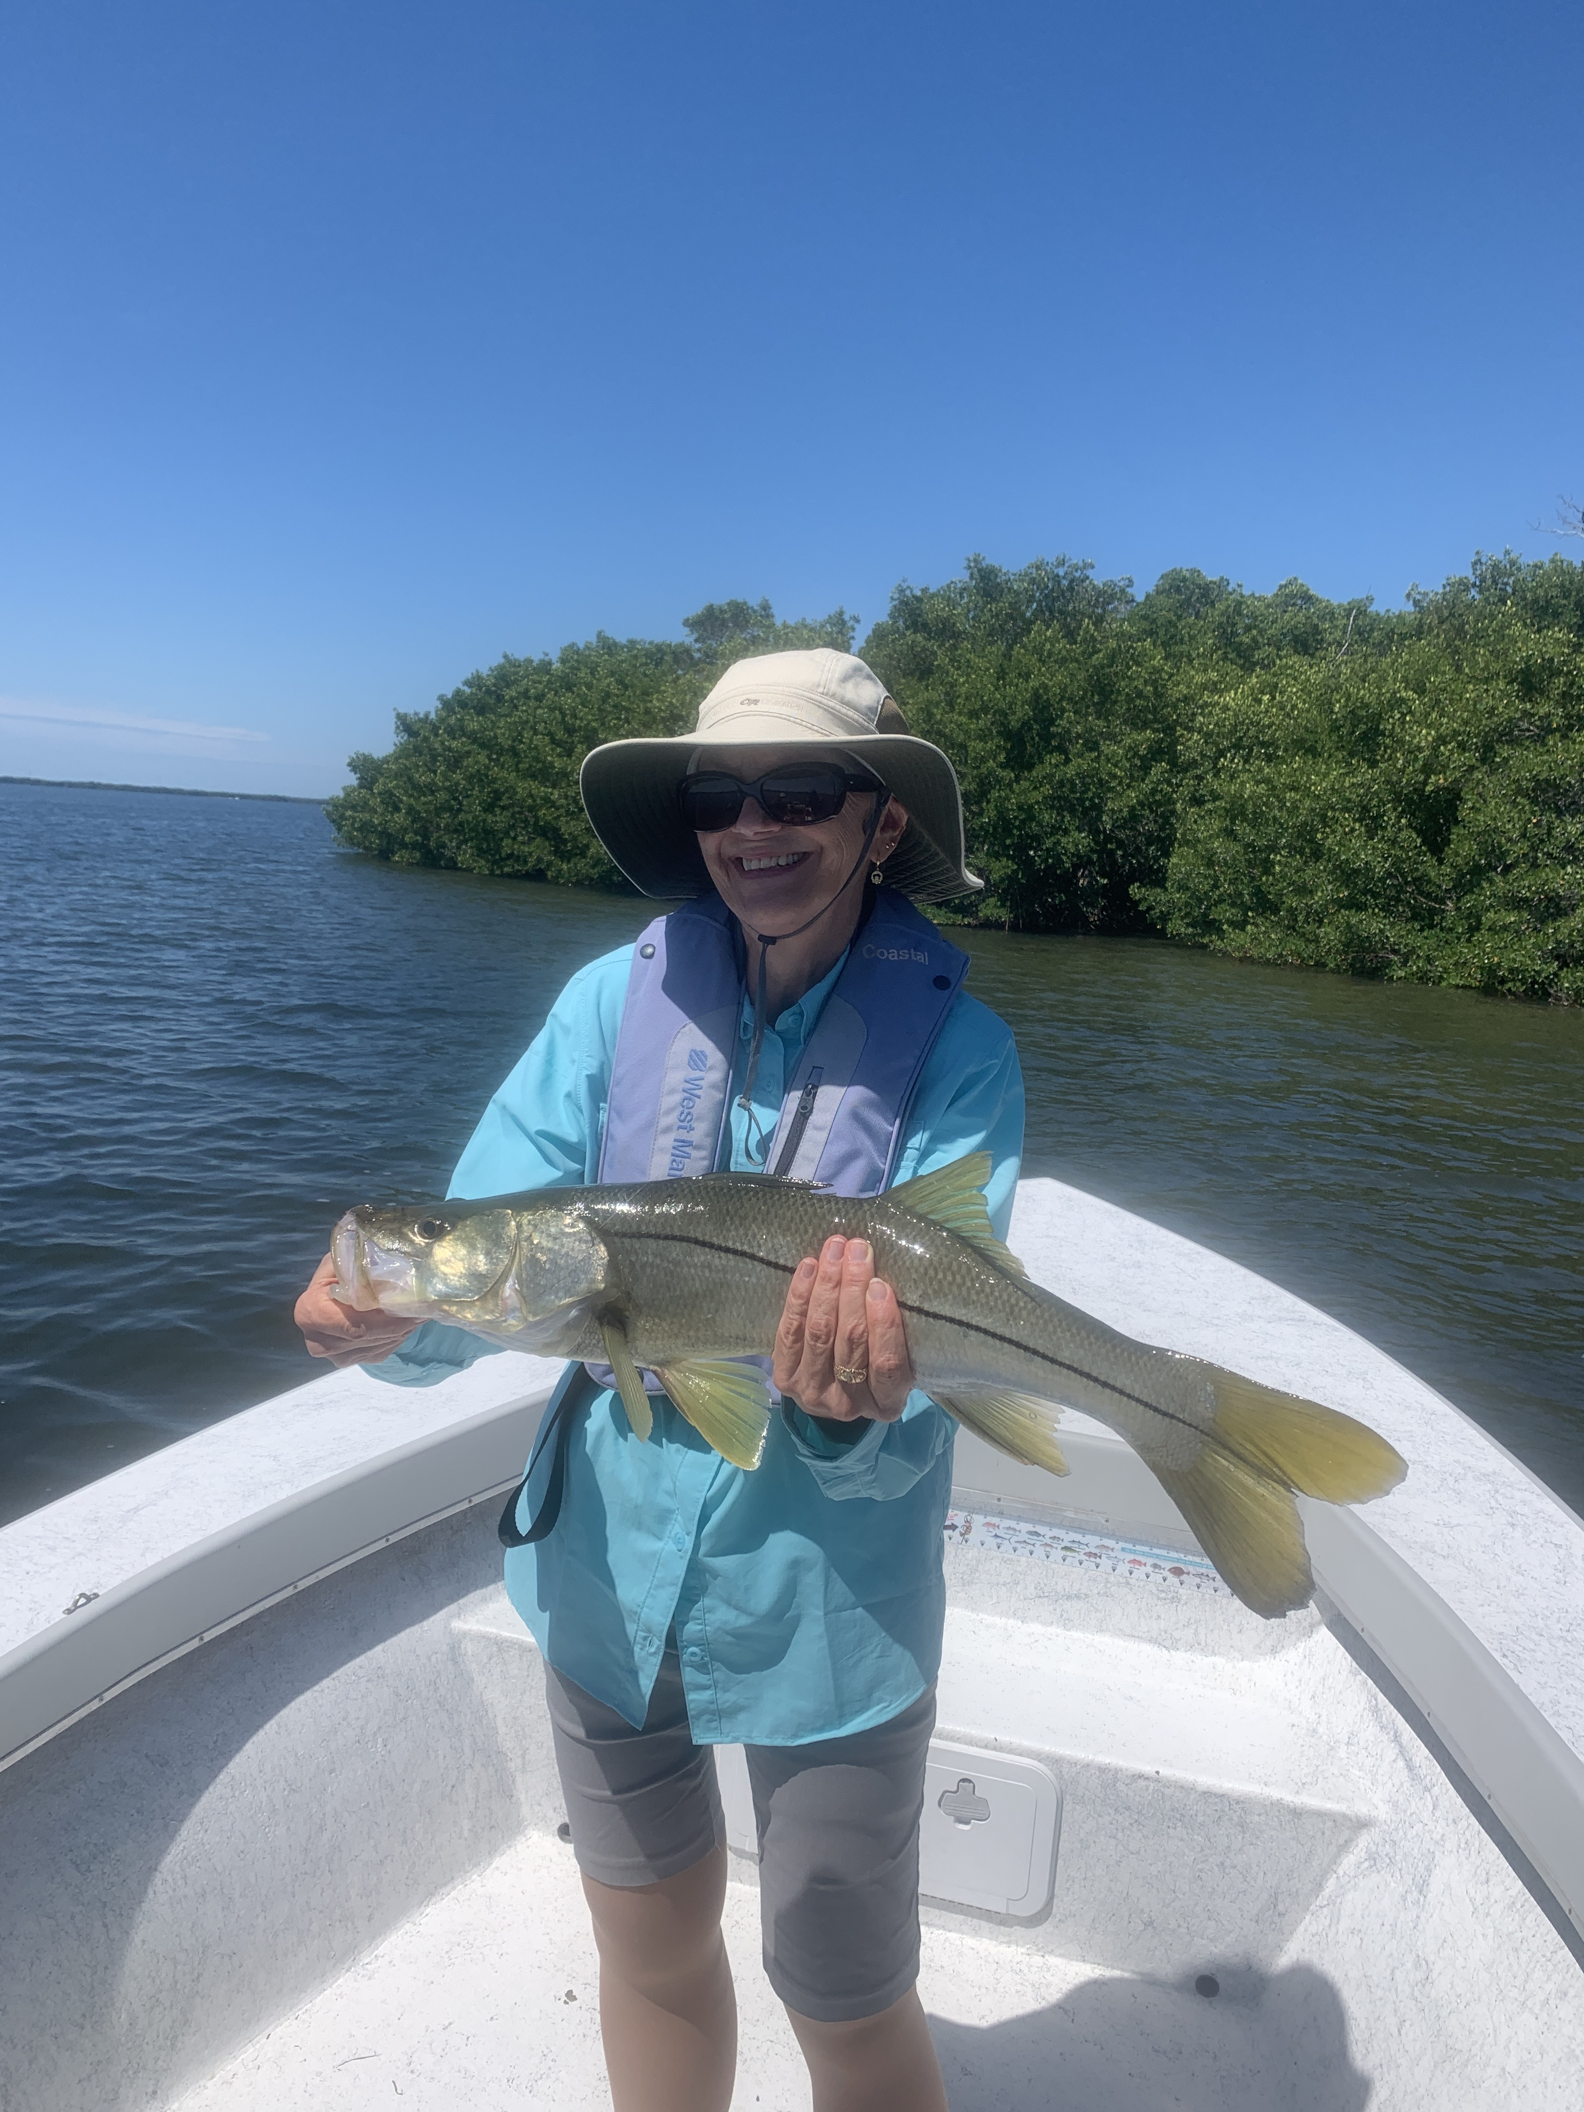

Summer time tactics

Pic: Suzie Cullen AKA “snook lady” of Sanibel with a quality snook caught while fishing with Capt Matt Mitchell this week.

During this oppressive heat of summer our fishing has begun to make that annual change. Most of shiners we usually fish with have all but disappeared and grunts, pinfish and cut baits have become the go to. Water temperatures creep in the 90’s as we see lots of sea grass die off and float in large clumps. This makes fishing in the shallow eastern side of the sound almost impossible at times. Getting out early or late during the cooler times anglers will find the fish are more active.

Tarpon fishing this week continued to be best in the northern end of the sound or from Redfish pass north past Boca Grande. Making this run in the dark before the sun came up paid off with lots of shots at rolling fish. One morning over the weekend we jumped three fish before 7am and managed to release one while fishing out of my new small skiff. Being the first boat to the fish is never a bad thing either though boat traffic lets up during the week.

Pass fishing for snook and redfish is a great option that can be productive on either tide as long as the water is moving. Small pinfish and grunts rigged with just a large enough weight to keep them close to the bottom are deadly. Drifting the passes is a technique that covers lots of ground until you get the bite dialed in. Bouncing from pass to pass you can always seem to find action all summer long.

During the summer months we utilize bait traps to catch pinfish and grunts. Small pinfish traps can be found at most local tackle stores and can easily catch between 50-100 baits just over night. We like to set our traps in roughly 4-6ft of water close to a grass flat. Frozen sardines seem to be the best bait in these traps. Having a few traps set throughout the sound makes it easy to stop and pick up fresh live bait anytime during the day with very little effort.

