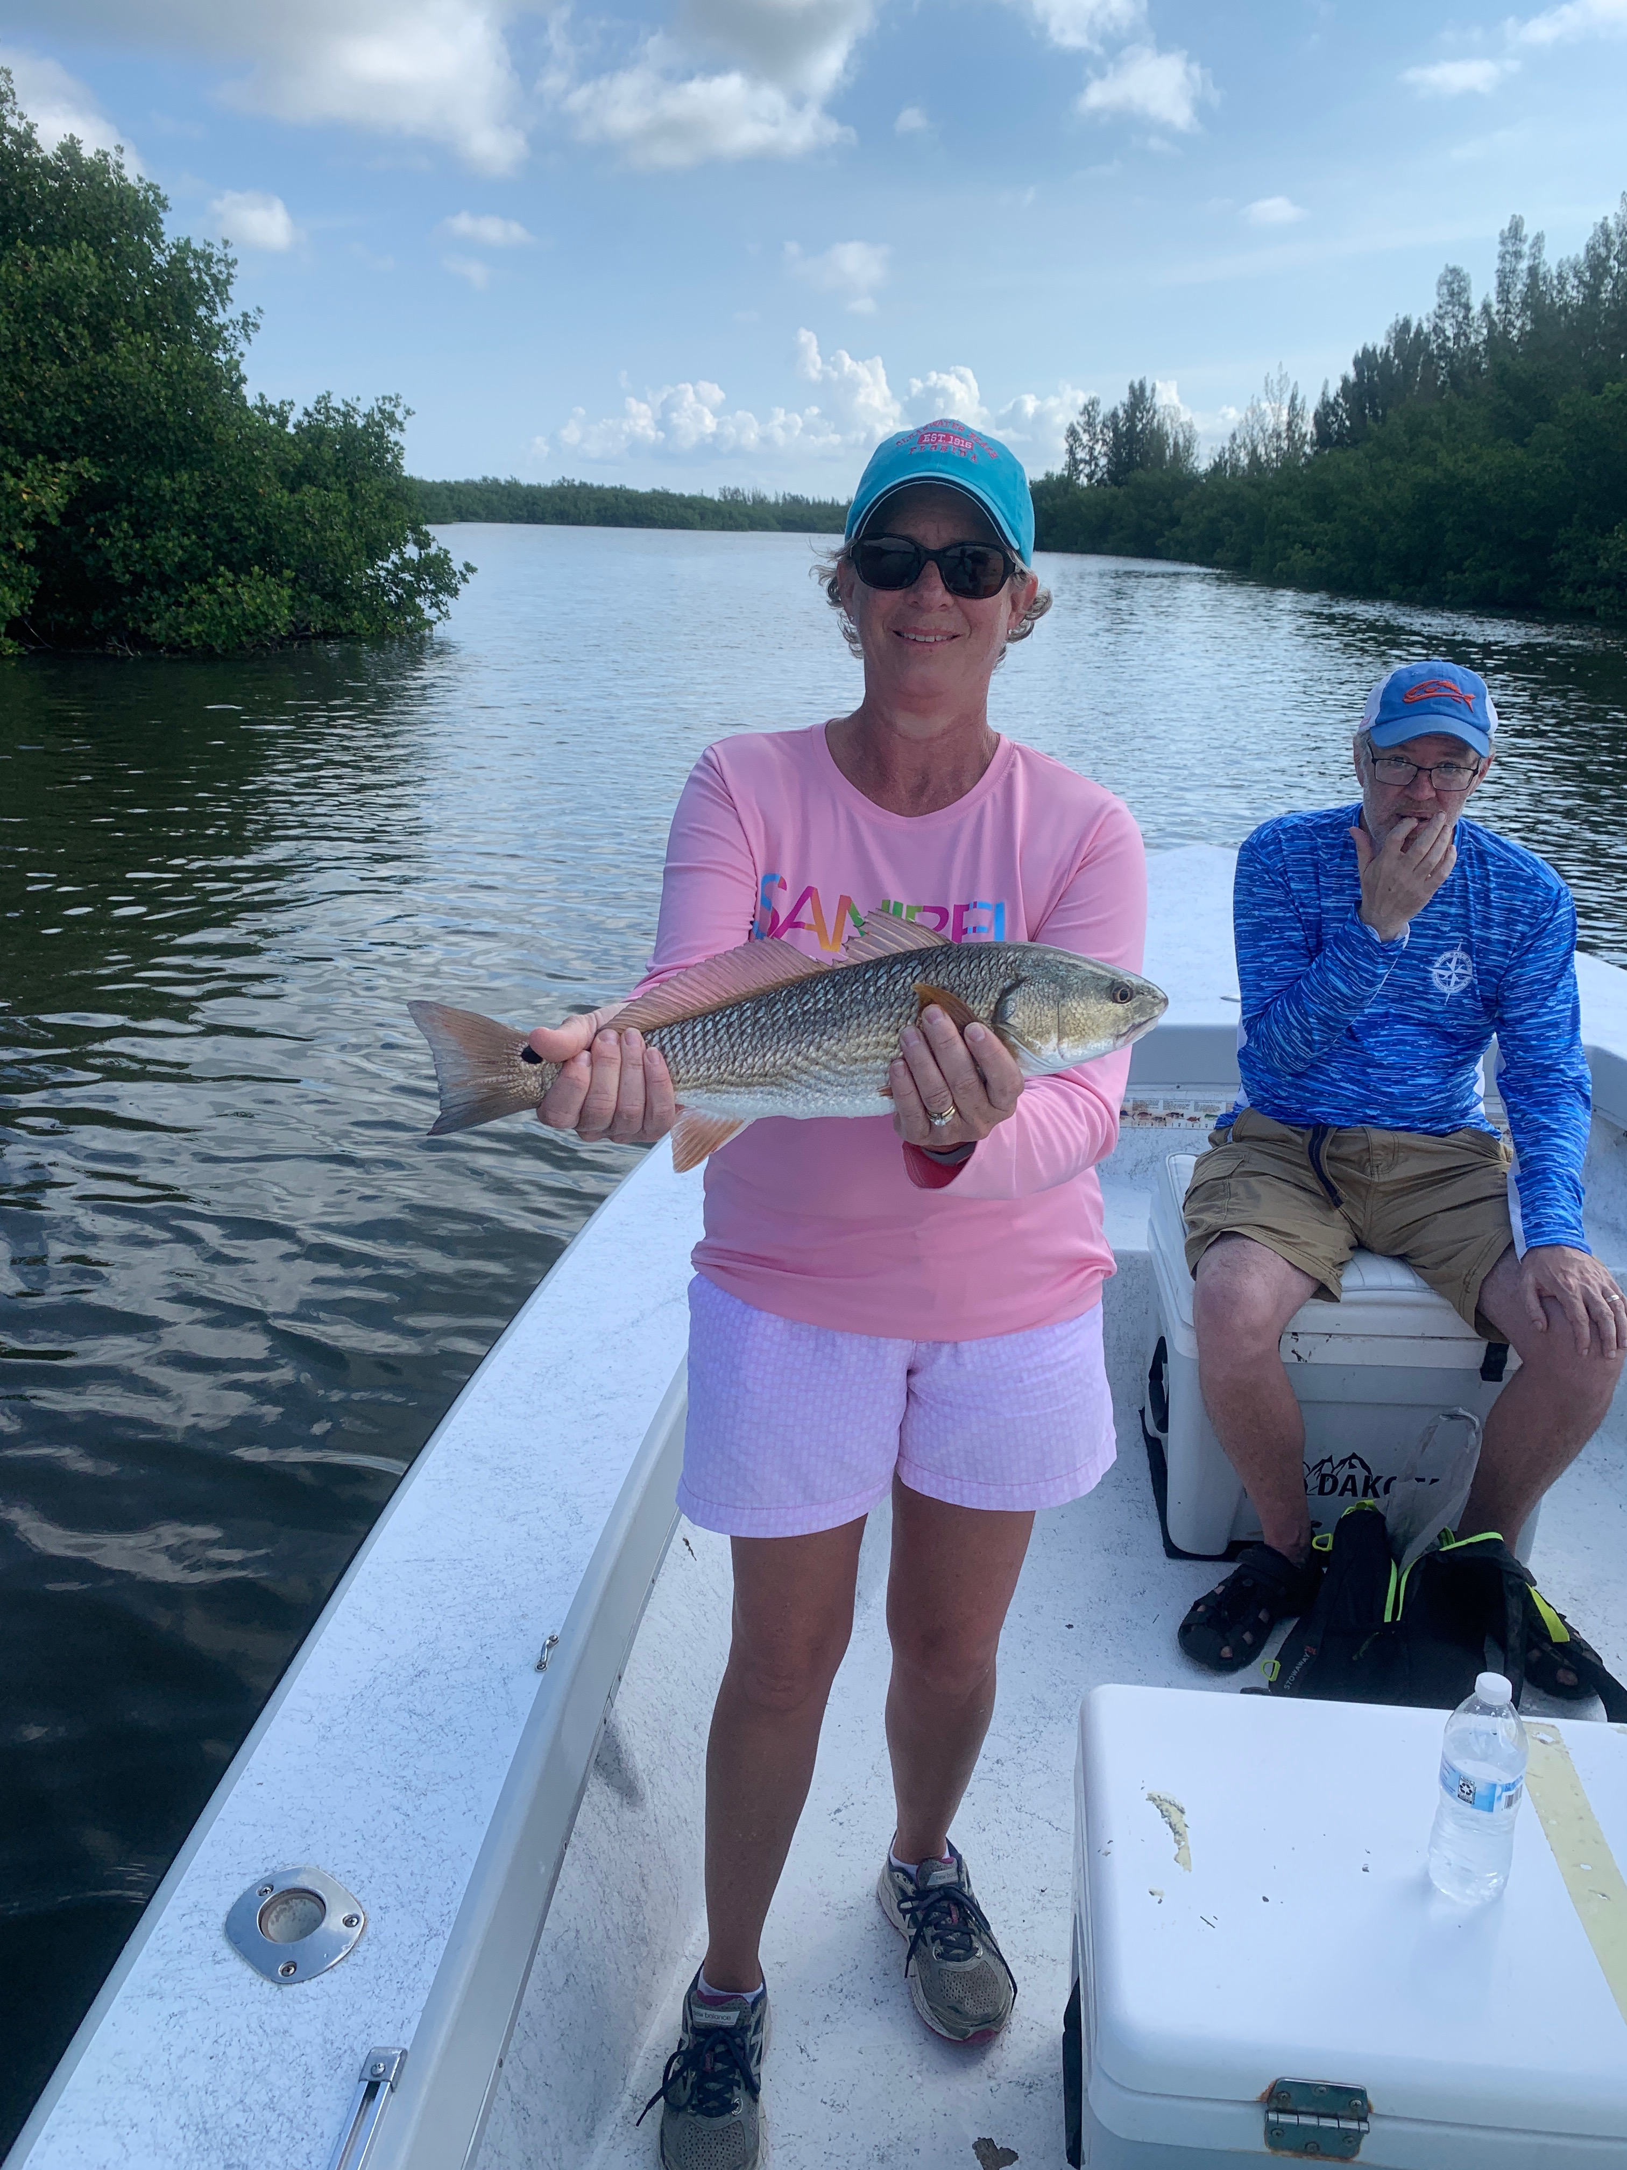

Summer heat has arrived

Pic. Teresa visiting from Ohio caught a “Pine island slam” while out fishing with Capt Matt Mitchell this week

Summer really kicked it into high gear this week with morning coastal showers brought on by westerly winds causing a disturbed atmosphere. Small fast moving rain was easy to dodge most days if you kept your eyes to the sky and radar on the IPhone. With no lightening these showers where a refreshing cooling off from the oppressive heat.

Several mornings while on a tarpon trip this week we sat in non stop rolling fish for hours and saw no hook ups. Waiting to get that perfect shot while moving around on the trolling motor to a laid up or slow moving fish is what it took some days while other days it was a matter of soaking cut baits and just being patient. Sitting in rolling tarpon and watching them all around you is just part of tarpon fishing. When set up in these fish you know you are in the right place and hopefully they decide to feed. All of a sudden for no rhyme or reason for a very short period of time they decide to eat and 3 or 4 boats hook up.

Mangrove snapper fishing just keeps getting better with the deeper passes including Captiva and Boca Grande producing lots of limits. Small pinfish, shiners and shrimp dropped to the bottom have been giving anglers non stop action. These fish have very good eyesight so the smaller the hook and lighter the leader the better. Though these fish have not been huge your average fish is still 12 inches plus. These snapper, stay in here all summer long and are a great option during periods of slow to no tides or when you just have to bend the rods and sent clients home with dinner.

Mangrove fishing with shiners produced Snook, more mangrove snapper and a few redfish most trips this week. With switching wind directions almost daily this took a little more effort than usual this week. The south end of Matlacha pass continues to be my go to area with lots of action very close to home. Free lined live shiners are the bait of choice for this.

With our water temperature hovering right around 90 degrees its been harder to keep our shiners alive due to this heat and low oxygen content. One solution is to start the day off with much less bait than I usually do. By putting only a couple of hundred baits onboard to start the day and not blacking it out the shiners seem much happier and make it all day. Giving them more space in the live well gives them more oxygen. Once you do have a few shiners start to die off it can go down hill quickly as it starts a chain reaction.

