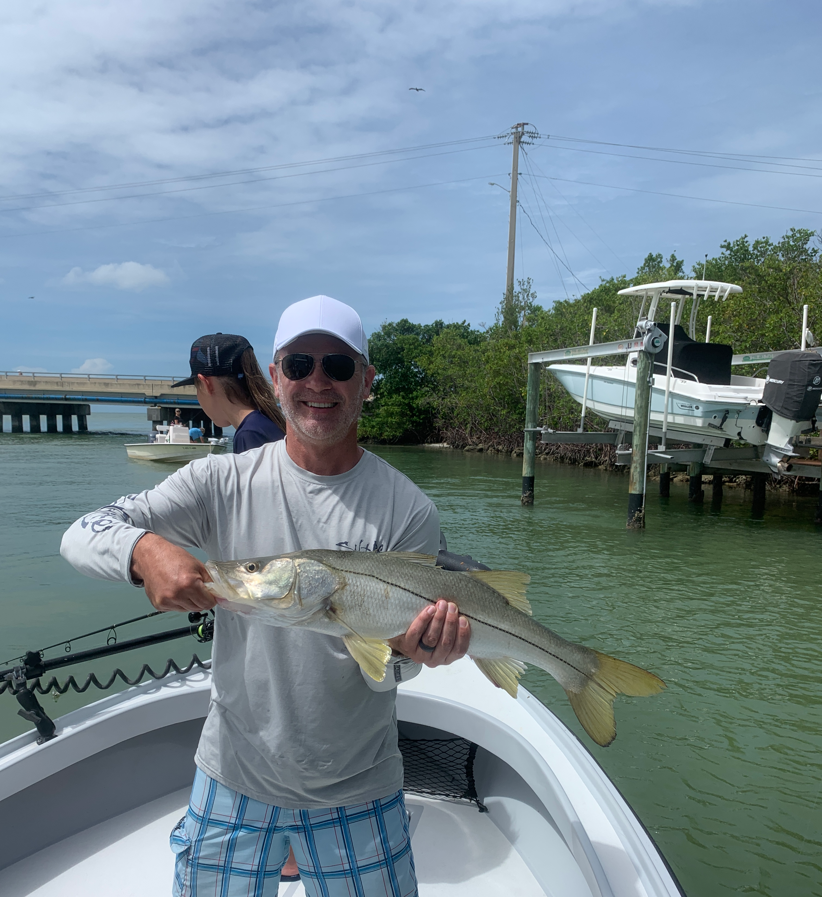

Pic: After flats fishing we have still been catching a few good snook.

Summer family fun

Most of our charters during the summer months are family trips. We often break up the time on the water between fishing, part eco tour and or beach time. Showing off what our area has to offer is always a favorite for me. Most of the fishing we do on these trips is high activity flats fishing.

Finding birds and fry bait schools on the flats has been the easy way to locate feeding fish. For family fun fishing or just keeping the rods bent nothing works better than a popping cork rig. This set up with a live shrimp will bring non stop action and keep everyone smiling. It helps give inexperienced young anglers a visual indicator of when they have a bite.

For popping corks I like a concave style float that makes lots of noise when you twitch the rod tip. This style float comes rigged on a heavy mono or even no kink titanium wire with beads that rattle. Each end of the rig has a swivel for easy attachment. The popping sound of these corks make a clicking noise resembling fleeing baitfish or shrimp and attracts the fish.

When rigging the popping cork use 18-24 inches of leader before tying on a hook or jig head. I use a 1/4oz jig head with a 2/0 hook. This allows the bait to sink quickly after you pop the cork. A regular hook will do the trick simply add a split shot to keep the bait down.

You can fish this rig with a variety of baits including live shrimp, small pinfish, grunts and even shiners. Gulp shrimp along with a variety of other soft plastic’s will get the job done when this bite is on too. D.O.A along with a few other companies make this rig with a plastic shrimp thats ready to go right out of the package.

Get the family out on the water for easy family fishing fun!

