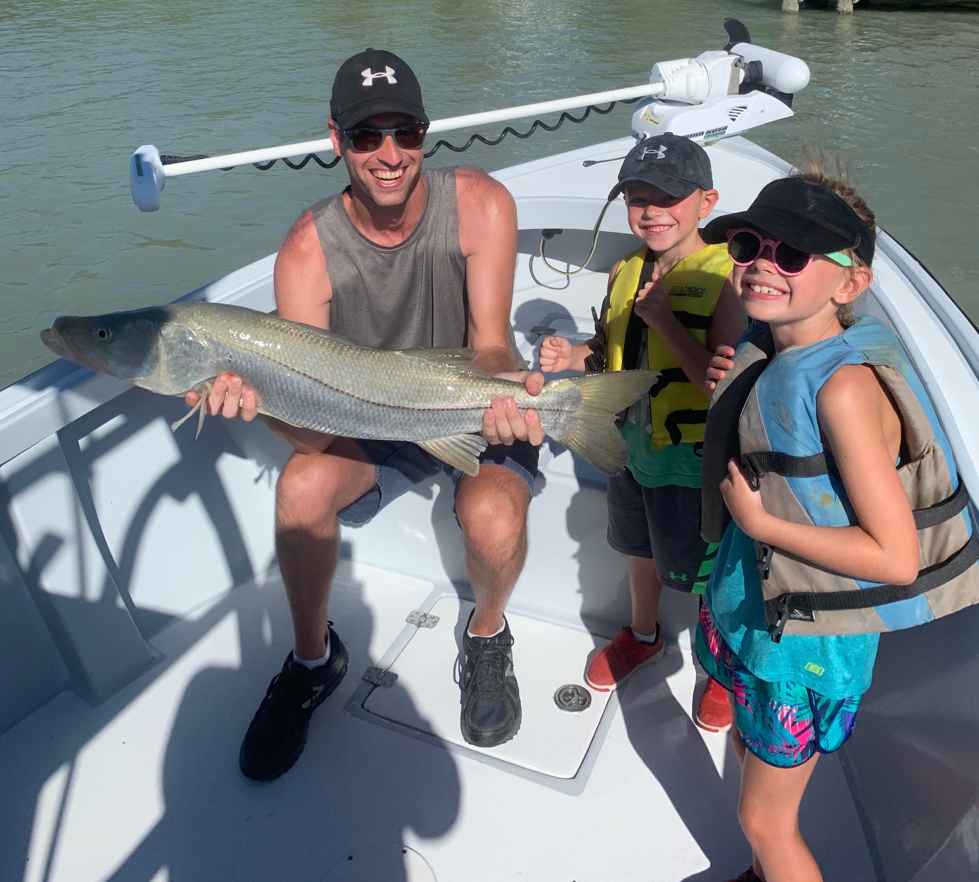

Summer family fun trips.

Pic: Making memories this big Snook was caught as a family group effort while fishing with Capt Matt Mitchell this week

Over the past month the majority of our charters are families with children enjoying some quality time on the water together during summer vacation. On these charters its always important to gear the trip towards the kids and this very much depends on the age of the children. Generally, the younger the kids the shorter their attention span. Often these trips are all about finding fast paced action and keeping the kids interested rather than chasing a trophy fish.

When the bite slows its important to keep the younger kids focused. Take time to show them Dolphins, Manatee’s or birds. Breaking up the trip by going for a swim at a beach or even pulling up on a sandbar to explore what lives there is also a good idea. Have lots of water and snacks to help keep them happy, Lots of sun screen is a must along with having the right sized life vest for the age/weight of the child.

When getting children out fishing for what can often be their first time its a good idea to take some live shrimp and smaller baits to guarantee catching fish. Bobbers are a good idea too to give that visual aspect. Getting bite after bite is much more important than the size of the fish caught. The highlight for some much younger clients I had out this week was catching and getting to hold several blow fish we caught. These cute fish gave them more of a thrill than the 34 inch snook they caught as a family group effort.

With shark week on TV what seems like all month we get lots of calls from families wanting to go shark fishing. Seems kids love sharks almost as much as they love puppies. These shark fishing trips make for a great family adventure and are a good choice for even the novice angler.

As a kid growing up on Sanibel I was lucky enough to spend lots of my free time both out on the water fishing and just exploring the surroundings. Now I get to share this amazing watery back yard with the next generation. There is something very satisfying about seeing it again for the first time through young eyes.

