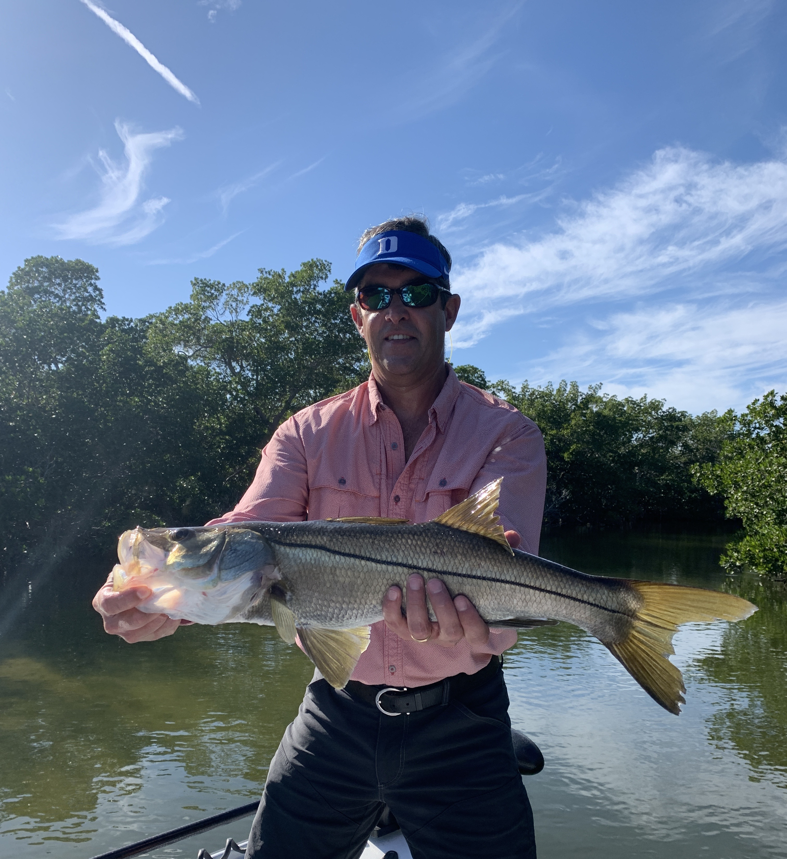

Spring fishing has arrived

Pic: Chris from NJ got to enjoy a wide open Snook bite while out with Capt matt Mitchell this week.

The change of seasons in south Florida is very subtle though the signs have certainly begun. Last week we witnessed the first changes that Spring has arrived. Its still too soon to think our cold fronts are completely done though each front will be less extreme and temperatures will rebound much faster.

Over just a few days last week our water temperature in the sound went from mid 60’s to mid 70’s. When our water gets in the 70’s everything just comes back to life. After seeing very few Manatee’s over the past few cold months we are now seeing them all over the flats as they come out from their warm water winter hangouts. Grass flats also came alive with shiners, feeding fish, and bird life.

Mangrove creek fishing went off with some of the best Snook and Redfish action we have seen in years. Morning minus low tides are my favorite set up for fishing these small fast flowing tidal creeks. Clear shallow water made for great sight fishing action. There is nothing as exciting as watching a hungry snook charge out and grab your bait.. Having these creek systems explode on live shiners is something that has to be seen. Clients got to enjoy Snook and Redfish up to 30 inches along with several freight trains that just could not be slowed. This is a close quarter fishery that turns into full combat when you hook a big fish

Landing big fish in tight creeks requires a different style of fishing than out in the open. With so much structure for these fish to break you off its all about steering these fish out to the middle of the creek. Pulling low and often even putting the rod tip all the way down in the water gives you a better angle to keep the line of the sharp barnacle crusted roots. Solid short pumps of the rod even if you are only gaining a few feet of line each time can be the difference between smiles or heartbreak.

The average size and amount of the fish both in these creeks and throughout our area has been amazing over the past few years. I completely contribute this to the FWC closure letting these fish recover after what was a devastating red tide in 2016. With this prolific rebound in the populations of Snook, Redfish and Trout lets do everything we can to keep these fisheries catch and release only for at least another year. This would let more of these fish grow enough to be over the slot size and have a chance to spawn. Just imagine what another year of closure would do to help our long term fishery. Go to MyFWC.com and voice your opinion.

