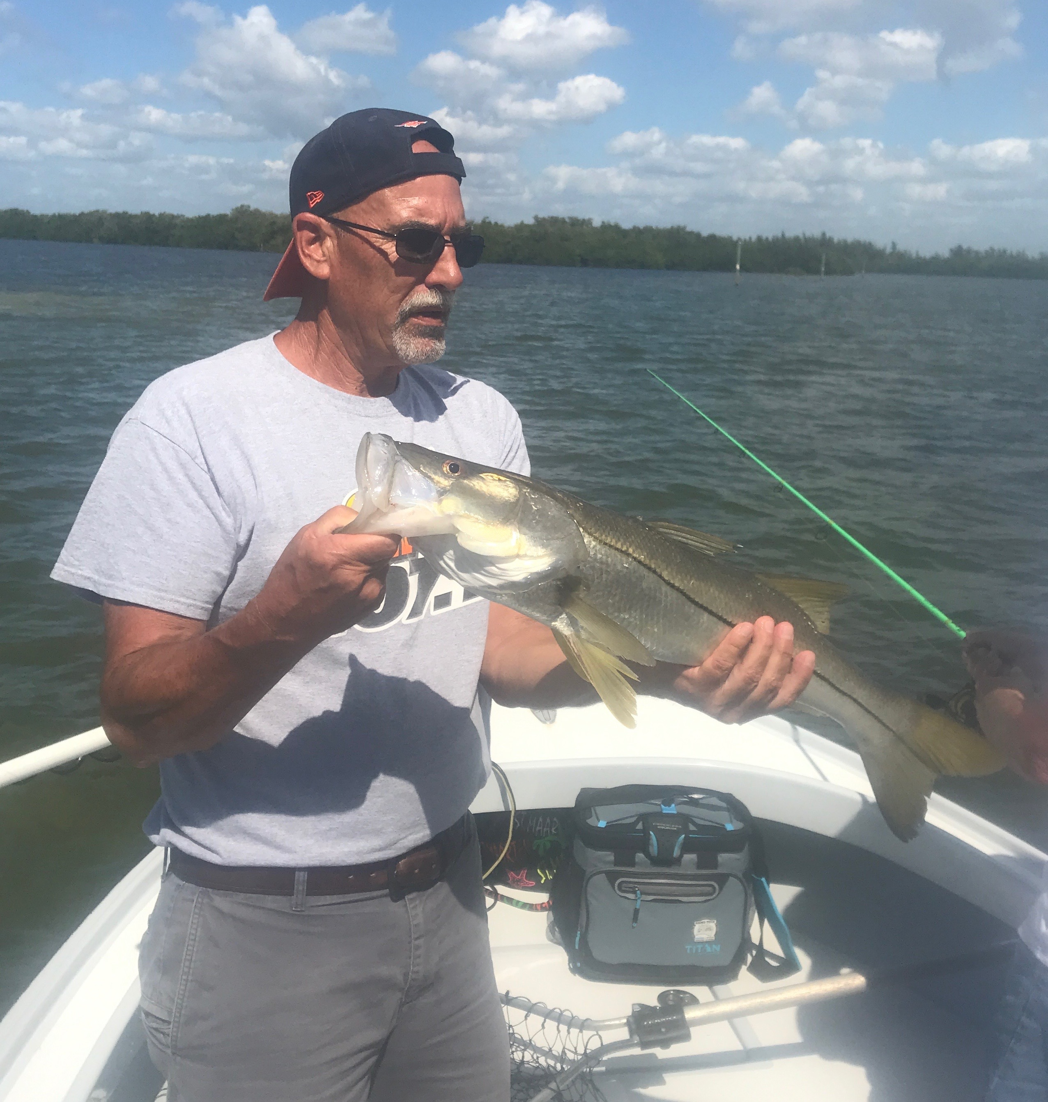

Spring Snook Bite

Picture: Mark from Michigan with a 30 inch Snook caught and released with Capt Matt Mitchell this week

Fishing this week can only be described as the switch was flipped to the on position. Snook came out of a long winter hibernation and started feeding and wow are they hungry. Over what was only a 3 day period our water temperature went from high 60’s to mid 70’s which is the magic number for the whole sound to come alive with life

Shiners flooded into the bay with the warming waters and can now be caught on most grass flats throughout the sound. Inside the passes we have now begun to see ladyfish and Spanish mackerel feeding on the surface. After what was an early and cold winter its great to finally change gears from Sheepshead fishing to catching Snook. Its still a little early to think we won’t get another cold front though it certainly seems spring is here.

After not catching shiners for over 2 months due to the cold water it felt great to have a livewell packed pull. Pulling into the usual deeper channels where I target Snook this time of year the bite was non stop. Half day trips we have been catching and releasing 20-30 Snook. The better Snook bite for me came on the eastern side of the sound in the cleaner water.

Along with the Snook we also caught several really large trout this week while fishing around oyster bars. This is great to see some 20 inch plus trout as they have been really hard to come by since our water issues of summer. Clean clear water in the middle sound has made sight fishing for many species possible.

Fishing with a group of Michigan clients on a afternoon trip this week we caught the first inshore slam I’ve put on the boat in months. Starting our trip on a oyster bar in the middle sound we caught lots of 20-24 inch Snook but did manage one right around 30 inches. At the next oyster bar we caught a 20 and 21 inch trout and then a few minutes later caught a 19 inch redfish.

Although are seasons are not as black and white as they are up north watching our waters come back to life after several months of unusual cold is a great sign Spring is here. The influx of bait fish and feeding birds wakes up all the fish after a lean winter.

