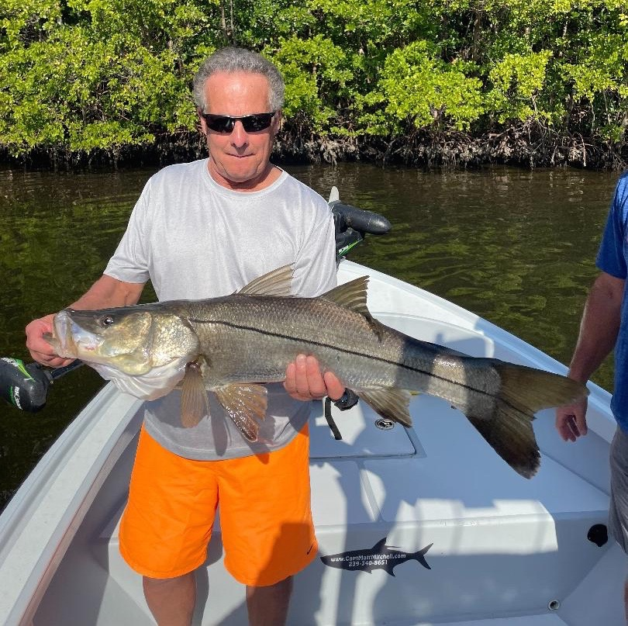

Slow it down, take it all in.

Pic: A 37inch snook caught and released with Capt Matt Mitchell this week

The older I get and the longer I guide the more I’m noticing what has probably always been right there. Whether it just taking a little more time to see everything that’s going on instead of quickly moving it is paying off. When fishing with clients you just can’t give any spot too long when its not happening. We often fish at warp speed until we find the action that we are looking for.

Many days we locate that wide open snook bite on smaller fish that eat with abandon. After catching a few dozen, we generally move on looking for larger fish. Feeding fish attract feeding fish and this proved true as we upped the size of our baits and stuck it out in these same places to catch more than a dozen quality snook over 30 inches. This week was one of the best big snook bites I can remember in the past few months.

Casting big shiners quickly upped the game as for each larger snook we managed to get out of the structure and to the boat we lost at least one or two other big ones. The largest fish measured was 37 inches although we lost at least a dozen others that were noticeably larger. This wide-open bite came during the last hour of the falling tide and was consistent for 4 straight days. But like all good things as the tides got later in the day the window slowly closed to target these fish.

Catching bait is without a doubt the most important part of our day as guides as it assures that our clients will catch fish. Without the right bait our job becomes extremely tough. Over the past few weeks, I have found my bait consistently in a place that I have passed right over for the last 20 yrs. By slowing down and taking in the subtle signs I have worked out a pattern that has been right under my nose. This is twofold, frustrating that I never saw this bait opportunity before but satisfying that even after so long I have a new trick.

No matter how long I’m lucky enough to continue fishing our waters I’m always learning something new. This amazing fishery has lots of secrets that it just does not give up easily. Something so simple can be such a game changer if you just slow down and take it all in. The one thing that rings true it’s that the day you stop learning or claim to know everything it’s time to hang it up. I just know a very small part of a large puzzle which luckily most days is enough to catch fish.

