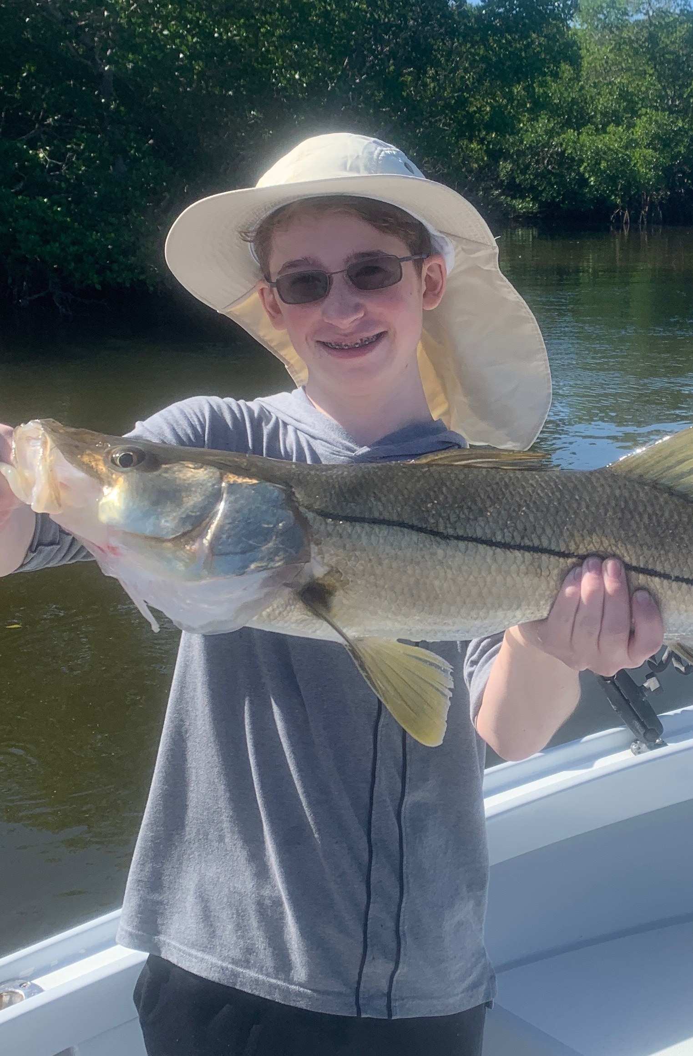

Pic: Porter from MI with a big snook caught while fishing with Capt Matt Mitchell this week.

Shiner stress

With improving conditions following a bitter cold Christmas after days of shrimp fishing it was time to switch to shiners. It only took the slightest warm up to go from targeting sheepshead and redfish around the passes to catching just crazy amounts of snook. This quick change made for very hungry snook.

Inside the passes was a parking lot over the holiday week. What was amazing was despite the massive amount of boats while riding by almost everyone was catching fish. I opted to stay away from this congestion and fished mostly in lesser known mangrove creeks. We had a few really impressive trips when we got to fish the minus low incoming tide. Catching lots of snook and redfish was a normal day. Once we located the fish this bite went on for a hour or more in the same 100 yard area. Add in a few 30 inch or better snook and a couple of upper slot redfish January fishing can be amazing.

Shiners have been plentiful on the causeway bridges. During calm periods right after sun up they can be seen flipping around the pilings. Picking up enough bait for the days fishing has required only a few well placed casts. Throwing a net on the bridge requires basically scrapping the piling with a well placed open cast net. Use a heavy 3/8th mesh net to quickly reach the bottom in this deep water.

So your all baited up with a live well full of candy snook shiners and then your heart just sinks. Shiners are floating up to to the surface dying while others leap out of the water onto the deck trying to escape. Start up the boat and run fast to the mouth of the river to reach clean water. This way at least a percentage of the prized bait may live. After a couple of times this scenario gets old.

If you can fill the live well full of water away from the red tide and close off the flow. Add a running Air head live well circulator. These floating recirculating pumps inject the live well water with oxygen. Once away from this bad water then re open the intake. Constantly tending to the bait and looking for any signs of bad water that will kill both you bait and chances at a great days fishing is nerve racking.

These small patches of red tide have been somewhat isolated. The majority has been around the causeway bridges at the eastern end of Sanibel. The Roosevelt channel and area’s just inside redfish pass have been a little sketchy during the end of the outgoing tide.There are very few signs of this red tide besides seeing a few old, floating dead mullet. Concentrations have been bad enough in certain areas to kill your bait. Taking live shrimp as back up has been a must, as they are not effected by the red tide.

Though dealing with slight effects of red tide sucks the fishing has been outstanding. Going through the added daily stress of keeping your bait alive has paid off with some memorable trips this week. Even these small effects of red tides bring back the memories of the nightmare we dealt with in 2017. After a amazing rebound in our fishery within 3 weeks of more massive nutrient rich water releases from the Lake we have red tide . Until the flow of water from Lake O is diverted south through the Everglades this will continue to be a major problem.

