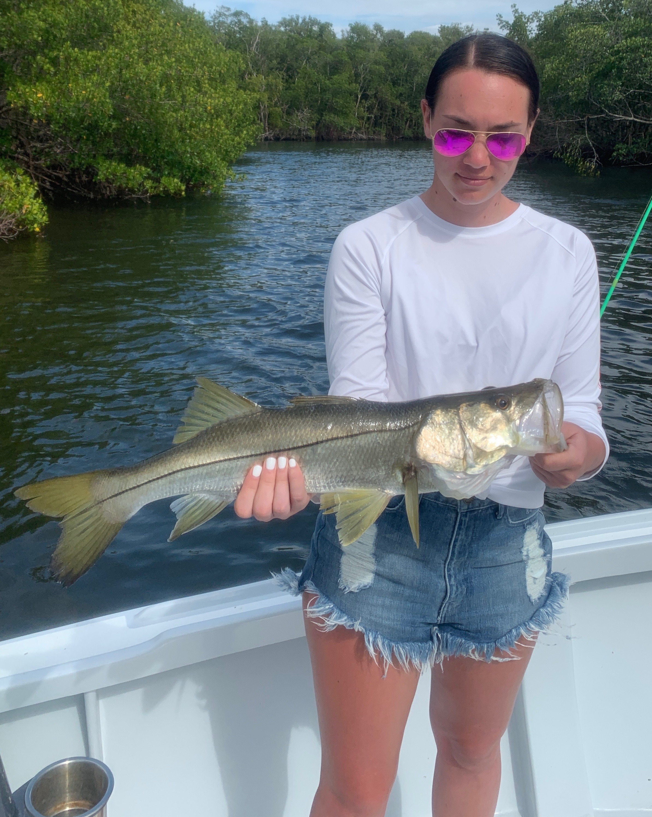

Picture: Bigger Snook have been feeding better during the warmer afternoons.

Sheepshead in the morning then Snook in the afternoon

Even though Spring is officially here the weather most mornings this week certainly felt more winter like than it has in the past few weeks. Then as things did warm later in the day we had a few afternoons of crazy strong winds causing cancelled trips and making fishing about impossible anywhere but in sheltered canals and creeks.

Switching back to winter tactics of shrimp fishing was very successful during these cold mornings for sheepshead which I thought had all but disappeared. During the warmer afternoon periods snook fishing on shiners was the go to which some days offered clients a slower bite than it has been. With our water teeter tottering right around the magic 70 degree mark time of day has meant everything when choosing which species to target..

Super moon tides had the water screaming in and out of the passes often making it too fast to fish. Hitting the passes during the slower period when the tide was switching provided my anglers with some of the largest sheepshead we have seen in weeks. This window of slow tide movement was as short as 30 minutes most days. Tried and true sheepshead spots throughout the bay provided a few more keepers but nothing like the larger models that came from the passes during the ebb tide.

Schools of ladyfish both in the middle sound and between the lighthouse and the causeway brought some non stop action on calmer days catching mackerel, bluefish and trout mixed in with them. Sharks are also working these same areas and its often as easy as throwing a chunk of fresh cut ladyfish out to hook up with a much harder fighting fish. Rocky channel went off too this week with drag ripping lager sharks that many times could simply not be stopped on the gear we had. Super low tides are the best time to get in on this big shark bite in the northern sound.

With yet another mild cold front in the forecast for this week it will give us another few days of windy rough water. Without a doubt NW wind is the toughest wind to fish the sound. All you can do is get tucked away and fishing options become fewer. Like with any cold front the best bite well come right as the front approaches, once it passes high pressure moves in and the fish turn off. With each passing front we are getting closer and closer to more consistent weather and fishing.

