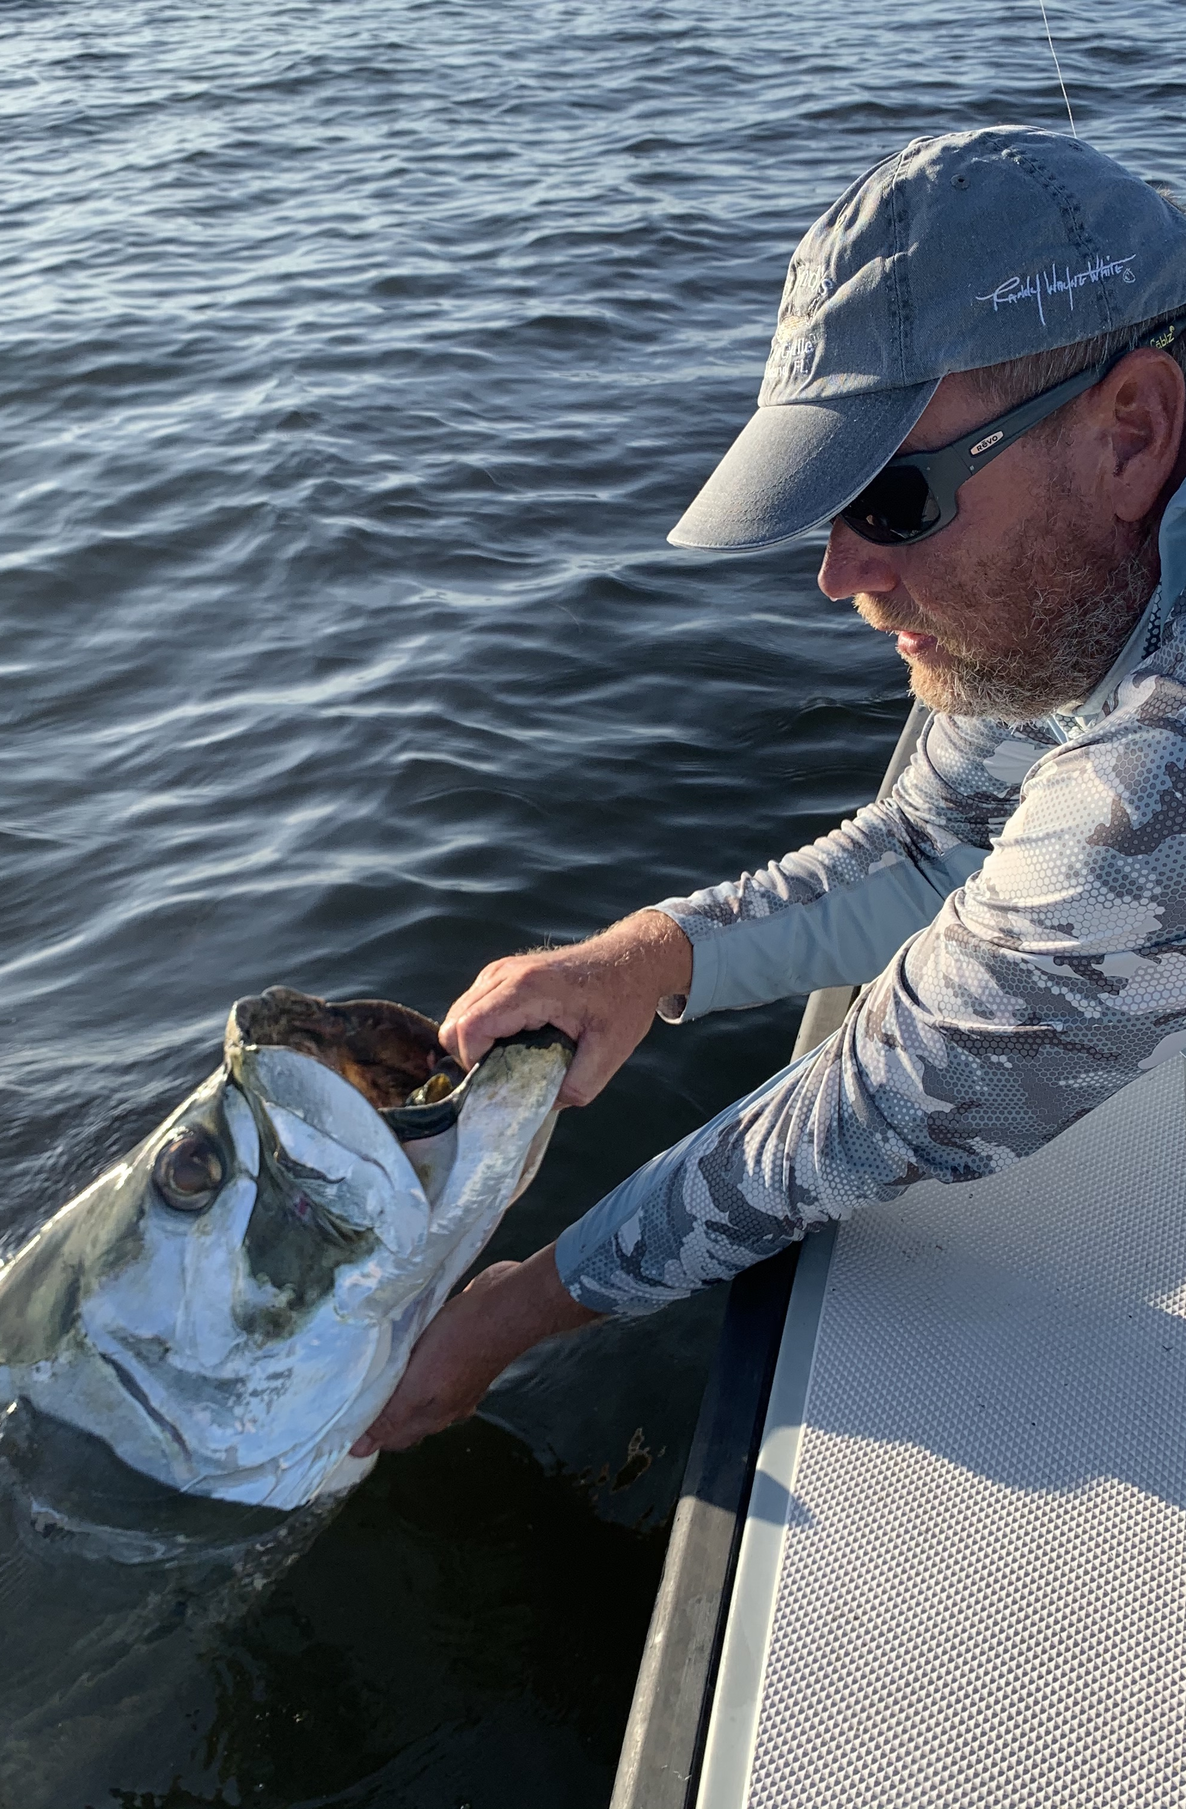

September grand slams

Pic: Capt Matt Mitchell with a tarpon caught on a day off this week

As expected September fishing has been nothing short of spectacular. No matter what the species it is, its all here and there is very little angler pressure. Weather conditions as always are the major factor on what will be the days main target. Once in a while though you get that magical day everything can come together for that “Grand Slam”

During the light wind days tarpon have been my main target with first light until mid morning being prime time. Both the sound and the beaches have held these fish. Sight fishing has been the main method of catching them. The tarpon in the sound have just seemed to feed better though the greater numbers have been out on the beaches. These beach tarpon have been so dialed in on glass minnows and small hatch bait at times they simply won’t eat anything else why the fish in the sound seem to jump on any well presented offering.

On a day off this week I was lucky enough to catch a tarpon myself which was the first one I have done battle with in quiet some time. After stalking these slow rolling laid up fish in the sound I finally got a shot at them. Landing a live pinfish within 10 feet of this laid up tarpon it did not take but a few seconds to be hooked up. This full sized estimated 120 pound fish made two huge jumps as it quickly peeled off almost 200 yards of line. Chasing this fish on the trolling motor it made one more jump before deciding to stay down and slug it out. After 30 minutes the tarpon came to the boat, we removed the hook and got a few great photos.

Over the weekend while fishing with long time client Jim Robertson with an approaching front my fingers were crossed the bite was going to go off. We started out catching trout and snapper out on the flat as we let the tide get lower. After trying a few mangrove spots with little success I headed to a favorite deep mangrove channel. The strong northeast wind was now blowing and pushing the tide out quickly . For that last hour this fast falling tide the bite went off with almost every cast getting hit. Small tarpon, big snook, redfish and jacks kept the rods bent. Although Jim lost his tarpon Lucia caught hers giving us a grand slam for the boat. This unpredicted minus low tide was wind generated and had lots of fish bunched up in this tiny narrow deep channel.

The ups and downs of our weeks weather have made fishing both easy and challenging from day to day. Letting the days conditions dictate what species your going to target has been key to staying on fish.

