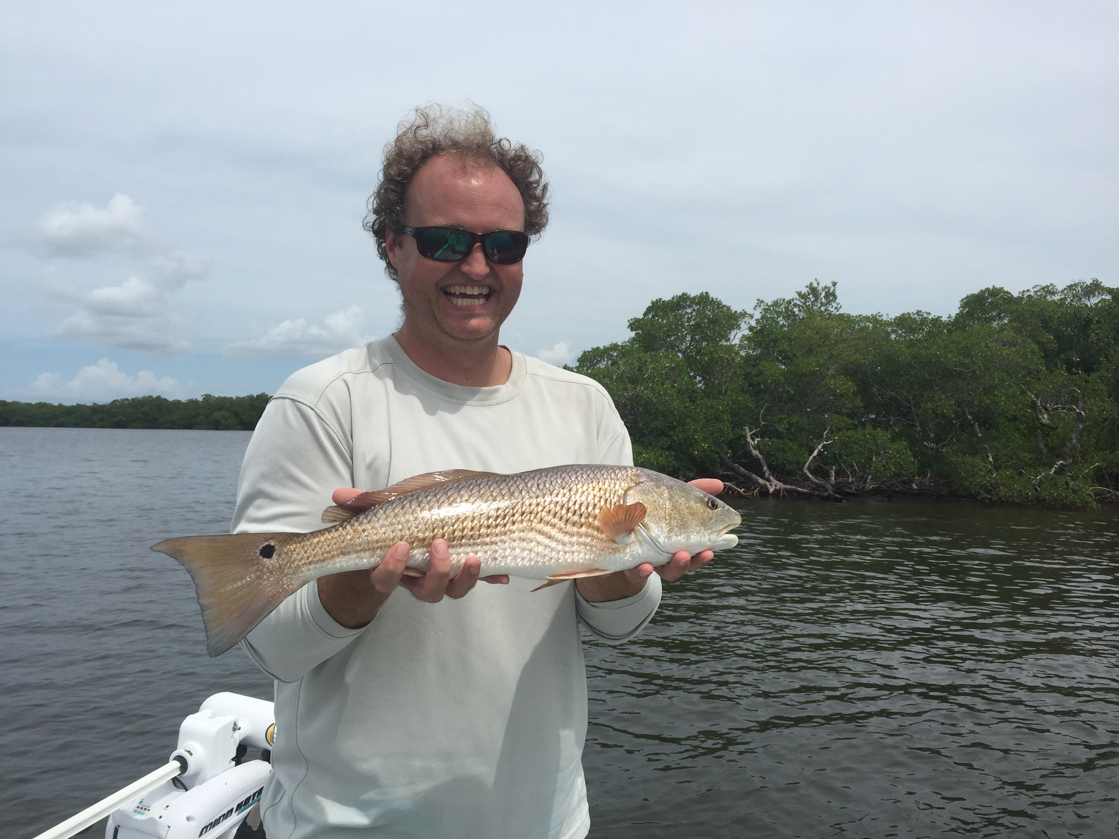

Picture: Redfish action is starting to heat up.

Busy fishing and dead baiting.

Morning outgoing tides brought with them some of the lower water conditions we have experienced all summer. Changing it up and fishing the channels edges and deeper cuts through the shallow flats was very productive for a mixed bag of fish and what I just like to call “busy fishing”. Mangrove snapper and sea trout along with a few mackerel, jacks and small Gag grouper fired up to live shiners and just kept feeding as the tide fell out. Once you got these fish around the boat it was crazy how many fish one little 50 yard long 4-5ft deep channel would have in it. Open flats in 4-6ft of water up around Captiva pass offered anglers much of this same non stop action.

As usual free lined live shiners are the bait for this. The better larger shiners have been in the northern sound and have required a early morning 20 mile round trip before picking up my clients. From Redfish pass south the majority of the shiners though plentiful are all on the small side so making the morning run up past Redfish pass to get the better bigger bait has been a daily event for me the last 6 weeks. How the days fishing will go is often decided on the bait so having a live well full of the right sized bait and lots of it generally assures that we will have a busy day fishing.

Redfish action should improve as we get better tides to target them starting this week. Early morning high incoming water will be the set up to fish under the mangroves and around oyster bars. Big schools of redfish will also start to show up on the shallow flats just inside all the big passes as this month progresses. September and October are our prime redfish months with big schools of over sized spawning fish found both in the passes and out cruising the shallow flats. Chasing these schools in shallow water and casting weedless spoons and dead baits at them is some of the most exciting redfish action of the year.

When chasing redfish this time of year a cut bait is hard to beat and a chunk of fresh caught ladyfish is about as good as it gets. Spend some time catching ladyfish up around the passes on jigs while waiting on the right tide to redfish. Ladyfish has a very short shelf life and even when packed on ice is only good for a couple of days before getting too mushy and soft to stay on a hook.

Frozen jumbo shrimp are also a great bait for summertime redfish. I fish these big dead shrimp on a jig head to keep them put under the tree’s or on a float and let it drift down a mangrove shoreline or oyster bar. Frozen Spanish sardines are also another option. When the water is hot it seems Redfish often just don’t want to chase down a live bait and will sniff out and find a dead bait from much further away.

