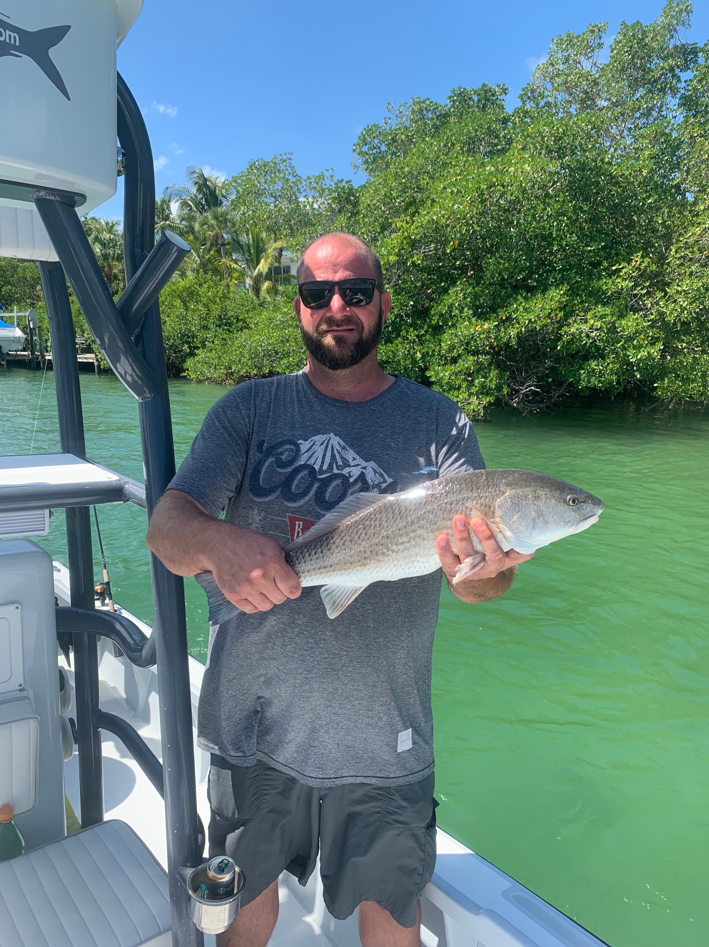

Picture: Lots of redfish kept clients smiling this week

Red October

October is traditionally our best redfish fishing month and this is proving true with anglers experiencing the most wide open redfish action of the year. Schooling reds of all sizes can be found anywhere from the passes to the backcountry. Once you locate these fish it awesome to watch multiple fish follow out the fish you have hooked up.

Both area’s in and around the passes along with mangrove islands and oyster bars held lots of hungry redfish. Choosing where and when to fish these places is all about the stage of the tide. During higher water the best bite came while fishing mangrove islands and oyster bars on the eastern side of the sound. The higher the water the further to the east I have been fishing. During the lower water look for these fish in the passes along with the channels inside the passes.

Once you get this bite dialed in its possible to return to the same place day after day to catch that same stage of the tide and get right back in on this action. Several days in a row this week we set up around the passes and waited for the tide to get just right and these redfish showed up like clockwork and the bite was on. During the incoming tide the water in and around the passes has gone from dirty to clean within about a hour. Once it cleans up you can see these fish laid up.

Pitching baits to hungry redfish in fast moving current in and around the passes has been a blast. Often in would take a almost perfect skip cast to get a bait to these laid up fish. Though once you make and land that perfect cast there is something very satisfying about watching these hungry redfish charge out of the trees and inhale your bait.

Mangrove and oyster bar fishing in the dirty water has been more about covering ground until you locate these fish Cut bait has been hard to beat in the dirty water while live bait has been the better choice in the clean clear water around the passes. Like the passes once you find these fish you can return to the same mangrove shorelines and oyster bars on the same stage of the tide and catch these fish day after day.

