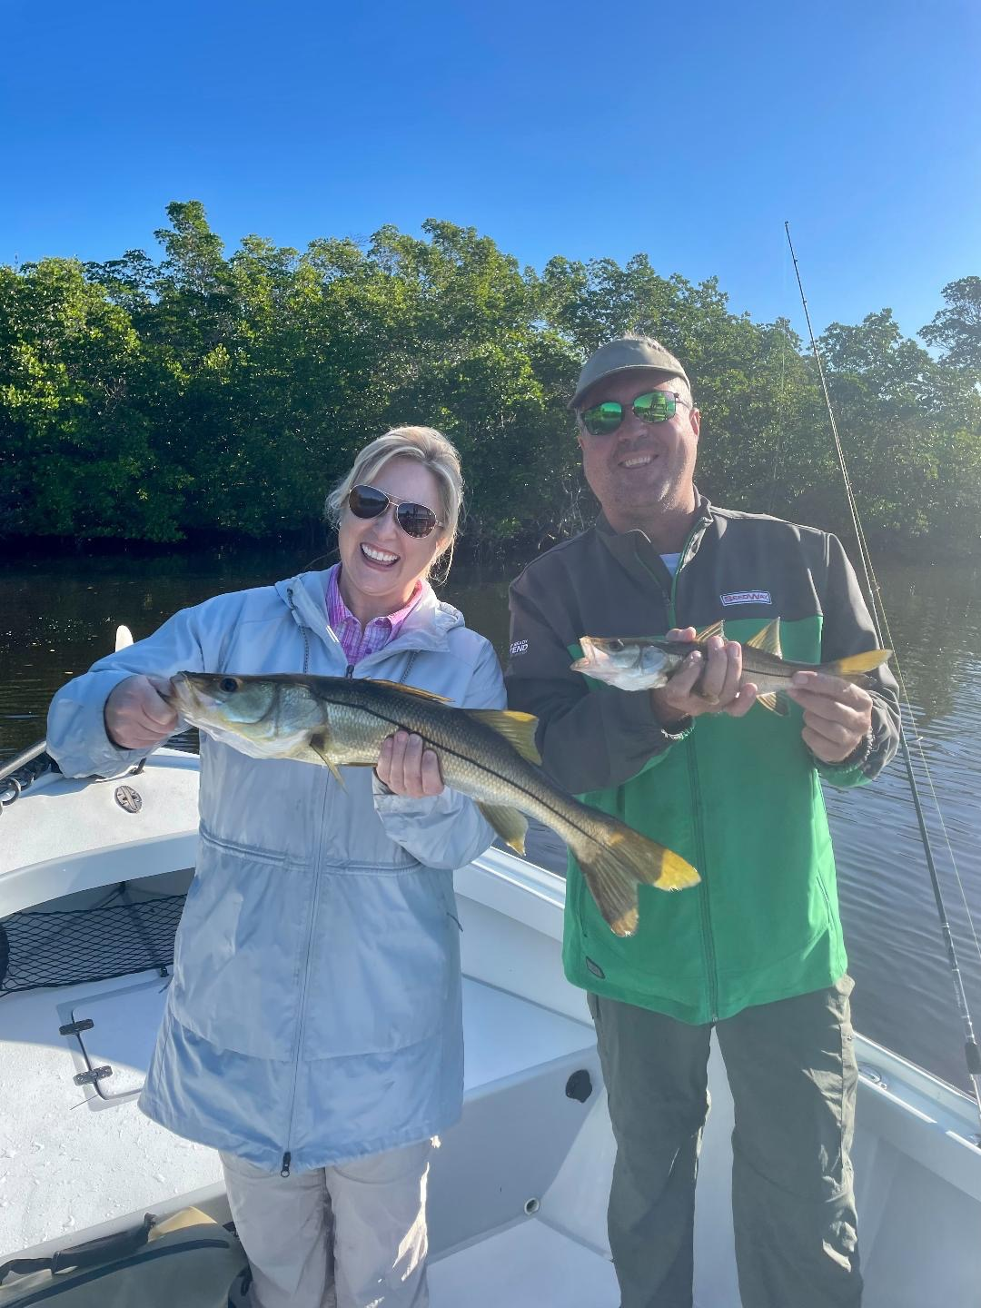

Pieces in the puzzle

Pic: Susannah and Jake both braved the cold and caught lots of snook with Capt Matt Mitchell this week

Just when you think you have a pattern figured out some days you might as well just forget it. Fishing early in the week during the coldest mornings our water temperature bottomed out with a low of a chilly 62 degrees. Taking my normal 100 live shrimp my plan for the day was to find some redfish and maybe even a few sheepshead back in the mangrove creeks while ducking from the brisk north wind. I headed to the causeway to make a few throws of the cast net hopefully to add some shiners to the mix.

Even with a few hundred shiners I was confident any action would still be on the shrimp in the live well. Shrimp are always my go to bait when the water is any cooler than 65. During this coldest morning of the week the last thing I would of thought of doing would be snook fishing. Snook are generally more effected by cold than any other species and often just do not eat.

Anchoring up deep in a narrow mangrove creek I slung out a few live shiners. While taking my rods rigged for shrimp fishing down from the tower, I was amazed to watch snook chasing and popping these baits. Switching up to the free lined rigged rods we immediately starting catching snook. For the entire trip we caught snook after snook while going from creek to creek. Although we did not catch any trophy snook we had a banner day and caught over 30 fish ranging in size from 16-26 inches.

Catching so many snook during such a cold period is just not a normal occurrence. Days like this make you wonder if you really know anything at all. Seems the more time I spend on the water the less I know about what is a forever changing puzzle. Be ready to adapt and change the days game plan to take advantage of what mother nature gives you.

