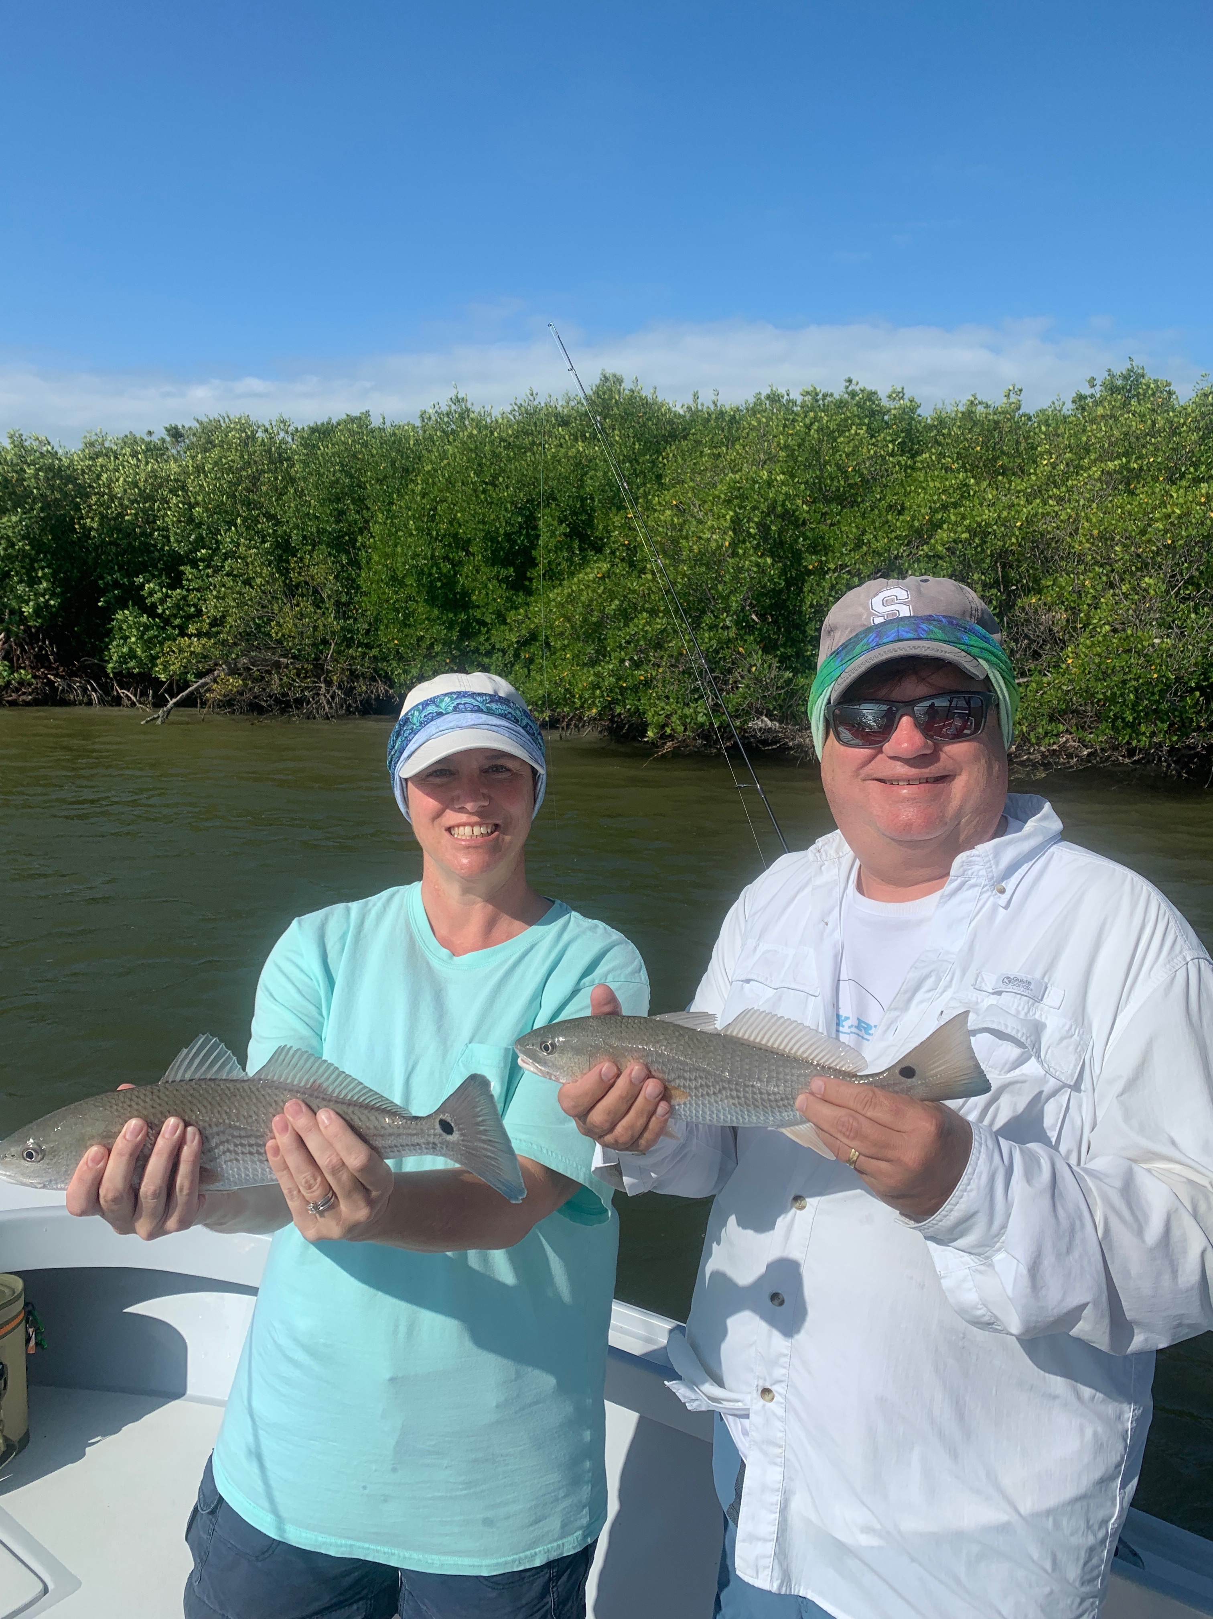

Picture: Pam and Kevin Murray got in on the redfish bite with Capt Matt Mitchell this week

Our first cold front fires up fishing

Our first noticeable cold of the season front finally passed through this week. After the warmest October on record this cool down was much needed to fire up our fishing and give us that much anticipated change of season After a brief period of strong northerly winds the lower humidity and cooler temperatures made for a much welcomed change. Now that we have had our first cold front the gates are open for what is a almost week to ten day pattern of cold fronts.

Out from the beaches Spanish Mackerel, King Mackerel and Bonita will be following the south bound bait migration. Taking a live well full of small shiners out here is a great way to fire up the open water action by live chumming though its certainly not necessary. Most days the live chumming is not needed though it will keep these feeding fish close to the boat and within easy casting distance. Getting in on this action during calmer days will be as easy as finding feeding birds within sight of the beach. Look for surface feeding action right under these birds. Some days this action can be as close as the no wake buoy line while other days its out a few miles.

Once you locate these feeding frenzies it is “run and gun action”. Run the boat up to the feeding fish, shut down and start rapid fire casting. Small heavy spoons are the best choice out here as the bait these fish are targeting is small. As fast you you can work a spoon across the surface these lightening fast fish will chase it down and crush it. Replacing the treble hooks on your spoons to a single J hook not only does a lot less damage to these fish and makes unhooking them much safer.

This week marked the arrival of the first huge flocks of white pelicans which are a sure sign winter has already begun for our northern neighbors. Sheepshead fishing will finally start to pick up as our water temperatures continue to drop. These fish move in closer to shore for there annual spawn. After months of cleaning very few fish its now time to sharpen your fillet knife.

