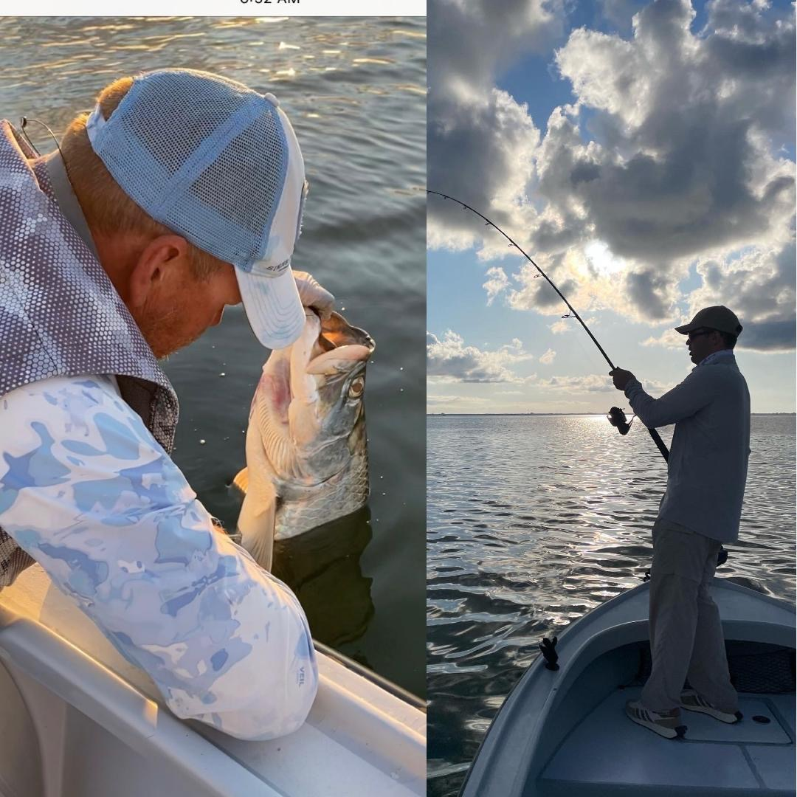

One cast away from being a rockstar

Pic: Start to finish Max from MN got his 1st tarpon this week while fishing with Capt Matt Mitchell.

Being a full time guide for more than 20 years the more time I spend tarpon fishing the more unknowns there are. After a full week of chasing this king of all gamefish during both challenging windy conditions and perfect slick calm conditions it boils down to one bite making a trip.

Early in the week I had long time clients down from MN to tarpon fish for their very 1st time. Slick conditions along with an early morning pick up we headed to a better known spot. With just enough light we slowly trolling motored in as we watched happy tarpon surface to gulp air. Within 10 minutes of arrival, I set up the boat on the line the fish seemed to be traveling and pitched a crab under a float. Before I could get another rod down from the tower we were on. The estimated 60# fish made some crazy runs and trade mark jumps before coming boat side.

Returning to our mark we could still see tarpon everywhere. Making long casts we drifted both pinfish and crabs as we watched hundreds of tarpon slowly making their way through this gap. The wait for the 2nd bite took roughly 20 minutes as another tarpon exploded on the pinfish suspended under a float. Wild jumps and long runs we gave chase before a quick face grab of a roughly 50 pound fish. By 7:41am we were 2/2 and I had extremely happy clients.

The very next day I was fishing with another long time client who had caught a big tarpon with me 5 or 6 years ago on his very 1st tarpon trip. Since then, every year we have tried and just cannot get it done for one reason or another. Leaving the dock at zero dark thirty I had a plan and even a little swagger as conditions could simply not be any better. Pulling into the same place as the day before we were greeted with lots of rolling fish.

We sat for almost 3hrs and despite having these fish roll over our baits simply could not get a bite. At one point I called in a fellow guide who sat up behind me and while throwing the exact same bait caught one right next to me. Moving up towards Captiva Pass for the last hour we danced around pods of 20-40 fish landing baits right on their track without success. We saw many more fish than even the day before though in one day these fish had developed all that can be described as lock jaw.

Fast forward a few days and the mornings gave us that dreaded 15-20 mph winds making tarpon fishing that much tougher. Even during near perfect conditions catching a tarpon is not a sure thing, throw in high winds making them difficult to locate and your odds drop even more. One of my two clients on this trip Jeff had been out tarpon fishing over a dozen times with other people and had never caught one. After spending most of the morning running all over the sound, I had not seen a single fish by 10am and really thought it was going to be another one of those days for him. Making the hail Mary move I set up in a confident spot to soak cut baits for the last hour in hopes of finding a bite.

About 10 minutes in we hooked and did battle with a big shark before it parted ways. Resetting the cut baits after about 15 minutes I noticed one line slowly moving against the tide and lifted it out the holder. As the line became tight, I handed the rod off to Jeff just in time to see a 100 pound plus tarpon sky. Dropping the float buoy, we gave chase as this fish put on an awesome ariel display. Thirty minutes later after a few pictures Jeff could mark tarpon off his bucket list.

After all the days we spend chasing the magnificent tarpon often the success of an entire trip can come down to the matter of getting one single bite. In a perfect world it would always be calm conditions and endless sight fishing opportunities. Lots of days we tarpon fish its far from perfect and getting one bite is what it’s all about. Guiding these fish, you see both disappointed and extremely happy clients based on that one thrilling bite. When tarpon fishing you are only ever one cast away from being a rockstar.

