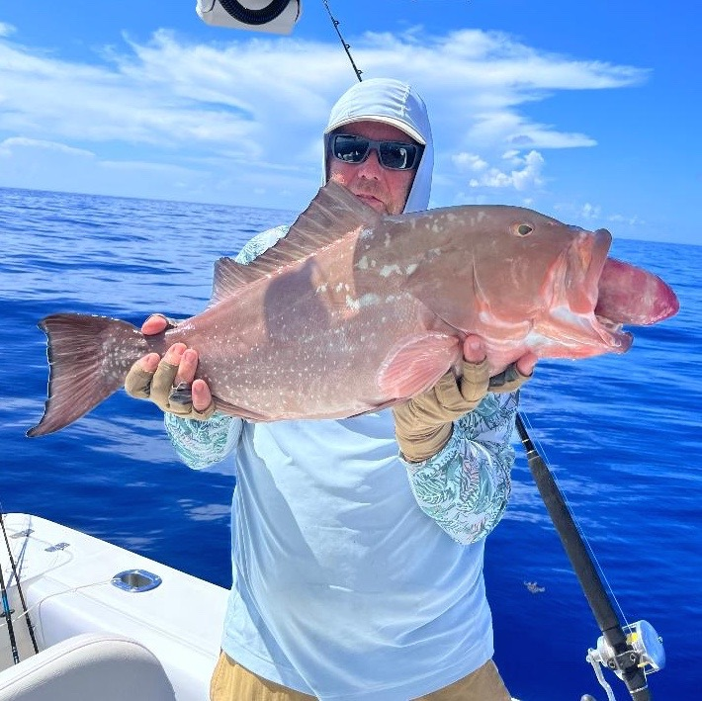

Offshore fun

Pic: Enjoying a day offshore catching Red grouper and Red Snapper

This is the time of year business begins to slow down and its possible for me to go fishing. This week one of my clients invited me to go on an offshore trip. Another Captain along with a mate would be running the boat targeting Red Snapper and Red Grouper. With a great weather forecast and a early start the plan was to head 60 miles out of Redfish pass to some hard bottom he had been catching fish on. Getting to go fishing without having to run the boat and do all the prep involved is a pretty rare occurrence for me.

Once all loaded up, we made the roughly 21/2hr run between coastal showers as we watched land disappear and the water become that amazing purple cobalt colour. I don’t get to go offshore very often and am still amazed how clear and pretty the Gulf waters get once you get well offshore. Growing up here I did lots of offshore fishing back in the days of either drifting or anchoring. This trip would be a introduction for me to offshore fishing with a spot lock trolling motor. This has totally changed the game out in this deep water.

Once on our mark a show of fish we would look for a show of fish on the sonar then put down the trolling motor down. This holds the boat in place and allows you to drop baits directly onto them. This precise method takes the whole anchoring and re anchoring to get properly set up on the mark in wind and tide out of the equation. Being able to quickly and effectively put and hold the boat on top of the marks allows you to fish more places much faster than with an anchor. Once set up we would drop a variety of baits to the bottom and usually get several fish before moving on. A GPS spot lock trolling motor is a game changer for offshore fishing.

Working a few square miles of hard bottom in the 145ft-155ft range almost every stop produced a few quality fish. Though no one stop was on fire we ground out a limit of bigger fish including a few bonus Mangrove Snapper, Yellowtail and even a massive porgy. Our big Red Snapper of the trip was a respectable 14# and our largest Red Grouper 15#. I really enjoyed my day offshore doing something different and getting out of my comfort zone.

