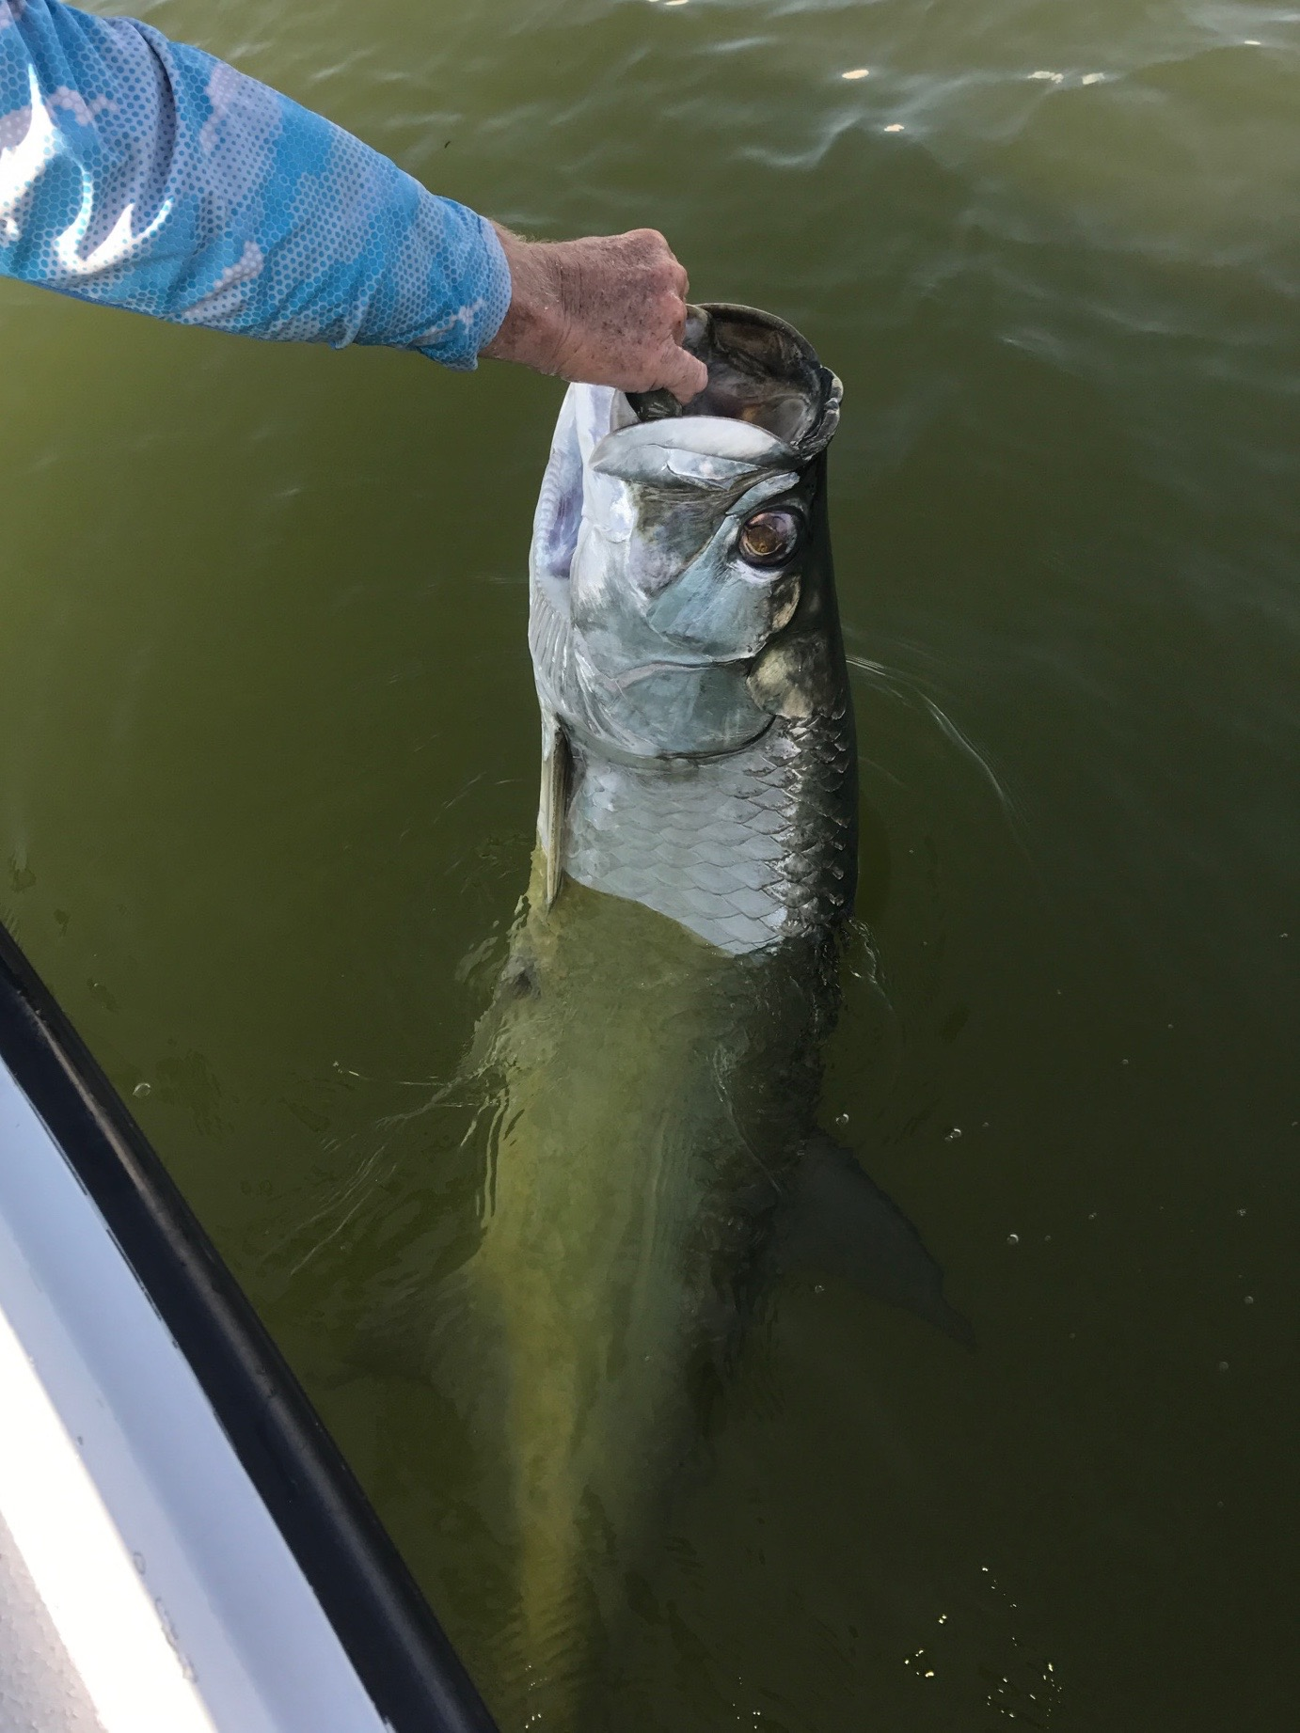

My September favourites are here.

When asked what’s your favourite time to fish my reply never has a second thought: September! The end of August and September are the slower months of the year for my guide service, which allows me to get out on the water and fish without clients. For the next few weeks there are very few boats on the water and the species options are limitless though when conditions are right I choose to tarpon fish.

Unlike in the Spring when tarpon are in the pre spawn mode and often just do not want to eat a bait these post spawn tarpon are around huge schools of small fry bait and feeding better than the do any other time of the year. These tarpon have very little if any angler pressure if any on them and will often stay in the generally the same location for days if not weeks making them easy to return to and enjoy over and over. Unless something drastic happens with the weather pattern to cause the baitfish schools to move on they tarpon pretty much stay put.

Once I locate these tarpon my bait of choice is a large pinfish 3-4ft under a float. Watching these lazy tarpon roll and crash through these schools of fry bait gets your heart rate up even if you don’t even hook one. They often roll right around your bait as you anticipate that magical pick up. What makes one tarpon decide to eat a bait while others will not we will just never know. The average size of these tarpon is right around 50 pounds, which is just perfect. They are strong, fast, jump high and often and only require about a 15-minute battle. Yes there are some larger tarpon over 100# in the bait schools but for me a 50# tarpon is as good as it gets.

My mornings off work this week I’ve been lucky enough to enjoy some of the best most consistent tarpon fishing we have seen all year. I’ve got to watch that big silver flash followed by a giant hole in the water before all hell breaks loose. That first run after hooking a tarpon is just wild as the fish goes airborne time and time again while making long drag screaming runs. If you can keep the fish hooked for the first few minutes your odds of getting a release on the fish just got a whole lot better. The thrill is that pick up and the first few crazy runs and jumps what happens after that just does not matter.

