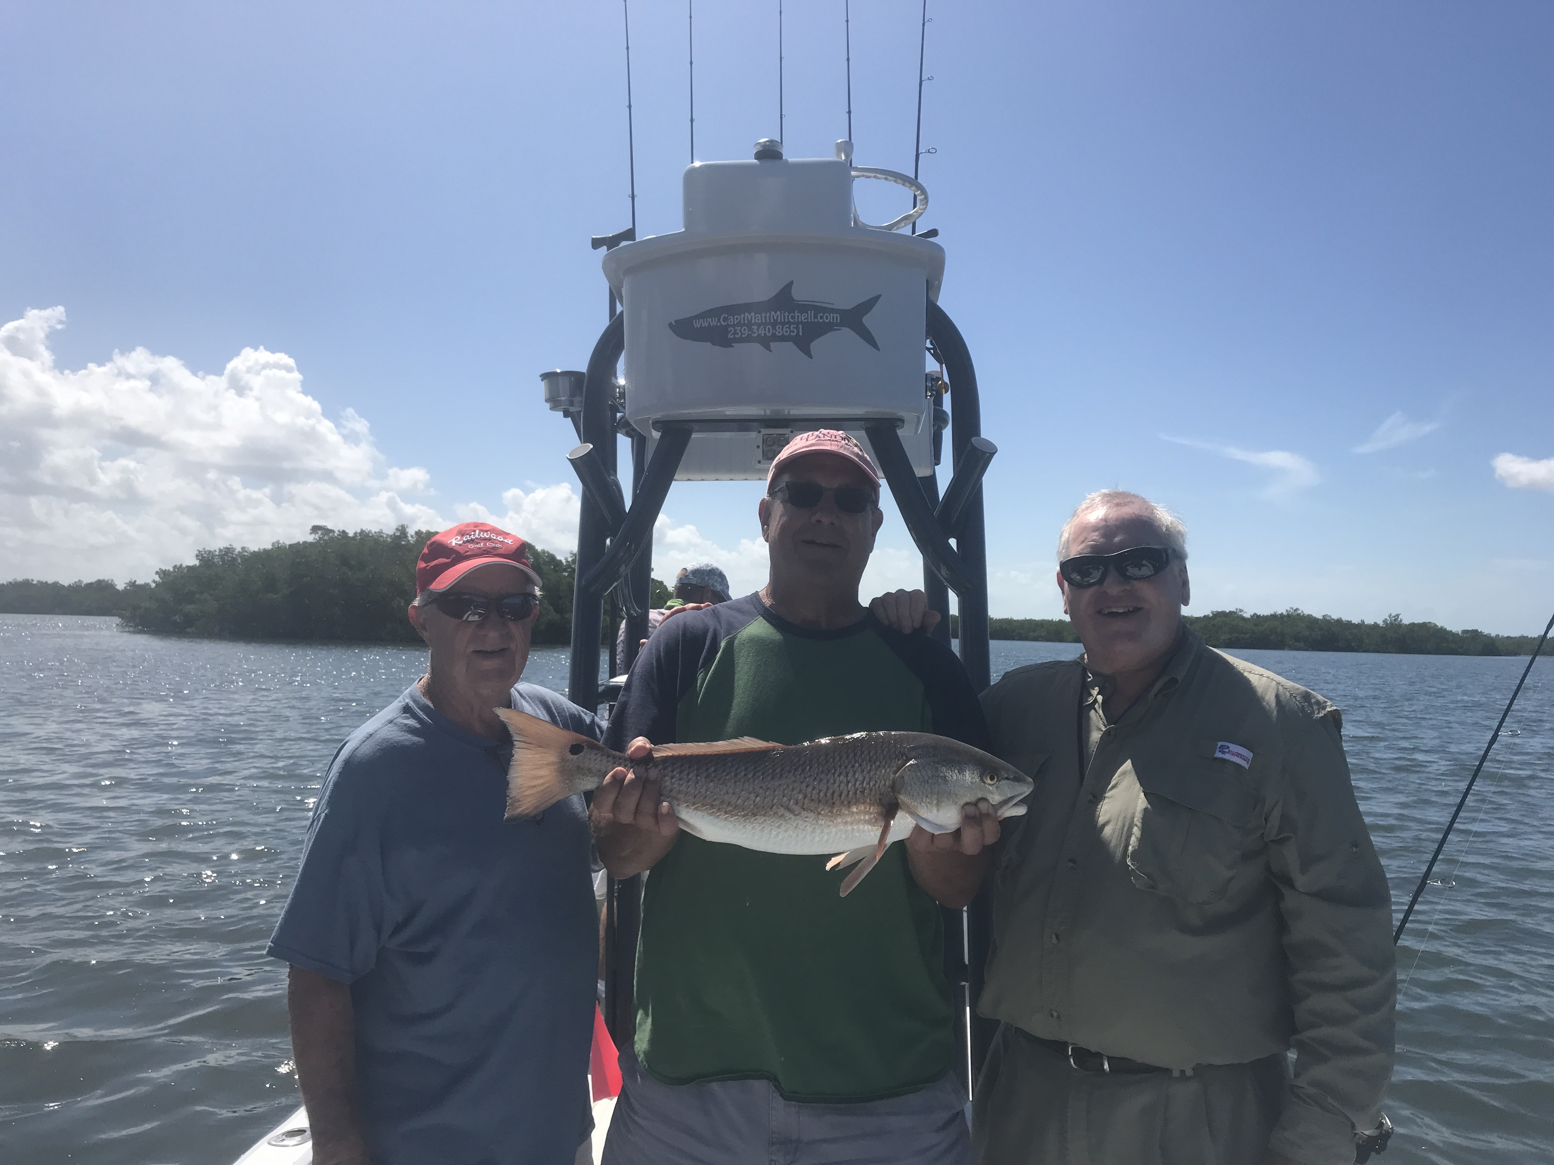

Memorial day wash out

Pic: Henry, Ken and Chuck from St Louis planned on Tarpon but got in on a great back country bite this week

Subtropical storm Alberto put a quick halt for most on getting out on the water over the past holiday weekend. In the days leading up to this rain event, fishing was good unless you were Tarpon fishing. The days I targeted Tarpon even though we found and often sat in rolling fish we just could not get them to go nor did we see another boat hook up. Switching gears and targeting Snook Trout and Redfish action was the call and we where rewarded with some awesome action that made you ask yourself why am I even trying to catch these Tarpon.

Two of the groups I had this week had multiple Tarpon trips scheduled with me and after we had a unsuccessful tarpon hunt I talked them both into targeting Snook, Redfish and Trout which we did with great results. I was lucky enough to get on some of the better Redfish action I have seen in months along with big Snook in the passes and scattered Trout action.

Even when conditions have been near perfect the Tarpon bite has just been tougher most trips than in previous years. The longer I do this, the more I really prefer to Tarpon fish in the fall when there is very little pressure on these fish and they just eat. This week every time you found a few Tarpon, other boats would simply pile in on you and spook the fish., You would see a group of fish come up and roll then they would go down and just never resurface and it was over as quick as that. After a few days of running many miles looking for Tarpon and just not finding any decent numbers of fish its brutal as a guide and really just starts to wear you down.

Low incoming morning tides proved a very productive set up for the passes with a variety of species taking our live shiners. The amount of different species was impressive with Snook, Trout, Grouper, Snapper, Mackerel and Jacks being just part of the bite. As the tide got faster we added a split shot to our rigs to get it down closer to the bottom and the bite kept on going. South winds added to the high tide and let us mangrove fish by mid morning most days. Going mangrove shoreline to shoreline, free lined shiners caught Snook, Redfish and big Trout. Most of these fish on the mangroves where up super tight to the trees and the best action came right after the tide change as the water began to go out.

We are very lucky to have lots of options, and that is one of the things that makes this fishery so incredible. Being able to switch it up and change species was what I had to do this week to keep my clients smiling. Even though they had Tarpon on the brain when Tarpon are just not doing it, it was a better choice to go out and catch some of the other quality game fish that our area offers anglers.

