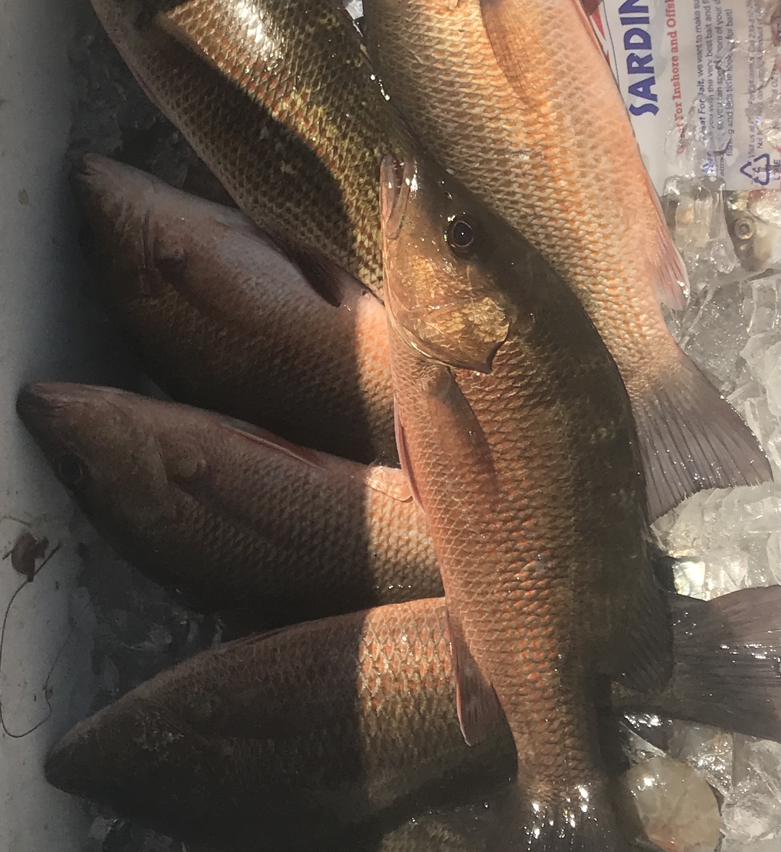

Mangrove snapper mania

Pic: Another successful morning of snapper fishing.

Lots of bait and lots of fish go hand in hand. The amount of hatch bait we are witnessing all through the area is just nuts. Taking a live well full of this generally small bait and live chumming is giving our clients amazing non stop action on a wide variety of species. Everything that swims is dialled in on this plentiful bait. What this bait lacks in size it makes up for in sheer numbers and is easily caught in large amounts.

For clients looking a bag of fillets mangrove snapper fishing has been the call. July and August are our best months for this outstanding annual fishery. Though we have mangrove snapper here all year the average size of these fish is much larger during these hot summer months. Mangrove snapper are very abundant with a 10 inch minimum size and a 5 fish per person limit. Although its legal to keep a 10 inch snapper they yield very little meat, a 12 inch or better fish is much more ideal to fillet.

Live shiners have been the most successful way to catch these fish. It takes small hooks, leader and baits to fool these snapper. Some of the largest ones we have been catching have been out on the open flats. Watch for these fish to swarm and pop on chum in the many white sand holes on the grass flats. Docks and creek mouths have also been a good choice to get in on the action. I’ve had one favorite dock in the southern sound that has a insane amount of snapper its holding. Basically everyday this week its given up a limit of Mangrove snapper. A few scoops of live chum and it just explodes with fish.

All summer long Mangrove snapper are the favorite of my clients who want to cook the days catch. Generally I fillet them describing the flesh as mild, sweet and firm. These fillets can be cooked lots of different ways and will even hold up well on a hot grill. Another option is to cook the fish whole after you scale, gut and gill them. Score the skin and season before you grill, fry, bake or even steam. Cooking the fish whole gives you not only a great presentation it keeps the flesh extremely moist. Many of my clients prefer to simply take the fillets to a local restaurant and have the catch cooked immediately after the charter. I personally can’t think of a better lunch than the fresh fish you just caught.

