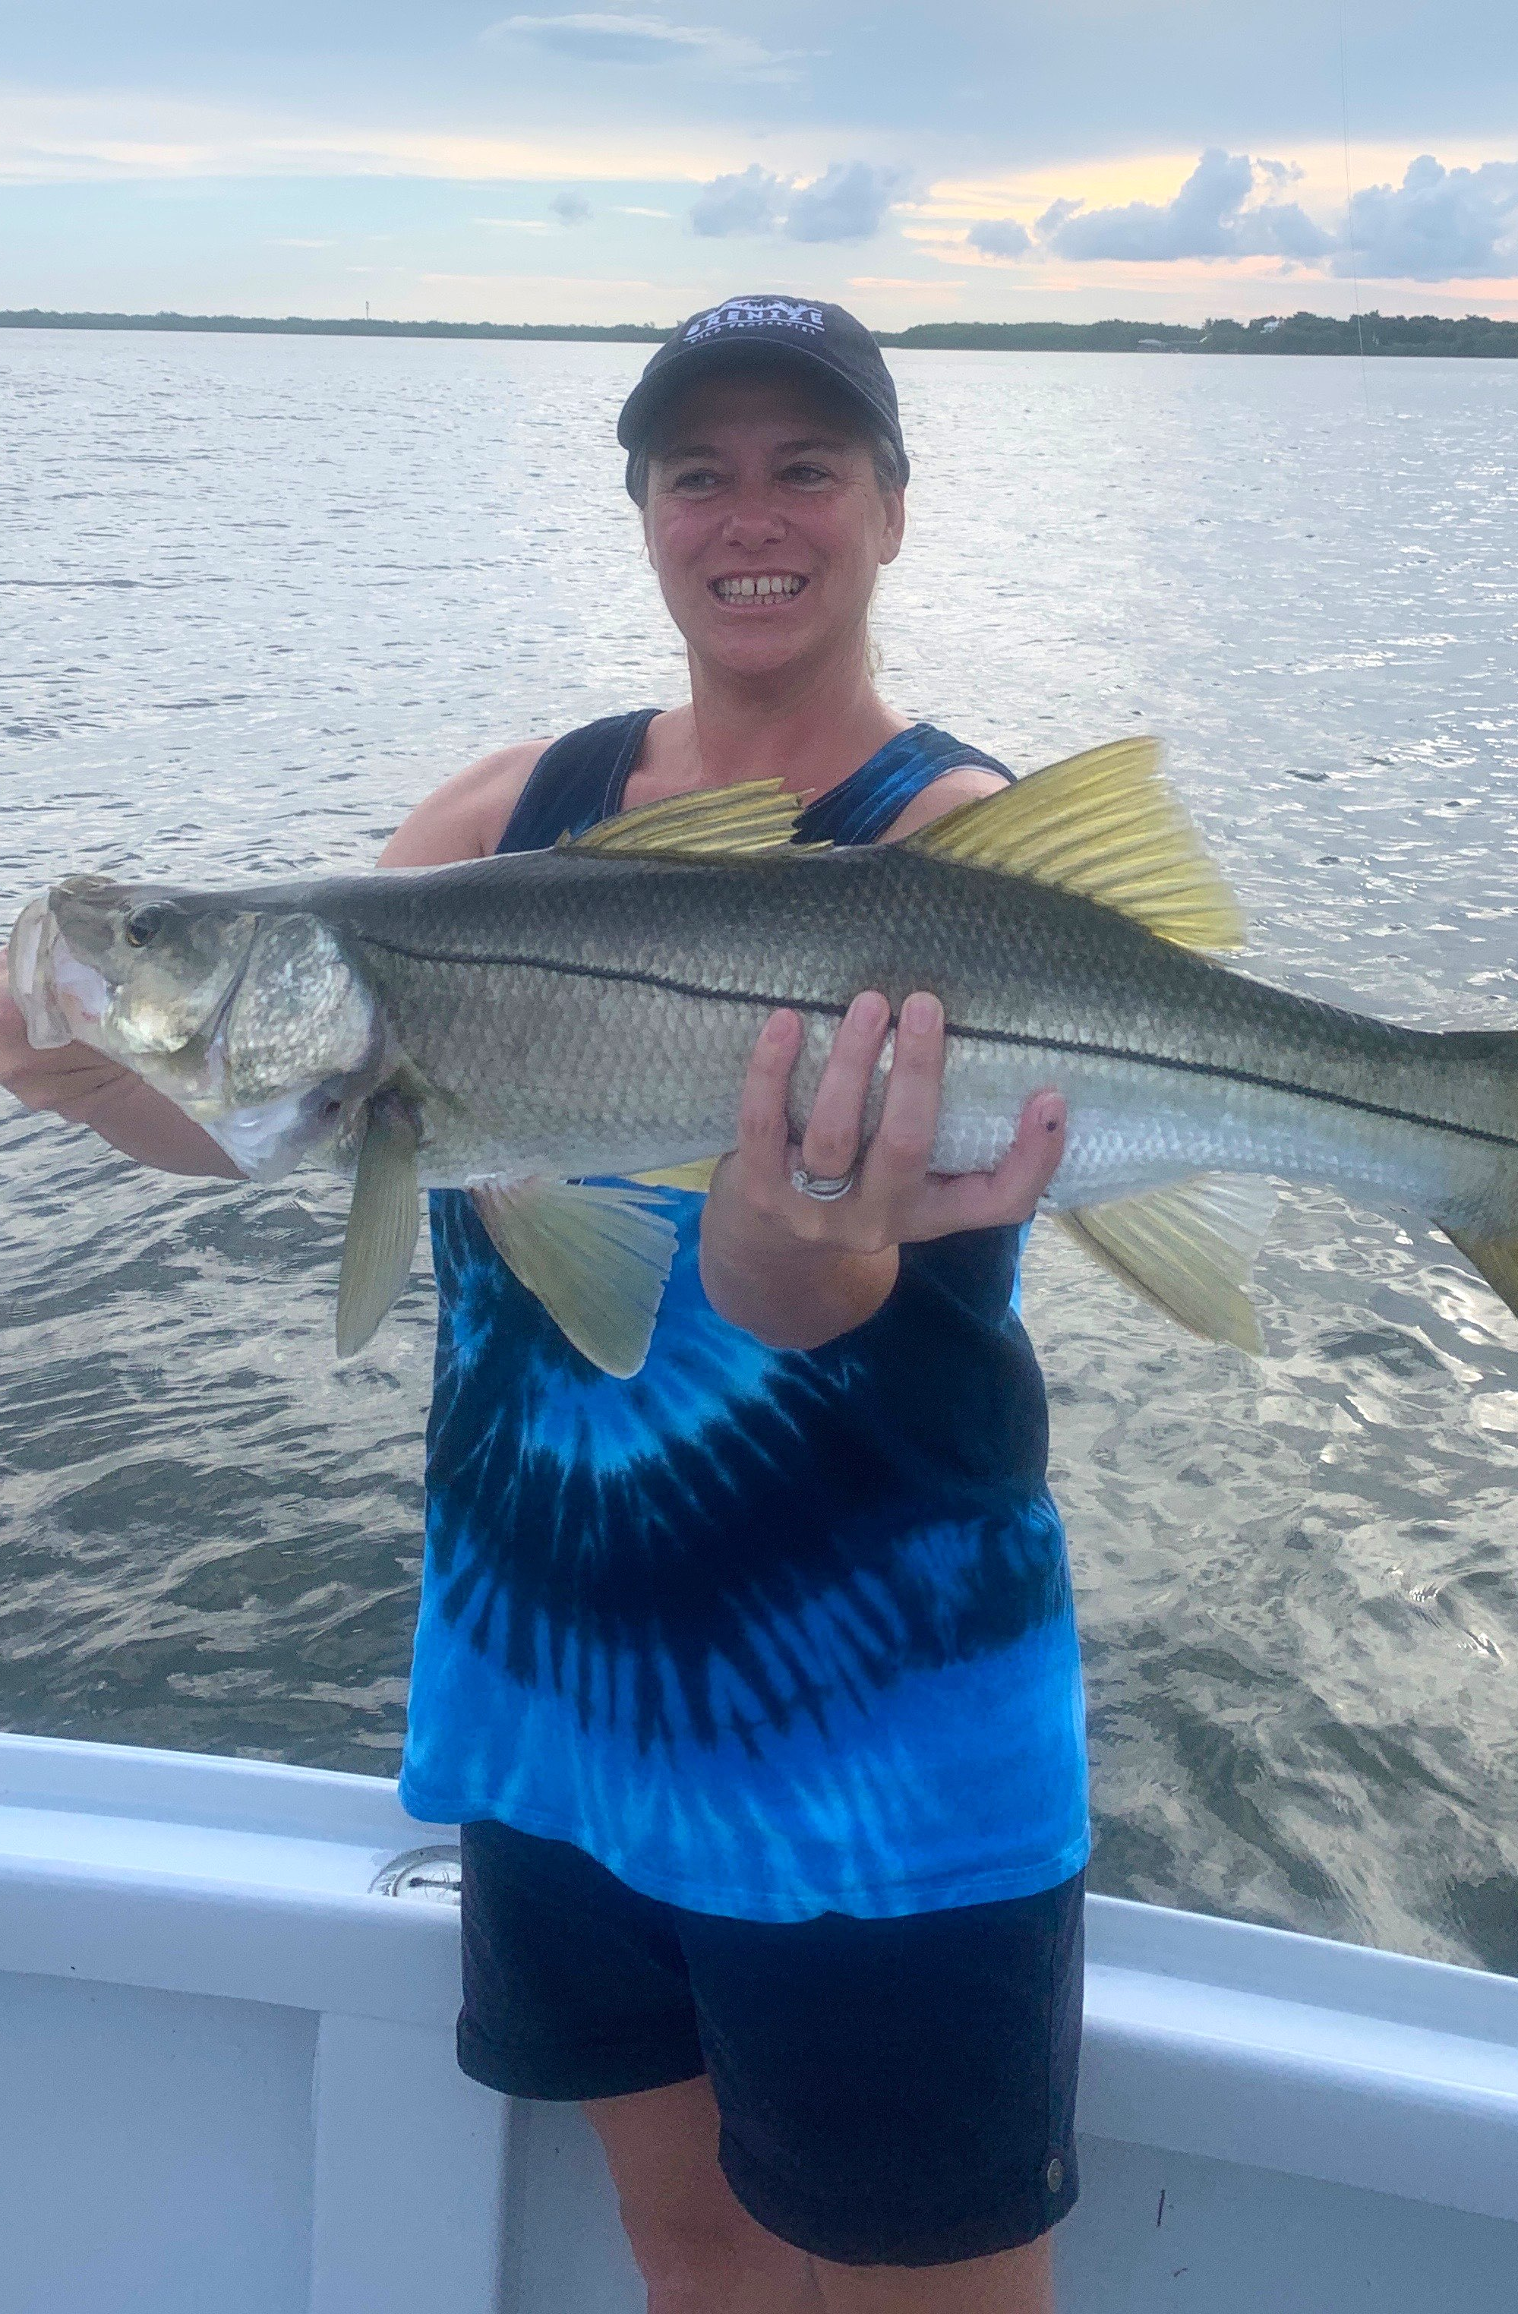

Pic: Pam Murray with a big Snook she caught while fishing with Capt Matt Mitchell this week.
Make a plan for success

Great morning tides this week meant amazing fishing. Having a game plan based on the days tide was s a major part for successful fishing trips. The days plan no matter how well thought out can often evolve during the trip. This proved true all week with unpredictable morning coastal showers. Despite being on some fish at the northern end of the sound we opted to fish some places closer to home until the weather improved. This plan panned out well catching my clients several Pine island slams that included quality Snook, Redfish and trout.

I always have a game plan before I pick up clients. Ideally I like to start out a trip with high activity fishing and get everyone on the board before upping the difficulty level and targeting larger species. Trout on the flats have been ideal to get everyone catching fish, this fast paced bite gives everyone confidence and takes the pressure off. In these high action area’s of the sound always have a larger rod ready rigged with a float and a large pinfish or even a chunk of fresh ladyfish. Some days we are lucky enough to have tarpon and larger sharks working these same area’s where we are catching trout.

Being on the water daily means being able to return to places you caught fish on the previous day. Going back to these places on the same stage of the tide is a major advantage to catch fish day in day out. Taking what you have learned over the past few trips are big pieces to the puzzle.Wind and weather can quickly put a stop to a location no matter how good the good the bite has been in previous days.

While moving locations keep your eyes open for feeding birds as they are a sure sign of feeding fish. Once located this surface action will offer anglers a variety of species..Plan your day not only around the days tide but also the weather forecast. To take full advantage of your time on the water have not only a variety of tackle but also of baits. Being able to quickly pounce on a opportunity can make or break a trip. Try to stay open minded while sticking to the days plan and see how the trip plays out.

