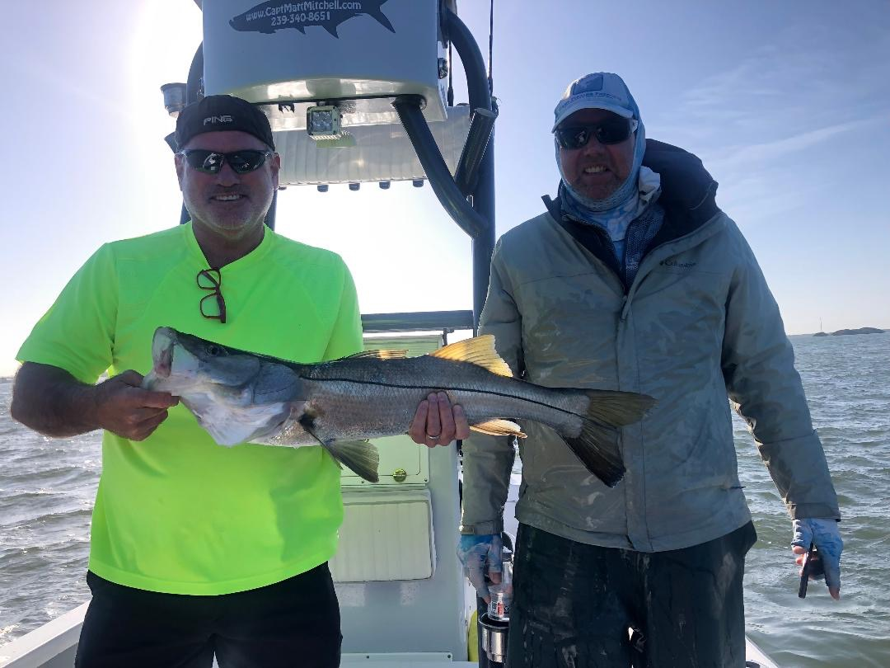

Just dumb

Pic: Bryan Thomas with a pre front windy day snook caught while fishing with Capt Mitchell this week.

I cannot state enough the importance of timing around cold fronts. The past week this played out in all that can be described as a crazy wide open bite, at times it was just dumb. Don’t get me wrong fishing all week during the south wind was very consistent with lots of fish caught on each trip. This bite peaked with a 4th of July like finale in the last few hours before the front went though

Let me describe the timing and how this amazing bite played out. With yet another front forecast to come through last Thursday each day the timing on this was pushed later and later in the day. Strong south winds and a slow moving incoming tide turned out to be the perfect set up with some of the highest tides we had seen in weeks. With a falling barometer no matter where we fished the bite was on.

Picking windblown islands and oyster bars around the southern end of Pine Island every stop had hungry fish. From snook over 30 inches to redfish and even mid 20-inch size trout days like this don’t come very often but when they do its pure magic. Getting out and enjoying this crazy action is all about timing with the bite only getting better and better until the front passes through.

Come Friday morning the front had passed through with winds switching to north, big high pressure made the bite much more like work than just the previous day. Getting tucked away in mangrove creeks out of the wind we continued to catch snook and trout though the action was a trickle compared to the days before. Each day after the front the bite improved though we are yet to see south winds and high water again yet.

With everyone running some kind of weather app on a smart phone anymore I often get contacted by clients concerned about the weather up to even a week out. With all the forecasting technology still more times than not the exact timing of these fronts or weather events is not precise until just a few hours before. If you’re lucky enough to get that magic weather window of an approaching weather event jump on it. As guides we simply don’t take clients in dangerous or bad conditions which often means making the call to cancel or go the morning of the charter. If the timing plays out in your favour on approaching weather event it more often than not can lead to another dumb day fishing.

