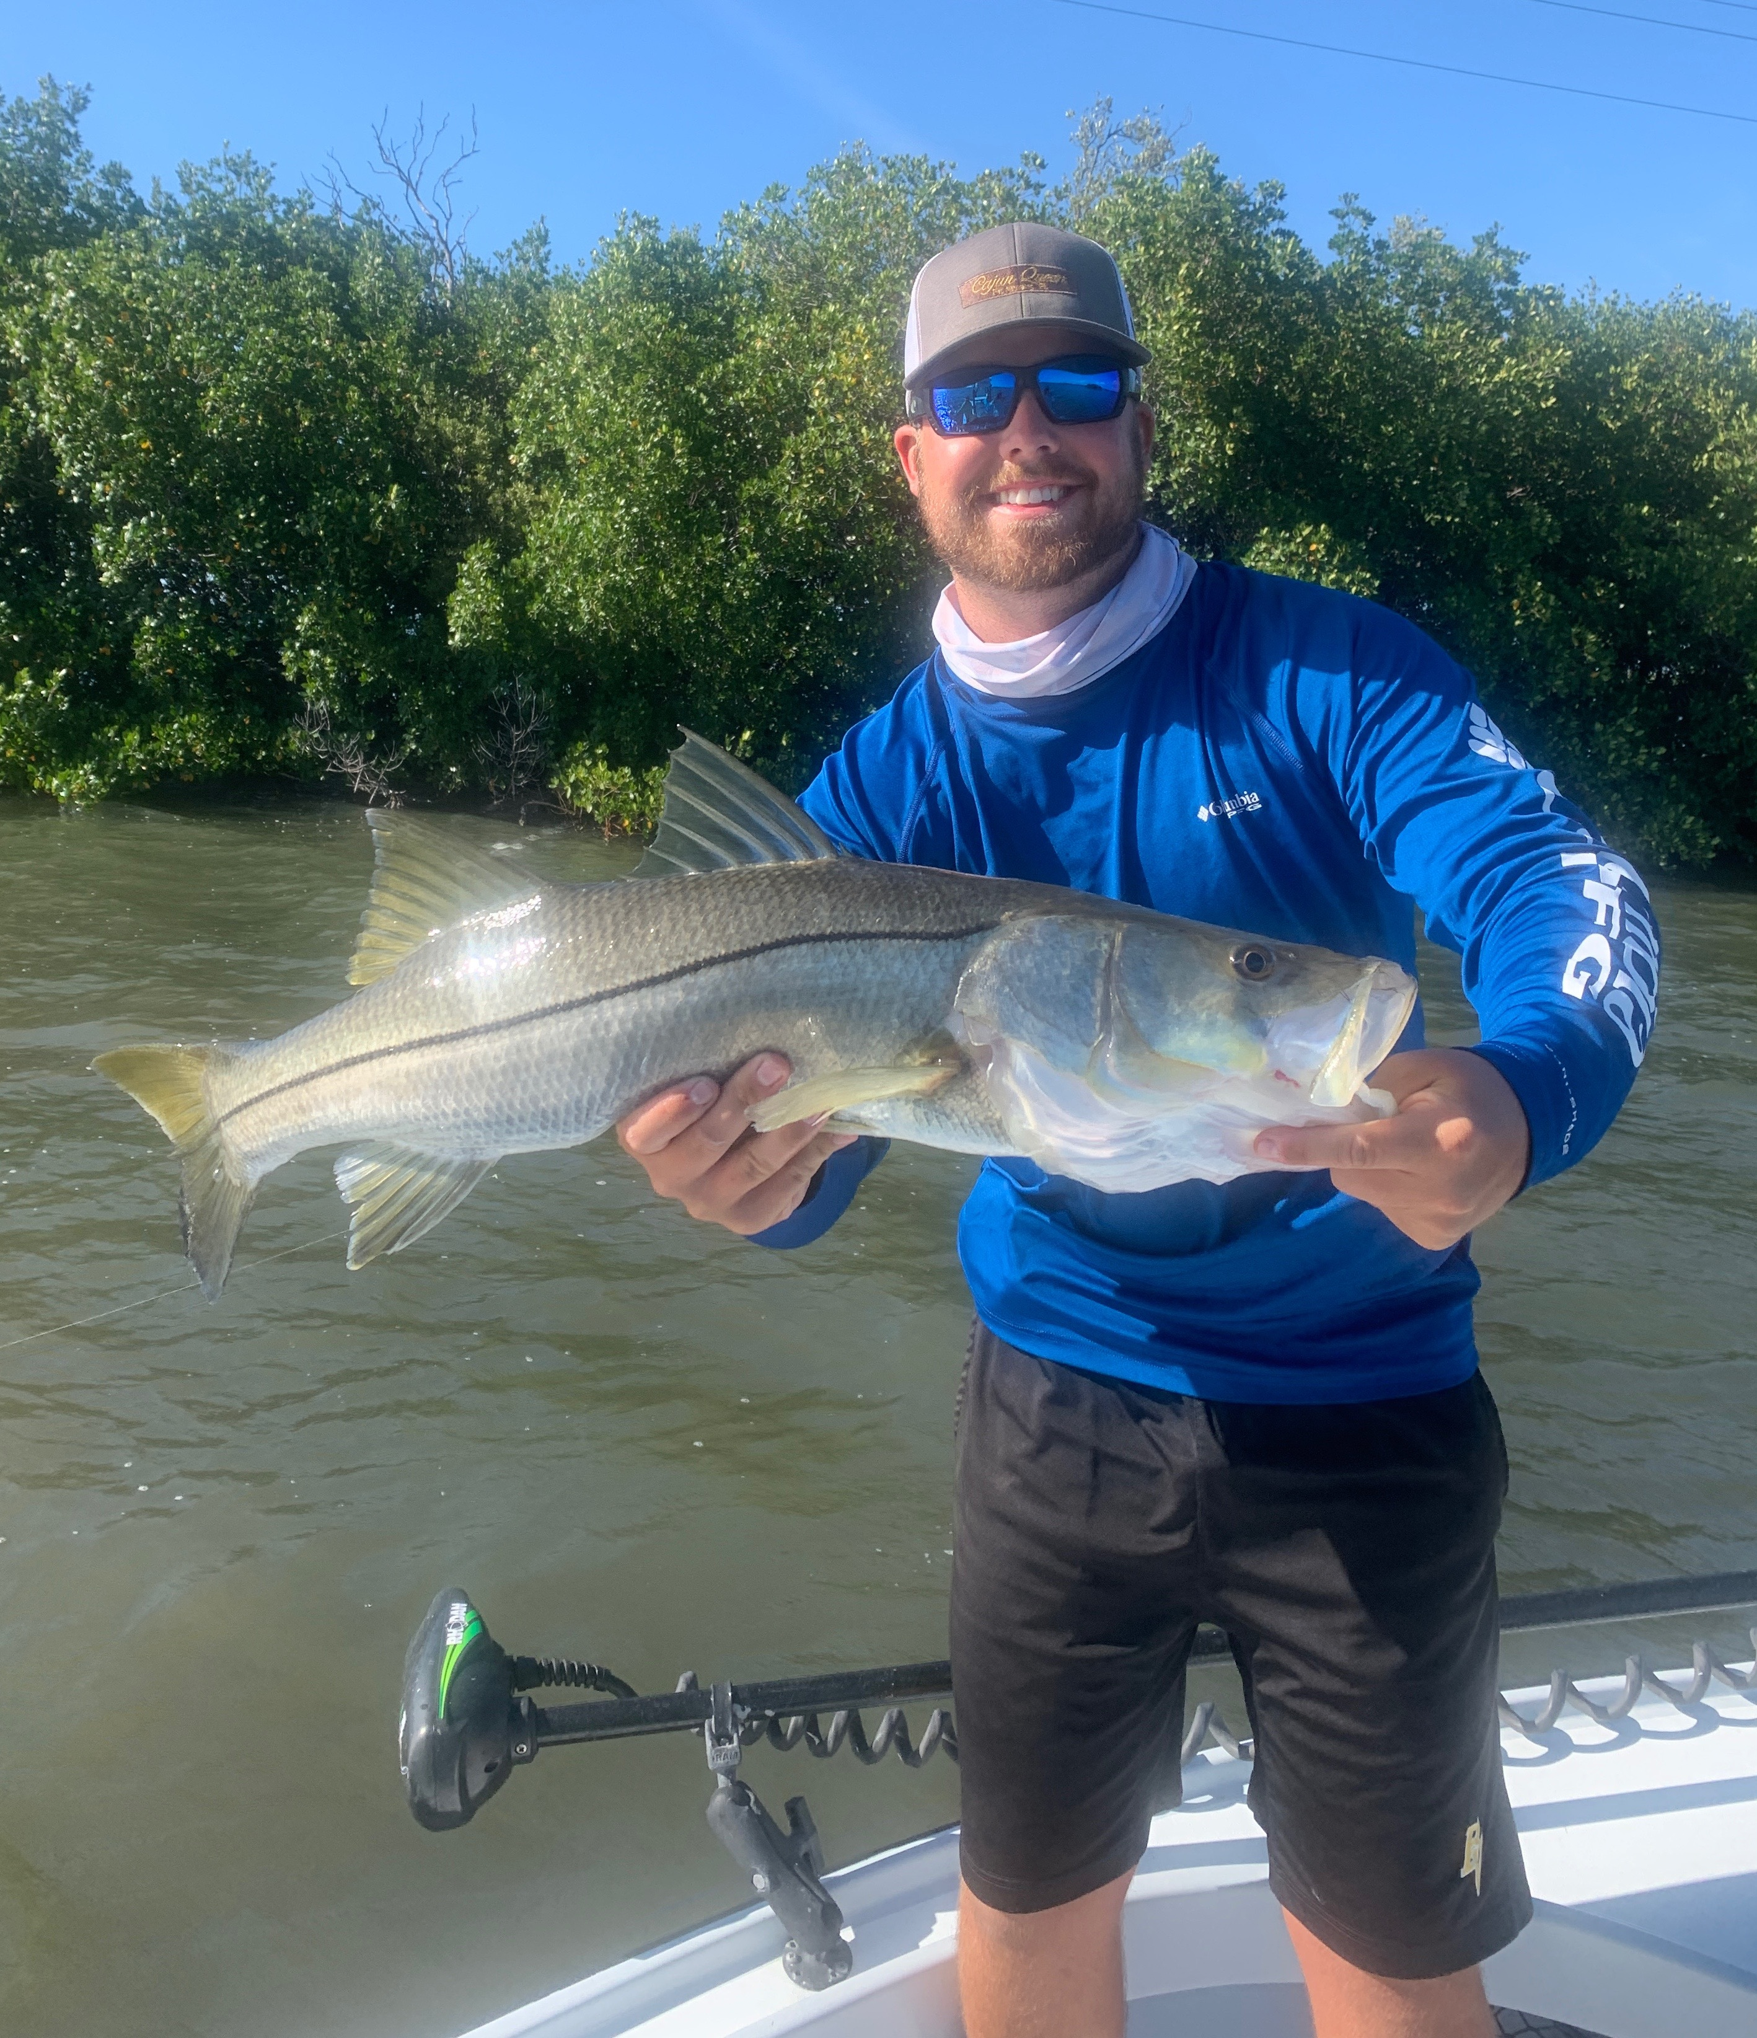

Instant gratification fishing

Pic: Charlie got this big Snook on a afternoon trip with Capt Matt Mitchell this week.

March started off with a bang as clients enjoyed amazing Spring like snook and redfish action. With warming water we caught fish from the back country creeks, oyster bars, mangrove islands in the middle sound and all the way into the passes. Slow to no tide days made things a little tougher though we still managed respectable outings.

Jacks, ladyfish, mackerel and even a few blue fish have begun to show up all through the region. Look for feeding birds both in the sound and around the faster moving tide rips just outside the passes. Lighthouse point was on fire this week with the edges of the long sand bar that drops off to deep water giving up a variety of these fish. This fishing can be done very productively on both small diving plugs, spoons, plastics and my favorite a small buck tail jig.

Flats fishing really lit up this week with lots of trout being caught out in 3-5ft of water. Grass flats with sand patches from Chino Island to Demere key where a great area to bend a rod. A soft plastic on a 1/4 oz jig head was all it took. Another option was a popping cork rigged with the same soft plastic jig roughly 3ft below it. Drifting was the best way to locate these fish then simply anchor up.

During higher periods of the tide snook and large trout could be found around the many oyster bars throughout our water ways. When picking a oyster bar I like to fish the side that both the wind and tide are pushing against. Pitching live shiners I have my clients gently lift and reel. This method is just like slow fishing a soft plastic jig and keeps the bait fish from tangling in the grass. Making the bait flutter down had these fish feeding often blowing up on the surface.

Mangrove creek fishing was my daily choice. Some of these magical creeks went off with snook of all sizes along with some big redfish. These narrow tight winding mangrove waterways may be my favorite place to catch fish this time of year. To be successful in this environment it requires a really accurate cast. When you do land that perfect “money shot” the bite is explosively quick, sometimes as faster than you can close the bail of the reel. Once your hooked up steering these fish out from around mangrove limbs can only be described as full combat fishing. Talk about instant gratification, this creek fishing is it.

