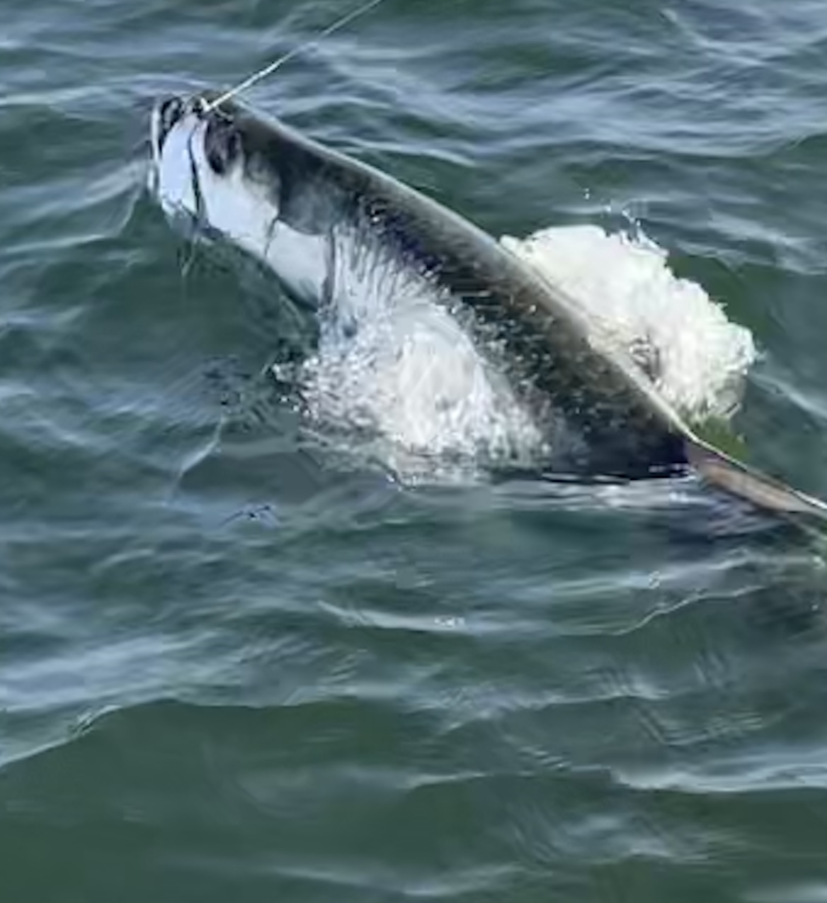

Hungry post spawn tarpon

Pic:Fall tarpon fishing is heating up

Our little area of the world has been famous for over 100 years for its amazing Spring Tarpon fishing. Pre spawn tarpon show up usually early April and stack up in Boca grande pass like no other place on the plant. Along with all these fish come all the boats and anglers chasing silver.

By mid June most of this tarpon craziness has slowed as our water temperatures get in the high 80’s. The majority of these highly migratory fish continue pushing north up to the panhandle of Florida. We always seem to have some fish here all summer though the numbers drastically decrease from the prime time of April and May.

During Spring you often get a lot of shots at rolling fish. We get many days that we sit in hundreds of fish and no one gets a bite. Simply put these Spring time fish have love on the mind and many times just don’t eat. This is so frustrating watching tarpon roll all around and even over your baits while refusing to play. We do have days in the Spring that the bite goes off though the frustrating days far out number the great days.

Post spawn Fall tarpon fishing is the opposite, not as many fish though these fish are ready to eat. Starting in September until we get our first hard cold front that drops water temperatures into the low 70’s is my favorite tarpon fishing of the year. Not only are there far fewer boats targeting these fish they will eat most offerings. Wide open mornings of jumping 5 to 10 fish are common when you locate these hungry cooperative fish.

Find the bait and the tarpon will be close by. Before these fish migrate out for winter they are packing on weight and often gorging with abandon. They feed in and around the masses of glass minnows and fry bait. This set up seems to be their Fall favorite forage. Find these bait schools along with ladyfish and mackerel in the mix and most of the time the tarpon will be there.

Places to start your search include the beaches from Knapps point north. Sanibel rocks has been amazing the past few years with these fish being here for months when the weather is stable. Ft Myers beach south to Bonita beach can also light up. The open water in Charlotte harbor along with the east and west walls are famous for the fall tarpon fishing in the dark rain stained water. Look for feeding birds to show you the way to the schools of bait. Once you locate these tarpon it’s possible to return to them for days if not weeks if there are no drastic weather changes.

After not targeting tarpon since mid June it felt good to locate these fish again. Sitting and moving around these fish they did not disappoint as we managed to land 3 out of the 4 we hooked. These fish where aggressive and ate like Fall tarpon should. Every time we got a open shot to cast a bait to a rolling fish it resulted in a hook up.

