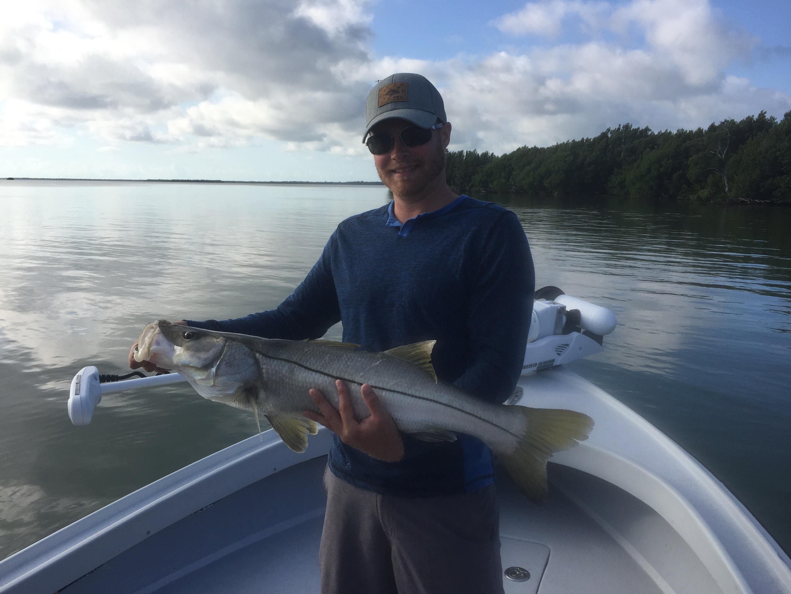
Hot Enough?

Pic: A early morning snook caught mangrove fishing with Capt Matt Mitchell.

Mid day summer heat shuts everything down, both anglers and fish become slow moving and lethargic. Early morning, late afternoon or even night fishing is a great option as the mid day summer heat is just oppressive. At first light shallow water fish are most active then gradually slow down as water temperatures creep into the 90’s by mid day.

As always this time of year huge schools of white bait including a mix of small shiners, small threadfin herring and Spanish sardines have shown up inside the passes. This small bait is easy to locate and catch, just look for feeding pelicans. It makes not only great live chum but when rigged up on light leader and light hooks will catch just about everything that swims. I like to pick through this bait as I catch it saving just the scaled sardines as the other stuff quickly dies off. With our water temperature so warm don’t over crowd your live well as everything will die off.

Deeper cooler water in the passes offered anglers the best opportunities during the day as this water just stays just a little cooler. Gag grouper and mangrove snapper action has been non stop in the deeper passes. For Gag grouper use larger live baits with enough weight to fish straight up and down giving you the best chance to pull one up from the structure. Mangrove snapper have great eye sight and require down sizing your gear: #2 hook, 15# leader, small split shot and small bait. Small shiners fished close to the bottom in the deepest sections of the passes caught limits of Mangs in both Captiva and Boca Grande passes.

Deeper docks near these same passes with fast moving current also held lots of mangrove snapper. The problem on many of these docks is hungry aggressive dolphins that will grab your hooked fish before you can get it to the boat. One favorite dock up by Captiva pass became almost un fishable as a dolphin which I would guess has been fed by people made it just about impossible to land a mangrove snapper. After we lost a few fish to the dolphin even though the bite was going off we had to pick up and leave.

Many of our passes are still loaded up with lots of snook. During the outgoing tide I ride the edges while looking from the tower until I spot these fish schooled up. Setting up and casting small free lined shiners to them brought the best snook action of the week with clients catching fish after fish on small baits. The big bait snook bite has slowed during the mid day hours but these smaller snook still eat small shiners at just about anytime of day.

Fishing the deeper grass flats from Redfish pass to Captiva pass continued to be some of the best open water mixed bag action. Small shiners and pinfish rigged 4-5ft under a float while drifting in 6-7 ft of water not only caught trout but small blacktip sharks and Spanish mackerel. Once you get the fish feeding its possible to sit in one place and catch fish after fish along with daily limits of trout ranging from 17-22 inches.

