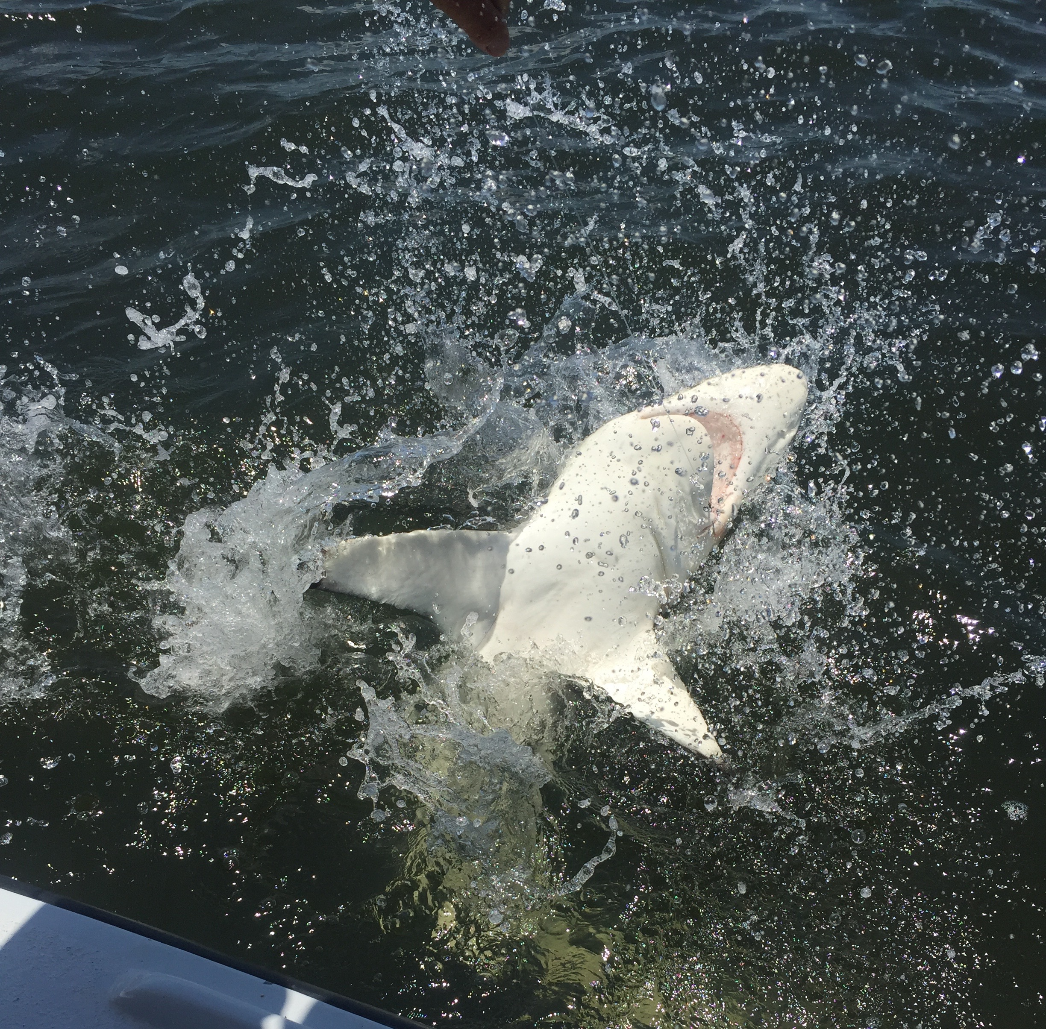

Picture: Sharks are only part of a mixed bag of species we enjoy all Fall.

Hints of Fall fishing.

October is a big transition month for fishing in our area and generally the first noticeable break from the high humidity of a long steamy summer. Pelagic fish such as Mackerel, Bonita, ladyfish and Jacks have already started that move down the beaches in hungry schools as our water temperature has cooled just enough to fire off the annual southern bound bait migration.

Over the past weeks we are seeing lots more bait appear in the bay as the change of season has begun. Snook and Redfish are taking advantage of this huge amount of bait and begin to pack on extra calories before the winter cool off. Although water temperatures have not dropped enough yet to push these fish back into the mangrove creeks yet Snook are making that slow move in from the beaches and passes of summertime to oyster bars, mangrove islands and shorelines throughout the middle sound.

Catching 50-100 snook on a charter once you locate them has not been unusual. Sitting on one favorite oyster bar in the middle sound this week for almost a hour my anglers had a snook bite on almost every cast while throwing live shiners. This kind of action is what our fall fishing is all about. Though the majority of these snook are in the 20-24 inch range I can’t think of a better way to start a trip off than with multiple double snook hook ups. Sprinkle in a few keeper redfish in these same area’s and you have a very memorable day on the water.

Dark stirred up water from what seems like never ending hurricane Irma run off along with a windy week has not slowed the bite if anything its made it better. The amount of bait and life in this nasty looking coffee colored water is amazing, talk about nutrient filled water.. In this dark stained water gamefish feed almost by smell and vibration much more than by sight.

With our water temperature now in the low 80’s fishing action will only continue to improve. I’m often asked what water temperature our best fishing happens, i’d have to say in the mid to high 70’s which we get to experience in both the Spring and Fall. Despite how bad our water looks the fishing when I have been able to get out due to the wind and weather issues all week has been really good.

The mixed bag of species available to anglers will only continue to get better as we move further into Fall. Be prepared with a variety of bait and tackle when heading out to take full advantage of what a days fishing may offer. You never quite know what species may appear from day to day during this exciting time of year. From Tarpon to sharks, Cobia and king mackerel every species that visits our area is on the table for the couple of months and being prepared when a opportunity arises is often the difference between seeing and catching.

