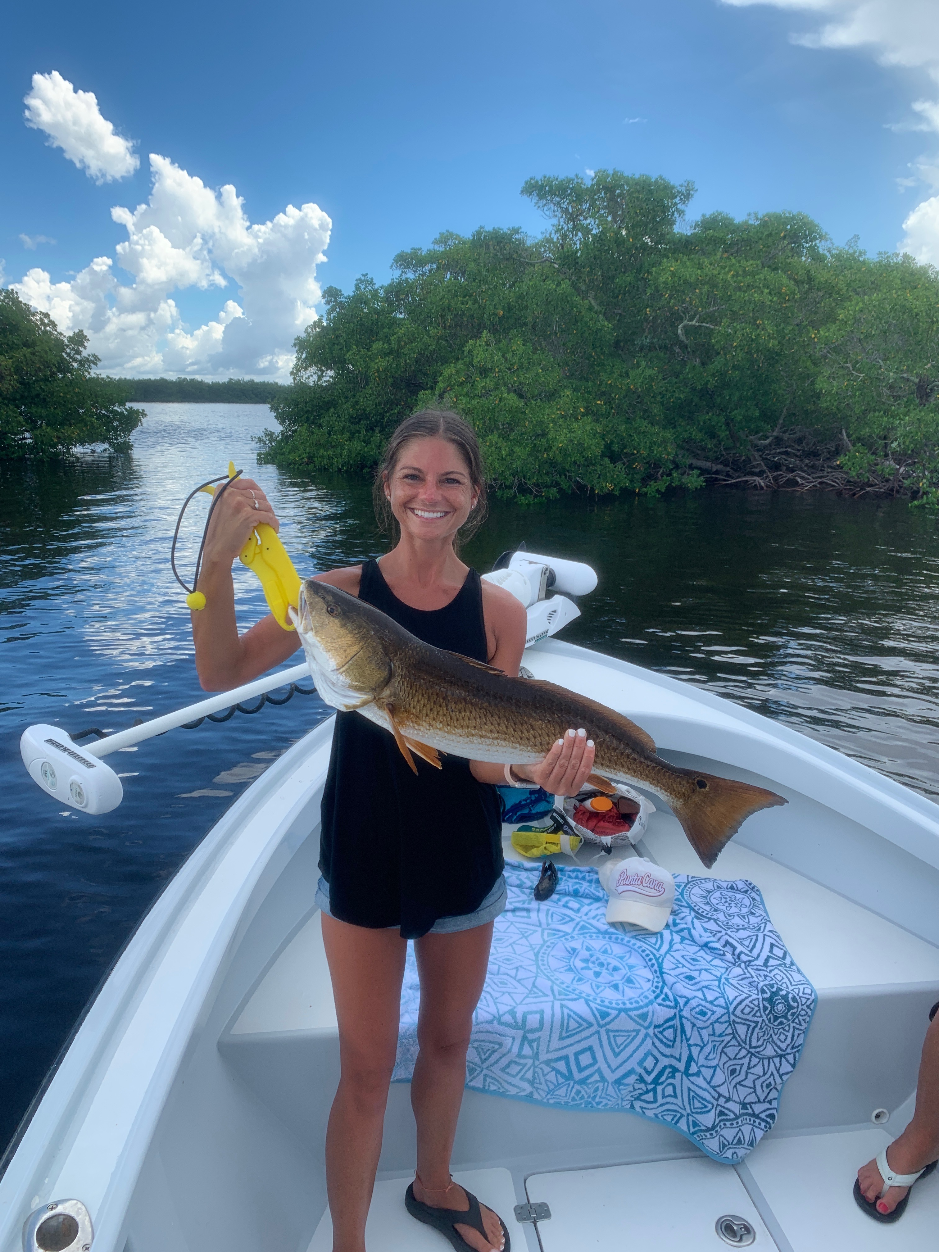

Pic: Abby from Illinois got in on the redfish bite this week while fishing with Capt Matt Mitchell

Fishing more predictable than Hurricane Dorian

Despite the approach of hurricane Dorian I resisted the urge to become glued to the TV and got in the last few scheduled charters before the weather shut us down over the holiday weekend. Some of the highest tides of the year also know as King tides made for some of the most amazing redfish action I have seen in years. Unfortunately, king tides are not such a great thing when it comes to an approaching hurricane.

The best redfish bite for me has come while bouncing around mangrove islands in the southern end of the sound during the last few hours of the incoming tide along with the first few hours of the falling tide. Some days locating these fish has taken a little more patience than other days but once you locate them the result has been the same with non stop redfish action. At times we managed double and even triple hook ups on redfish ranging from 20-30 inches.

Some days finding this redfish bite meant working mangrove shorelines by moving only 50 yards at a time and grinding it out. Cut ladyfish and tail hooked live pinfish where the baits of choice. If you don’t hook a redfish within 5 min its time to pick up and move down the shoreline. Don’t get disgruntled as the school of redfish your hunting can be as close as the next point. Once you do find them the bite is as quick as you can get a bait to them. Often times hooked fish will have other redfish follow them out all the way to the boat.

Mangrove snapper fishing continues to go off in the sound with these fish being around the large schools of fry bait. Red light shoal and Captiva rocks have been loaded with what has to be thousands of Mangrove snapper. Small light wire hooks, light leader and small shiners have been the set up to catch limits of these tasty fish. Mixed in with these snapper are all the trout you could ever want to catch. Seeing what seems like never ending trout all over our sound is an awesome thing.

