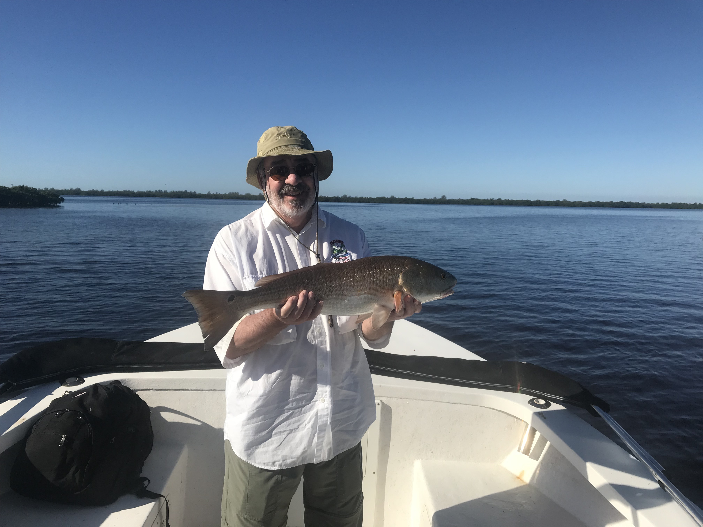
Picture: Mike Kelly from MO with a top of the slot redfish caught while fishing with Capt Matt Mitchell this week.

Fishing action rebounds quickly.

Weather played a major role for fishermen early in the week as cold mornings and strong winds pushed any kind of fishing action back deep in the mangrove creeks. As the week progressed temperatures rebounded and fishing action quickly got better. A 10 degree plus swing in water temperature over a weeks period is really not that unusual this time of year and if you learn to understand the movements of the fish you can still consistently catch them.

After being blown out early last week due to extreme wind and a second major cold front my expectations were very low once back on the job as we were seeing 62 degree water temperatures. Heading back into sheltered mangrove creeks I was pleasantly surprised to catch lots of small snook and mangrove snapper. This was at least enough action to keep my anglers busy for a few days until the warm up . With a gradually warming weather pattern each day fishing options improved and we slowly began to make the switch and start fishing more out in the open. We followed the fish out into the sheltered bays and mangrove creek entrances and points as they gradually moved out of the creek systems..

By later in the week conditions had basically got back to our normal November fishing with redfish being caught on oyster bars during the higher tide periods along with lots of mangrove shoreline snook too. Sheltered bays with grass bottom and sand pot holes came to life with some of the best sea trout action we have seen in months. Anglers fishing deeper mangrove channels while using shrimp caught some of the first keeper sized sheepshead of fall.

Outside the passes and in the northern sound our water has finally began to clear up for the first time since Irma. Mackerel, Ladyfish and Bonita schools can all be found within sight of the beaches as this temperature drop really kicked the annual southern bait migration into high gear. Sight fishing these blitz’s out along the beaches is some of the fastest paced action of the year and is very predictable as long as our water temperature stays in the low 70’s. Whats not predictable out along the beaches is what other species you may run across. Keeping a open mind and having the gear to back it up can produce tripletail, Cobia, kingfish, sharks and tarpon just to mention a few. Even though the white pelicans of winter have started to arrive we are still fishing a Fall pattern.

